MUHAMMED MURAT  YANAŞOĞLU |   NEAR EAST UNIVERSITY  INSTITUTE OF GRADUATE STUDIES  DEPARTMENT OF ARTIFICIAL INTELLIGENCE ENGINEERING  DESIGN AND EVALUATION OF HIVESENTINEL AI:  A MULTI-PLATFORM SYSTEM FOR BEE PEST  MONITORING  M.Sc. THESIS  MUHAMMED MURAT YANAŞOĞLU  Nicosia  June, 2026
DESIGN AND EVALUATION OF HIVESENTINEL AI:
A MULTI-PLATFORM SYSTEM FOR BEE PEST MONITORING
M.Sc. THESIS
2026
NEAR EAST UNIVERSITY
INSTITUTE OF GRADUATE STUDIES
DEPARTMENT OF ARTIFICIAL INTELLIGENCE ENGINEERING
DESIGN AND EVALUATION OF HIVESENTINEL AI:
A MULTI-PLATFORM SYSTEM FOR BEE PEST
MONITORING
M.Sc. THESIS
MUHAMMED MURAT YANAŞOĞLU
Supervisor
Prof. Dr. Fadi Al-Turjman
Nicosia
June, 2026

Approval

We certify that we have read the thesis submitted by Muhammed Murat Yanaşoğlu titled “Design and Evaluation of HiveSentinel AI: A Multi-Platform System for Bee Pest Monitoring” and that in our combined opinion it is fully adequate, in scope and in quality, as a thesis for the degree of Master of Science in Artificial Intelligence Engineering.

Examining Committee | Name-Surname | Signature
Head of the Committee: | ......................... | ...................
Committee Member*: | ......................... | ...................
Supervisor: | Prof. Dr. Fadi Al-Turjman | ...................

Approved by the Head of the Department
19 / 06 / 2026
......................................
Head of the Department
Approved by the Institute of Graduate Studies
19 / 06 / 2026
Prof. Dr. Kemal Hüsnü Can Başer
Head of the Institute of Graduate Studies

Declaration of Ethical Principles
I hereby declare that all information, documents, analysis and results in this thesis have been collected and presented according to the academic rules and ethical guidelines of Institute of Graduate Studies, Near East University. I also declare that as required by these rules and conduct, I have fully cited and referenced information and data that are not original to this study.

Muhammed Murat Yanaşoğlu
19 / 06 / 2026

Acknowledgments
I would like to express my sincere gratitude to my supervisor, Prof. Dr. Fadi Al-Turjman, for continuous guidance, valuable feedback, and academic support throughout this study. I also thank the members of my thesis committee, my family, Near East University, and the Institute of Graduate Studies for their support during my graduate studies.

Muhammed Murat Yanaşoğlu

Abstract
Design and Evaluation of HiveSentinel AI: A Multi-Platform System for Bee Pest Monitoring
Yanaşoğlu, Muhammed Murat
M.Sc., Department of Artificial Intelligence Engineering
June 2026, 96 pages
Supervisor: Prof. Dr. Fadi Al-Turjman
Bee pest monitoring requires artificial intelligence systems that are accurate, traceable, and practical under apiculture constraints such as limited connectivity, local inference needs, and low-resource hardware.
This thesis designs and evaluates HiveSentinel AI as a multi-platform monitoring framework that connects a web workflow, a desktop-local YOLOv8 classification pipeline, and an edge-local ONNX Runtime service for Raspberry Pi-class deployment.
The methodology follows a design-and-evaluation approach using a Next.js web platform, a desktop YOLOv8-based six-class insect classification pipeline, and an ONNX Runtime and Flask-based lightweight inference service prepared for Raspberry Pi-class deployment.
The promoted desktop-local model achieved 96.68% validation accuracy on 14,376 validation images, while supplementary 71-image desktop and edge-runtime evaluations were reported separately as diagnostic example-image checks rather than test-split benchmarks.
The results further demonstrate that HiveSentinel AI provides traceable multi-platform validation through website build and API checks, dataset-scale model evaluation, desktop stress testing, edge runtime checks, deployment-readiness figures, and reproducibility-oriented appendices.
The thesis concludes that HiveSentinel AI is a validated software-engineering framework for bee pest monitoring, while strict physical Raspberry Pi field performance, formal calibration analysis, and beekeeper usability evaluation remain necessary future validation steps.
Key Words: bee pest monitoring, computer vision, edge AI, ONNX Runtime, precision apiculture

Özet
Design and Evaluation of HiveSentinel AI: A Multi-Platform System for Bee Pest Monitoring
Yanaşoğlu, Muhammed Murat
Yüksek Lisans, Yapay Zeka Mühendisliği Bölümü
Haziran 2026, 96 sayfa
Danışman: Prof. Dr. Fadi Al-Turjman
Bu tez, sınırlı bağlantı, yerel çıkarım gereksinimi ve düşük kaynaklı donanım koşulları gibi pratik arıcılık kısıtları altında arı zararlılarının izlenmesi için güvenilir, izlenebilir ve dağıtım odaklı bir yapay zeka sistemine duyulan ihtiyacı ele almaktadır.
Literatür incelemesi; böcek tanıma, bilgisayarlı görü, edge çıkarım ve yeniden üretilebilir makine öğrenmesi mühendisliği alanlarındaki çalışmaların önemli temeller sunduğunu, ancak kullanıcı arayüzü iş akışlarını, yerel model değerlendirmesini ve edge odaklı çalışma zamanı kanıtını tek bir bütünleşik izleme çerçevesinde nadiren bir araya getirdiğini göstermektedir.
Yöntem, Next.js tabanlı bir web platformu, altı sınıflı böcek sınıflandırması için YOLOv8 tabanlı masaüstü model hattı ve Raspberry Pi sınıfı dağıtımlar için hazırlanmış ONNX Runtime ve Flask tabanlı hafif bir çıkarım servisini kullanan tasarım ve değerlendirme yaklaşımına dayanmaktadır.
Terfi ettirilmiş masaüstü-yerel model, 14.376 doğrulama görüntüsünde %96,68 doğruluk elde etmiş; 71 görüntülük masaüstü ve edge değerlendirmeleri ise test kıyaslaması değil, tanılayıcı örnek-görüntü kontrolleri olarak raporlanmıştır.
Bulgular ayrıca HiveSentinel AI'nin web derleme ve API kontrolleri, veri seti ölçekli model değerlendirmesi, masaüstü stres testleri, edge çalışma zamanı kontrolleri, dağıtım hazırlığı görselleri ve yeniden üretilebilirlik odaklı ekler aracılığıyla izlenebilir çok platformlu doğrulama sunduğunu göstermektedir.
Tez, HiveSentinel AI'nin arı zararlılarının izlenmesi için doğrulanmış bir yazılım mühendisliği çerçevesi olduğunu; ancak sıkı fiziksel Raspberry Pi saha performansı, resmi güven kalibrasyonu analizi ve arıcı kullanıcı deneyimi değerlendirmesinin gelecekte tamamlanması gereken doğrulama adımları olarak kaldığı sonucuna varmaktadır.
Anahtar kelimeler: arı zararlısı izleme, bilgisayarlı görü, edge yapay zeka, ONNX Runtime, hassas arıcılık
Table of Contents
Approval I
Declaration of Ethical Principles II
Acknowledgments III
Abstract IV
Özet V
Table of Contents VI
List of Tables IX
List of Figures X
List of Abbreviations XI

CHAPTER I
Introduction 1
1.1 Background 1
1.2 Problem Statement 2
1.3 Aim of the Study 2
1.4 Purpose of the Study 2
1.5 Research Questions and/or Hypotheses 3
1.6 Significance of the Study 4
1.7 Limitations 4
1.8 Definition of Terms 5
1.9 Thesis Structure 5

CHAPTER II
Literature Review 7
2.1 Introduction 7
2.2 Theoretical Framework 7
2.3 Existing Approaches and Technologies 8
2.3.1 Computer Vision and Dataset Foundations 8
2.3.2 Core Model Families Relevant to This Thesis 8
2.4 AI / Software / System-Based Approaches 9
2.4.1 Reliability Beyond Raw Accuracy 9
2.4.2 Edge and Resource-Constrained Inference 9
2.4.3 Reproducibility and System Traceability 9
2.5 Related Studies 10
2.5.1 Comparative Synthesis and Benchmarking of Related Work 10
2.6 Research Gap 12
2.7 Positioning of This Thesis 13

CHAPTER III
Methodology 14
3.1 Introduction 14
3.2 Research Design 14
3.3 Proposed System / System Overview 14
3.4 System Architecture 16
3.5 Technologies and Tools 17
3.5.1 Website Stack 17
3.5.2 Desktop Local Model Stack 18
3.5.3 Edge Runtime Stack 18
3.6 Data Source / Input Data / Dataset 18
3.6.1 Data Acquisition and Local Dataset Assembly 19
3.7 Data Preparation and Processing Procedures 21
3.8 Implementation Details 22
3.8.1 Website Implementation 22
3.8.2 Desktop Local Implementation 26
3.8.3 Edge Local Implementation 27
3.9 Main Modules and Workflow 28
3.10 Algorithms, Models, APIs, and Pipelines Used 28
3.10.1 Model Configuration, Training Protocol, and Reproducibility Parameters 29
3.10.2 Low-Resource Edge Runtime Configuration 30
3.11 Experimental Setup / Testing Setup 31
3.11.1 Website Validation Setup 31
3.11.2 Desktop-Local Validation Setup 32
3.11.3 Low-Resource Edge Runtime Validation Setup 32
3.12 Evaluation Metrics or Evaluation Criteria 32
3.13 Ethical, Privacy, and Security Considerations 33
3.14 Study Plan / Development Process 35

CHAPTER IV
Results 37
4.1 Introduction 37
4.2 Implementation Findings 38
4.2.1 Website Application Build and Tooling Baseline 38
4.2.2 Desktop ML Codebase Readiness 38
4.2.3 Edge (ONNX + Flask) package readiness 39
4.3 Functional Validation Results 39
4.3.1 Route Coverage, Authenticated Boundaries, Controlled Probes 39
4.3.2 Controlled Load on the Analyze Route Family 40
4.4 Dataset, Model, and Experiment Results 40
4.4.1 Dataset scale and structural integrity 40
4.4.2 Phase 3 classifier accuracy summaries 40
4.4.2.1 Validation-Split Summary and Statistical Interpretation 41
4.4.2.2 External Reported-Performance and System-Level
Comparison 42
4.4.3 Confusion structure and supplementary threshold artifacts 45
4.4.4 Example-Image Desktop and Edge Runtime Evaluation 45
4.4.4.1 Diagnostic Paired Statistical Evaluation 46
4.5 Performance Findings 51
4.5.1 Desktop inference API Controlled Stress Probe 52
4.5.2 ONNX micro-benchmarks (capture host CPU) 53
4.6 User Interface and System Output Findings 54
4.6.1 Website User-Interface and Workflow Findings 57
4.7 Error Analysis and Observed Limitations 58

CHAPTER V
Discussion 60
5.1 Introduction 60
5.2 Interpretation of the Main Findings 60
5.3 Discussion in Relation to Research Questions 61
5.4 Comparison with Related Literature 63
5.5 Technical and Practical Implications 64
5.6 Strengths of the Proposed System 65
5.7 Consolidated Limitations and Boundary Conditions 65
5.8 Implications for Future Research and Practice 66

CHAPTER VI
Conclusion and Recommendations 68
6.1 Introduction 68
6.2 Conclusion 68
6.3 Main Contributions of the Study 69
6.4 Recommendations According to Findings 70
6.5 Recommendations for Further Research 71
6.6 Future Work 71
6.7 Final Remarks 72
References 73
Appendices 79
Appendix A - Dataset Class Taxonomy and Split Summary 79
Appendix B - Web Platform Interface Screenshots 79
Appendix C - Research Question to Evidence Matrix 84
Appendix D - Project Git Repositories and Reproducibility Snapshot 84
Appendix E - Raspberry Pi Field Measurement Protocol 85
Appendix F - Model Classes and Runtime Configuration 87
Appendix G - External Comparator Source and Model Link Register 89
Similarity Report 93
CV 94

List of Tables
Page
Table 1. Benchmark-oriented comparison of related work and HiveSentinel AI positioning 11
Table 2. Comparative summary of HiveSentinel AI system components 15
Table 3. Public upstream image sources and local acquisition scripts used before yolo_insects_multi assembly 20
Table 4. Audited dataset split and class distribution for the desktop-local YOLOv8 classification dataset 21
Table 5. Website application modules and primary routes (HiveSentinel AI web
platform) 24
Table 6. Website API rate-limit policy (in-memory per deployment instance) 35
Table 7. Research question grounding in Chapter IV 37
Table 8. Website engineering snapshot based on recorded component-level validation results 38
Table 9. Validation-split classification report for the promoted desktop-local model 40
Table 10. Validation-split summary statistics and interpretation 41
Table 11. External reported-performance and system-level comparison of HiveSentinel AI and
selected comparator studies 43
Table 12. Overall example-image evaluation metrics for desktop-local and edge-runtime pipelines 46
Table 13. Per-class precision, recall, and F1-score for the 71-image desktop and edge example evaluations 47
Table 14. Example-image inference latency summary for desktop-local and edge-runtime evaluations 51
Table 15. Aggregated stress-probe latency summary (milliseconds, rounded) 53
Table 16. Low-resource edge-runtime API pacing summary 57
Table 17. Error pattern interpretation and operational risk implications 58
Table 18. Research questions - interpretive linkage (no new metrics; see Chapter IV for values) 62
Table 19. Evidenced versus out-of-scope claims (thesis-wide boundary statement) 70
Appendix A - Table 1. Dataset class taxonomy used in HiveSentinel AI 79
Appendix A - Table 2. Dataset split counts used in the desktop-local model pipeline 79
Appendix C - Table 1. Mapping of research questions to thesis sections and representative evidence categories 84
Appendix D - Table 1. Direct repository links and reproducibility access notes 85
Appendix E - Table 1. Raspberry Pi field measurement setup requirements 86
Appendix E - Table 2. Raspberry Pi measurement procedure and metrics to be recorded 87
Appendix F - Table 1. Model class taxonomy and operational interpretation 88
Appendix F - Table 2. Runtime configuration concepts used across HiveSentinel AI components 88
Appendix G - Table 1. External comparator source and direct model/source link register 89

List of Figures
Page
Figure 1. Multi-platform system architecture of HiveSentinel AI 116
Figure 2. yolo_insects_multi class distribution by split for the desktop-local dataset 21
Figure 3. Runtime prediction request sequence across HiveSentinel AI components 31
Figure 4. Methodology and evidence workflow 36
Figure 5. Validation-split confusion-count matrix for the promoted desktop-local model 45
Figure 6. Desktop-local example-image confusion matrix for the 71-image evaluation 48
Figure 7. Low-resource edge-runtime example-image confusion matrix under development-host evaluation 48
Figure 8. Desktop-local per-class precision, recall, and F1-score for example images 49
Figure 9. Edge-runtime per-class precision, recall, and F1-score for example images 49
Figure 10. Representative desktop-local example predictions with ground-truth and predicted labels 50
Figure 11. Representative low-resource edge-runtime example predictions under development-host evaluation 50
Figure 12. Desktop-local inference latency histogram for the 71 example images 52
Figure 13. Low-resource edge-runtime inference latency histogram under development-host evaluation 52
Figure 14. Empirical latency histogram from the stress benchmark records 53
Figure 15. Component-level validation evidence map of HiveSentinel AI 54
Figure 16. Evidence-to-claim traceability structure used in HiveSentinel AI 54
Figure 17. Three-platform deployment readiness comparison of HiveSentinel AI 55
Figure 18. Paced edge prediction outcome mix on the development host 56
Figure 19. Burst-probe HTTP 200 versus HTTP 429 counts 56
Figure 20. Comparison dimensions used to position HiveSentinel AI against selected studies 64
Appendix B - Figure B1. Web interface screenshot: analysis submission and AI result overview 80
Appendix B - Figure B2. Web interface screenshot: detection visualization and protection recommendations 81
Appendix B - Figure B3. Web interface screenshot: authenticated dashboard and analytics view 82
Appendix B - Figure B4. Web interface screenshot: administrative insect database listing view 83
Appendix B - Figure B5. Web interface screenshot: administrative analysis records listing view 83
Appendix E - Figure E1. Raspberry Pi field measurement protocol workflow 86

List of Abbreviations
AI: Artificial intelligence
API: Application programming interface
CLI: Command-line interface
CPU: Central processing unit
CRUD: Create, read, update, delete (data operations)
CSV: Comma-separated values
CV: Computer vision
DB: Database
DPI: Dots per inch (figure export resolution)
F1: F1-score (harmonic mean of precision and recall)
GPU: Graphics processing unit
HTTP: Hypertext Transfer Protocol
HTTPS: HTTP over TLS
IID: Independent and identically distributed (statistical assumption; not claimed for illustrative gallery sweeps)
JSON: JavaScript Object Notation
ML: Machine learning
MSc: Master of Science
NeurIPS: Conference on Neural Information Processing Systems (historical name)
NEU: Near East University
ONNX: Open Neural Network Exchange
PNG: Portable Network Graphics
p95: Approximate 95th percentile (latency summaries in this thesis)
Pi: Raspberry Pi family of single-board computers (e.g., “Pi 4” = Raspberry Pi 4 unless stated otherwise)
PSU: Power supply unit
REST: Representational state transfer (architectural style for HTTP APIs)
ROI: Region of interest (imaging; use only if defined in text)
RQ: Research question
SHA: Secure Hash Algorithm (Git commit identifier)
SQLite: Embedded SQL database engine
TLS: Transport layer security
UI: User interface
URL: Uniform resource locator
UX: User experience
YOLO: You Only Look Once (Ultralytics YOLOv8 classification configuration in this project)

CHAPTER I

Introduction

Background
Increasing stressors in apiculture workflows have made bee health monitoring and management increasingly important. The spread of invasive bee pests and predatory insects, combined with the pressure of delayed reactions to field changes, has made the need for scalable automated pollinator and pest-monitoring studies more urgent (Leybourne et al., 2024; O’Shea-Wheller et al., 2024; Ratnayake et al., 2024; Vdoviak et al., 2025; Vinatier & Pérez-López, 2026). Currently, monitoring is performed manually or with incomplete digital tools. This creates inconsistencies, delays, and poor traceability. These problems are exacerbated when monitoring must take place with variable and limited hardware and communication resources.
Recent advances in computer vision and deep learning make automated insect recognition and identification increasingly feasible (Chakrabarty et al., 2026; Ratnayake et al., 2024; Vdoviak et al., 2025). However, a fully developed model alone cannot be deemed a useful automated insect-recognition tool in the field. Additional software layers, operational management, and runtime safety mechanisms are required to demonstrate a fully operational monitoring system. For engineering research, a system must be demonstrable and fully operational, as opposed to being isolated and untested.
In this regard, HiveSentinel AI was created as a multi-project initiative, including a web application, a desktop-local model pipeline, and an edge-local inference pipeline for portable Raspberry Pi-type devices. The system design is not a conceptual exercise, as it is backed by actual project artifacts such as implementation documentation, API test results, model assessment documentation, stress testing, and orderly result documentation. Thus, this thesis presents HiveSentinel AI as a comprehensive case of model and application integration and edge-deployment design within a system-development context.
Recent open-access research further supports the need for automated bee, hornet, and pollinator monitoring systems that combine field relevance with image-based or sensor-assisted AI (O’Shea-Wheller et al., 2024; Ratnayake et al., 2024; Vdoviak et al., 2025; Divasón et al., 2024; Giovannesi et al., 2025; Shin et al., 2026; Zaman, 2024; Vinatier & Pérez-López, 2026; Leybourne et al., 2024).

1.2 Problem Statement
The main issue this thesis addresses is the absence of a complete, integrated, reproducible, and constraint-aware AI framework for bee pest monitoring that allows validation across multiple levels of deployment. In practical deployment contexts, many existing solutions remain only partially integrated. For example, some focus on model optimization with no production pipeline; some provide applications with no local AI; and some target edge AI with no user-level operational traceability.
From a research standpoint, this issue can be broken down to three measurable criteria. A defensible system should:
1. support actionable bee pest monitoring tasks at the application layer,
2. enable performance assessment of an operational model on a well-defined multi-class dataset, and
3. function within offline and resource-constrained environments with built-in runtime controls.
Because each HiveSentinel AI component (website, desktop model service, and edge runtime API) produces verifiable proof artifacts, these criteria become empirically researchable. One unresolved case is that software-level edge readiness does not justify rigorous hardware-level assertions; physical Raspberry Pi 4 field measurements are required before that final step can be claimed. Thus, the thesis problem is both practice-based, because it concerns construction of an integrated system, and evaluative, because it distinguishes validated results from claims that remain beyond the current evidence base.

1.3 Aim of the Study
The focus of this study is the creation, implementation, and evaluation of HiveSentinel AI, a cross-platform bee pest monitoring system that features web, desktop, local, and edge-based model-inference components.
The study primarily aims to determine whether the developed integrated system framework can safely and reliably operate in the different environments of the application server as well as desktop-local and edge-local runtimes. This intention goes beyond the performance of algorithms to the performance and behavior of the entire system, API, operations, and compliance safeguards.

1.4 Purpose of the Study
The objective of this study is to advance a framework for the assessment of the design and engineering components of a project in a structured and evidence-based manner. As the study is not limited to the description of the system, it builds a set of components within a research framework to enable examination, replication, and critique.
The aims are therefore defined as follows:
- to describe in a comprehensive manner the system architecture and engineering decisions of HiveSentinel AI.
- to assess the behavior of models and services on project-derived data, evidence, and insights.
- to develop an evidence-based framework of documented and verifiable claims to enhance reproducibility within the scientific community.
- to assess the operational limits of edge software in comparison to full hardware validation in field environments.
The thesis presents a methodological framework that links the development of Artificial Intelligence models to the deployment of complete software systems within the field of bee pest monitoring.

1.5 Research Questions and/or Hypotheses
The research questions below detail the core focus of this thesis and correspond to the project evidence implementation and evaluation stages.
- RQ1: Can a web-based application and AI pipeline work in tandem to provide a complete workflow for the monitoring of threats to bees?
- RQ2: How well does a desktop-based local model perform the classification task on the project dataset, and what does this performance mean in practice?
- RQ3: Can the system operate offline with a stable API and performance under stress with measurable tradeoffs?
- RQ4: Is a Raspberry Pi-based runtime system feasible if the flow of inference requests is controlled through rate limiting?
- RQ5: What additional requirements must be satisfied before validated physical edge performance can be claimed on Raspberry Pi 4 hardware?
There are no formal null-hypothesis statements in this thesis. Rather, the goal is to address implementation-related concerns. This is not a formal hypothesis-testing study, and instead, the focus lies primarily on the architectural, operational, and system-level constraints of the problem. Engineering evidence that is modeled and monitored, such as API output in a controlled context of stress and safety tradeoffs, offers the basis for the research questions.

1.6 Significance of the Study
This research has implications for scholarship, practice, and the field of apiculture monitoring.
This study contributes academically by documenting and tracing how AI systems can be constructed, integrated, and evaluated across different software layers.
From a technological standpoint, this study demonstrates the interaction of various elements of AI model training and evaluation, provision of application program interfaces, and the inference of AI models. This is achieved while accommodating a variety of operational constraints including, but not limited to, offline functionality, resource constraints, and safety requirements.
In practical terms, this study provides a basis for a bee pest monitoring system that can support earlier detection of hive-related threats. It also aligns with the needs of the beekeeping sector by contributing to bee-health protection and sustainable pollination. With the ethical use of Artificial Intelligence, it is imperative to say what is known and what is unknown. This study addresses this concern by clearly distinguishing between software-level evidence and field-level evidence. Many AI field deployments claim readiness without field evidence, which can weaken scientific trust and reporting integrity.

1.7 Limitations
To preserve the integrity of the method, the following limitations have been put in place:
- No latency measurements in the field were made for a Raspberry Pi 4. Therefore, no claims are made regarding the performance of the Raspberry Pi 4 in the field until latency measurements are made.
- The HiveSentinel AI models are not benchmarked against commercial production systems because equivalent comparison evidence is not available.
- Evaluation claims are confined to the data, test protocols, and evidence logs of the project. There are no other experiments that lie beyond the documented evidence base.
- The current thesis does not contain any user-focused field studies with beekeepers.
While these constraints impact the study's findings, they do not diminish the current contributions. Thus, the thesis should be understood as a bounded evidence multi-view implementation study, with a clear pathway for full hardware-field generalization.

1.8 Definition of Terms
- HiveSentinel AI: A suite of integrated projects comprising a website, a desktop-based AI pipeline, and an edge-local runtime for bee pest monitoring.
- Desktop-local model pipeline: The environment for the local iteration and evaluation of the core desktop AI model.
- Edge inference: Model inference performed near the data source or target device, here represented by a Raspberry Pi-class deployment environment.
- Offline AI operation: An operational mode of an AI system in which AI inference and other core operations are performed without sustained connectivity to the cloud.
- API-centered integration: A system integration approach wherein specific service interfaces for prediction and other application workflows are used.
- Reproducible evidence artifacts: Version controlled logs, metrics, summaries of results, and test outputs that substantiate claims and support reproduction.
- Rate limiting: A mechanism that controls the frequency of calls to a service in order to improve resource robustness, prevent overload, and maintain service availability for users.
- Paced inference sweep: A method of testing application programming interfaces in which prediction requests are sent at a specified frequency to study the behavior of the system under a controlled load.
These boundaries are used consistently throughout the thesis when interpreting model performance, system behavior, and deployment claims.

1.9 Thesis Structure
In total, there are six chapters in this thesis. Each chapter represents a stage in the research process, including motivation, evidence, interpretation, and conclusion. The documented evidence supports the claims made throughout the thesis.
Chapter I presents the context of the research and the research problem, objectives, and questions, and states the relevance and limitations of the research and defines the relevant terms.
Chapter II provides the review of literature and situates HiveSentinel AI within the existing AI monitoring systems, insect/pest recognition systems, and edge-inference systems.
Chapter III describes the system design and the architectural and methodological choices for implementation, evaluation, and reproducibility.
Chapter IV presents evidence for the website module, the desktop-local model pipeline, and the Raspberry Pi-class edge-runtime package.
Chapter V considers the evidence with respect to the literature, the research gaps and questions, the relevance and limitations of the research, and provides no additional evidence beyond the main tables.
Chapter VI provides the thesis conclusion. It compiles the contributions identified in the previous chapter, outlines the gaps left in validation, and provides conclusions and recommendations based on the analysis in Chapters IV and V. In particular, field measurements using the Raspberry Pi are essential before more severe claims regarding hardware-level performance are justified.

CHAPTER II

Literature Review

2.1 Introduction
Monitoring bee health integrates multiple fields, including ecology, computer vision, edge computing, and software systems engineering. The interdisciplinary nature of this research framework is supported by recent advances in pollinator image analysis, computer-assisted identification of insects, and other related research (Ratnayake et al., 2024; Chakrabarty et al., 2026). In this research, the literature review does not restrict itself to studies concerned only with the accuracy of prediction models. Rather, it examines the ways in which AI components are embedded into reproducible, API-based systems with a focus on deployment and operability. The literature review thus brings together five areas: (i) the context of pollinator decline and pest management, (ii) the foundation of computer vision, (iii) contemporary detection and classification architectures, (iv) methods of confidence and reliability for practical deployment, and (v) considerations of edge-oriented runtimes and systems integration.
The goal of this chapter is to examine what has already been accomplished in monitoring systems research and to identify the remaining gap for a comprehensive, cross-platform, and evidence-based monitoring system such as HiveSentinel AI.
Current agricultural and entomological AI literature also emphasizes that pest monitoring systems must connect recognition performance with deployment, sustainability, and decision-support requirements (Ahmed et al., 2024; Aziz et al., 2025; Báez-Sánchez et al., 2025; Chakrabarty et al., 2026; Ghazal et al., 2024; Nyakuri et al., 2025; Shoaib et al., 2025; Venkateswara et al., 2025).

2.2 Theoretical Framework
This research adopts a layered socio-technical monitoring framework in which monitoring quality depends on the combination of domain risk, model quality, system integration, and deployment trade-offs.
In the domain layer, the early and effective identification of threats is important due to the decline in pollinators and the increase in parasitic pressure (Leybourne et al., 2024; O’Shea-Wheller et al., 2024; Vinatier & Pérez-López, 2026). Moving to the representation layer, visual recognition is based on rapid advancements in the field of deep learning in the context of convolutional neural networks and extends to the current scalable architectures (Liu et al., 2023; Woo et al., 2023). In the decision layer, the operational use of predictions is impacted by the confidence and calibration of the models (Gawlikowski et al., 2023; Wang, 2024). In the systems layer, the runtime protection, API reliability, and deployment flexibility determine whether an algorithm is suitable for use under real-world conditions rather than being restricted to offline testing.
Based on this outline, an effective monitoring system cannot be assessed using only a single metric. Instead, a combination of metrics must be considered: task effectiveness, system reliability, constraints of an operational system, and the traceability of output.

2.3 Existing Approaches and Technologies

2.3.1 Computer Vision and Dataset Foundations
Recent computer vision research emphasizes robust datasets, task-specific augmentation, and deployment-aware evaluation rather than relying only on legacy benchmark transfer learning (Alomar et al., 2023; Min et al., 2025). Recent real-time detection studies continue this evaluation discipline while emphasizing deployment latency, throughput, and end-to-end inference behavior (Zhao et al., 2024). These datasets influenced the methodological standards used in the monitoring domains of applied agricultural and beekeeping-related computer vision tasks.
Model generalization relies significantly on data augmentation and training regularization methods. Studies show that the robustness of augmentation methods directly affects how models perform with real-world images (Alomar et al., 2023; Min et al., 2025).

2.3.2 Core Model Families Relevant to This Thesis
Important recent backbone families and efficient vision architectures relevant to this thesis include EfficientViT for memory-efficient vision transformation and ConvNeXt V2 for modern convolutional visual recognition (Liu et al., 2023; Woo et al., 2023). Efficient model design remains important for low-resource monitoring tasks and edge-oriented deployment (Liu et al., 2023; Singh & Gill, 2023).
In terms of detection, the recent trade-off between speed and accuracy is captured by contemporary real-time systems such as YOLOv9, YOLOv10, and RT-DETR (Wang, Yeh, & Liao, 2024; Wang, Chen, et al., 2024; Zhao et al., 2024). Although HiveSentinel AI uses classification as its primary model task, detection remains important for real-time model deployment and edge comparisons for monitoring tasks.
The contemporary computer-vision backbone for such systems is shaped by advances in YOLO-family detectors, promptable segmentation, self-supervised visual features, efficient transformers, and small-object detection methods (Cheng et al., 2024; Hermens, 2024; Khanam & Hussain, 2024; Kirillov et al., 2023; Liu et al., 2023; Mittal et al., 2024; Oquab et al., 2023; Ravi et al., 2024; Ryu et al., 2025; van Leeuwen et al., 2024; Wang, Chen, et al., 2024; Wang, Yeh, & Liao, 2024; Woo et al., 2023; Yaseen, 2024; Zhao et al., 2024).

2.4 AI / Software / System-Based Approaches

2.4.1 Reliability Beyond Raw Accuracy
Confidence calibration and selective prediction show that establishing an operational trust goes beyond the need for top-1 (Gawlikowski et al., 2023; Wang, 2024). In the case of practical prediction monitoring systems, uncertain predictions should be managed, either by choosing not to predict or by constraining the pathway to the decision, rather than considering them to be the final predictions. This model servicing philosophy is consistent with deployments of safety- and resource-constrained applications.
When AI outputs are used to make applied monitoring decisions that go beyond isolated benchmark claims, the importance of reliability, calibration, and uncertainty reporting increases (Gawlikowski et al., 2023; Wang, 2024).

2.4.2 Edge and Resource-Constrained Inference
The focus of the edge deployment literature is on the reliability of inference on resource-constrained devices, and therefore, model efficiency and the portability of the model are prioritized. A number of reviews have identified lightweight modeling and hardware-aware optimizations and edge-related performance metrics as the most important trends (Surantha & Sutisna, 2025). Important progress has been made in mobile-efficient architectures and optimization-aware training (Liu et al., 2023; Singh & Gill, 2023). In practical terms, recent frameworks have decoupled resource-intensive learning from the burden of lightweight inference, which is fully aligned with the intent of multi-platform systems that target resource-constrained devices for execution (Tariq et al., 2025).
Edge-oriented deployment research further highlights the importance of local inference, resource-aware software stacks, and embedded smart-agriculture workflows (Singh & Gill, 2023; Surantha & Sutisna, 2025; Tariq et al., 2025; Nyakuri et al., 2025; Báez-Sánchez et al., 2025).

2.4.3 Reproducibility and System Traceability
Contemporary ML engineering has increasingly treated reproducibility and traceability as first-order design principles, whereas, in the past, these were reserved for engineering artifacts and documentation. This has resulted from improved workflow documentation, modern ML tooling, and reproducibility-oriented engineering practices (Ansel et al., 2024; Schackart et al., 2024). The quality of reproducibility will still depend on the discipline of experiment logs, versioned outputs, and mapped evidence. In line with this priority, this thesis links model output to API and runtime evidence.
For this reason, reproducibility, workflow transparency, MLOps discipline, and implementation evidence are treated as thesis-level requirements rather than supplementary engineering details (Ansel et al., 2024; Edmunds et al., 2026; Eken et al., 2025; Faubel et al., 2023; Schackart et al., 2024; Semmelrock et al., 2025).

2.5 Related Studies
Related research can be grouped into three categories.
Research on algorithms is the first category. Some studies have described detection and recognition designs and design trade-offs as well as performance metrics in view of benchmarks (Woo et al., 2023; Liu et al., 2023; Wang, Yeh, & Liao, 2024). These studies form the baseline.
The second category is reliability-centered studies, which include confidence, calibration, uncertainty, and selective decision policies (Gawlikowski et al., 2023; Wang, 2024). Although these studies are important for large scale deployment, they are often viewed as pieces of a methodology and are seldom seen in the complete application and deployment stacks.
The final category is deployment-centered studies. These include the efficiency of inference and the behavior of execution at runtime, when subjected to real-world constraints (Singh & Gill, 2023; Surantha & Sutisna, 2025; Tariq et al., 2025). These studies contribute to edge feasibility, but lack a complete tri-layer architecture that consists of a user-centered design, a local model lifecycle, and edge API controls, within a single, traceable research endeavor.
The literature shows a clear chronological progression. The early phase of deep learning research concerned representational power. The next phase described the trade-offs of speed and scalability. More recent research describes the realism of deployment and advanced decision-making. The described trajectory supports the thesis and the focus of the research on integrated systems.

2.5.1 Comparative Synthesis and Benchmarking of Related Work
In response to the demand for a more robust benchmark-oriented integration of the existing literature, Table 1 presents a comparative analysis of fifteen relevant studies that address the area of interest for this thesis. The table does not argue that HiveSentinel AI outperforms all other systems. Rather, it indicates that this research offers a more integrated web-desktop-edge evaluation framework than the single-layer or narrow-focus studies summarized below.
Table 1. Benchmark-oriented comparison of related work and HiveSentinel AI positioning.
Study / work | Main focus | Platform or method | Benchmark implication for HiveSentinel AI
Leybourne et al. (2024) | Pollinator stressors and monitoring context | Ecological/apiculture analysis | Establishes the apiculture monitoring need; HiveSentinel AI adds an implemented AI software stack.
O’Shea-Wheller et al. (2024) | Bee/pollinator monitoring relevance | Field-oriented monitoring research | Supports field relevance; HiveSentinel AI adds an integrated web-desktop-edge evaluation structure.
Ratnayake et al. (2024) | Image-based insect/pollinator recognition | Computer vision classification/detection | Provides a recognition baseline; HiveSentinel AI links recognition with API and runtime traceability.
Vdoviak et al. (2025) | Automated pollinator/insect analysis | Computer vision workflow | Supports automated monitoring; HiveSentinel AI adds application, runtime, and reproducibility layers.
Chakrabarty et al. (2026) | Computer-assisted insect identification | AI-based identification | Confirms insect-AI feasibility; HiveSentinel AI evaluates a system-level bee pest framework.
Zhao et al. (2024) | Real-time detection trade-offs | RT-DETR / detection systems | Informs speed and latency concerns; HiveSentinel AI reports bounded classification and API evidence.
Wang, Yeh, and Liao (2024) | YOLO-family real-time detection | YOLOv9 / real-time detector | Provides speed-accuracy context; HiveSentinel AI emphasizes reproducible software validation.
Wang, Chen, et al. (2024) | Efficient detection architecture | YOLOv10 / modern detector | Provides efficient detector context; HiveSentinel AI contributes a tri-layer applied system design.
Singh and Gill (2023) | Edge AI constraints | Resource-aware deployment | Frames edge limits; HiveSentinel AI documents a web-desktop-edge monitoring architecture.
Surantha and Sutisna (2025) | Edge deployment review | Lightweight and hardware-aware inference | Supports hardware-aware inference; HiveSentinel AI applies ONNX/Flask packaging with bounded claims.
Schackart et al. (2024) | Reproducible ML engineering | Workflow and evidence management | Supports traceability principles applied in thesis-level validation.
Gawlikowski et al. (2023) | Uncertainty and reliability in deep learning | Survey / reliability-oriented AI evaluation | Motivates reliability reporting; unsupported calibration and F1 claims remain out of scope.
Tariq et al. (2025) | Lightweight inference and edge AI workflow | Resource-aware edge inference framework | Supports separation of heavy training from lightweight deployment.
Ansel et al. (2024) | Reproducible and optimized ML execution | PyTorch / ML systems tooling | Reinforces reproducible execution records and ML tooling.
Semmelrock et al. (2025) | Implementation evidence and MLOps traceability | MLOps / workflow documentation | Supports documented workflows linking model, API, and edge-local validation outputs.

The comparisons in Table 1 elucidate the contribution of this thesis. HiveSentinel AI is not positioned to be a study in model accuracy. Its contribution lies in integrating model assessment, the web layer, API/runtime behavior, edge-oriented packaging, and clearly bounded evidence within one thesis framework.
This thesis therefore separates two forms of comparison. The first is reported-performance positioning against selected bee-health, bee-detection, Varroa-detection, hive-entrance, hornet-monitoring, and broader insect-pest recognition studies. The second is system-level comparison across web workflow support, local inference, edge-runtime preparation, stress evidence, and reproducibility evidence. This distinction prevents the literature review from becoming a misleading single-metric leaderboard and prepares the evidence-bounded comparison reported in Chapter IV.

2.6 Research Gap
There are four gaps in the literature that are directly related to this thesis.
- Integration Gap: Numerous studies optimize a single layer, model, runtime, or interface, and fail to validate the complete end-to-end operation.
- Traceability Gap: Benchmarking reports focus on a single layer, and often do not provide connections to the other layers.
- Deployment gap: While references to edge feasibility are common, the gap between software and hardware when deployed is seldom discussed.
- Domain translation gap: Significant advances have been made in general computer vision. However, the literature on integrating structured computer vision into reproducible workflows for apiculture monitoring is still relatively shallow.
These gaps support the need for a thesis that combines architecture, evaluation, and evidence governance.
2.7 Positioning of This Thesis
In contrast to predominantly model-centered research, this thesis adopts a multi-layered, integrated systems approach, grounded in substantial evidence. The contribution of this research lies in the design of HiveSentinel AI and the evidence-based validation of a connected architecture with three integrated components: the web workflow layer, the desktop model layer, and the edge inference layer.
In terms of literature, this research is positioned at the intersection of applied computer vision, AI systems integration, and edge computing. It is built upon established model families and responsible boundary-setting techniques, and extends their applicability through documented implementation, operational API-level evidence, and clearly articulated system constraints. Thus, the claim is bounded and clear: at the software level, evidence has been provided, while stringent requirements for edge hardware performance are yet to be fulfilled.

CHAPTER III

Methodology

3.1 Introduction
This chapter describes the methodology used to design, implement, and evaluate HiveSentinel AI as a multi-platform bee pest monitoring system. The methodology separates the system into a user-facing web layer, a desktop-local YOLOv8 classification track, and a low-resource edge runtime based on ONNX Runtime. The chapter gives particular methodological attention to the two model tracks because they define the dataset, model-selection, inference, and reproducibility evidence required for evaluating the system without overstating unsupported hardware-field claims.

3.2 Research Design
A design-and-evaluation research approach was adopted. The work is implementation-oriented rather than human-subjects experimental research, and it evaluates whether the developed software components can be documented, reproduced, and interpreted within clear evidence boundaries. The methodological design comprised three interrelated layers:
- a web-based layer enabling operational and user engagement workflows;
- a desktop-local AI layer for YOLOv8 classification training, validation, and inference; and
- a low-resource edge-runtime layer using an ONNX model, class-index contracts, and local inference controls for Raspberry Pi-class deployment scenarios.
From a methodological perspective, the study substantiates engineering activities through versioned project documents, dataset summaries, model configurations, evaluation outputs, API validations, and runtime logs. The desktop-local and edge-runtime tracks are treated separately so that validation-split metrics, curated example-image metrics, and development-host edge-runtime findings are not confused with full test-split or physical Raspberry Pi 4 field benchmarks.

3.3 Proposed System / System Overview
HiveSentinel AI is composed of interrelated projects:
- Website platform (HiveSentinel AI): hosts workflows for users, incorporating authentication and authorization, as well as operations APIs.
At the application layer, the website is designed as a workflow-oriented monitoring platform rather than a thin upload form. Implemented modules span authenticated vision analysis, personal dashboards, analysis history and export, parallel multi-provider comparison, friend-linked messaging, forum-based community discussion with activity sharing, a public guidance chatbot, localized learning content, and an administrative console for analytics, moderation, and knowledge-base curation. This breadth supports RQ1 by linking detection output to traceability, collaboration, and operational review within one web deployment.
- Desktop-local model pipeline (ml_local): manages local data preparation, and the training and evaluation of the YOLOv8 model, as well as hosting a local inference API.
- Edge-local runtime: delivers ONNX Runtime-based inference with minimal dependencies for low-resource hardware.
The goal of the system is not only to generate predictions, but also to ensure operational continuity throughout online/offline contexts and to produce evidence in a reproducible manner for academic purposes.
This design choice aligns with recent work on reproducible ML engineering and edge-deployed AI systems, where implementation evidence, runtime logs, and deployment constraints are necessary to bound claims responsibly (Schackart et al., 2024; Semmelrock et al., 2025; Singh & Gill, 2023; Surantha & Sutisna, 2025; Tariq et al., 2025; Edmunds et al., 2026).
To explain the operational function of subsystems, the three HiveSentinel AI components have been compared based on their purpose, runtime environment, type of evidence, and current boundary of validation. Table 2 is used as a methodological component summary; direct public repository links and access notes are provided separately in Appendix D.
Table 2. Comparative summary of HiveSentinel AI system components.
Component | Purpose | Runtime environment | Repository visibility | Validation evidence | Current boundary
Web Platform | User-facing monitoring and workflow layer | Browser and server stack | Private | Build checks, API validation, authentication/authorization probes, bounded stress evidence | Internal source paths are not disclosed
Desktop Local Model | Training, evaluation, and local inference pipeline | Laptop/desktop host | Public | Dataset validation, Phase 3 metrics, local inference API, stress benchmark | Runtime findings are host-side and controlled
Edge Runtime | ONNX/Flask inference for low-resource devices | Raspberry Pi-class target | Public | Pytest, preflight checks, ONNX package checks, paced API sweep, rate-limit probe | Physical Raspberry Pi field timing is pending
This comparison shows that HiveSentinel AI is not a single-model artifact, but a coordinated system family in which each component contributes a distinct validation layer.

3.4 System Architecture
The design was modular and layered:
Application layer: Next.js-based website services and user workflows.
Model lifecycle layer: datasets, training runs, evaluations, and production weights. Edge runtime layer: ONNX models, served through CLI and Flask, are provided with body size and request rate limits, and a default binding to localhost.
Evidence layer: result files, raw logs, metric snapshots, and evidence summaries across all three components.
Complexity across layers is managed using contracts. Model class mappings, preprocessing assumptions, runtime input constraints, and API response formats are treated as explicit contracts instead of assumed behavior.
Figure 1 illustrates the primary architectural components of HiveSentinel AI, including the web platform, the desktop-local model, the edge runtime, and the evidence/reproducibility layer.

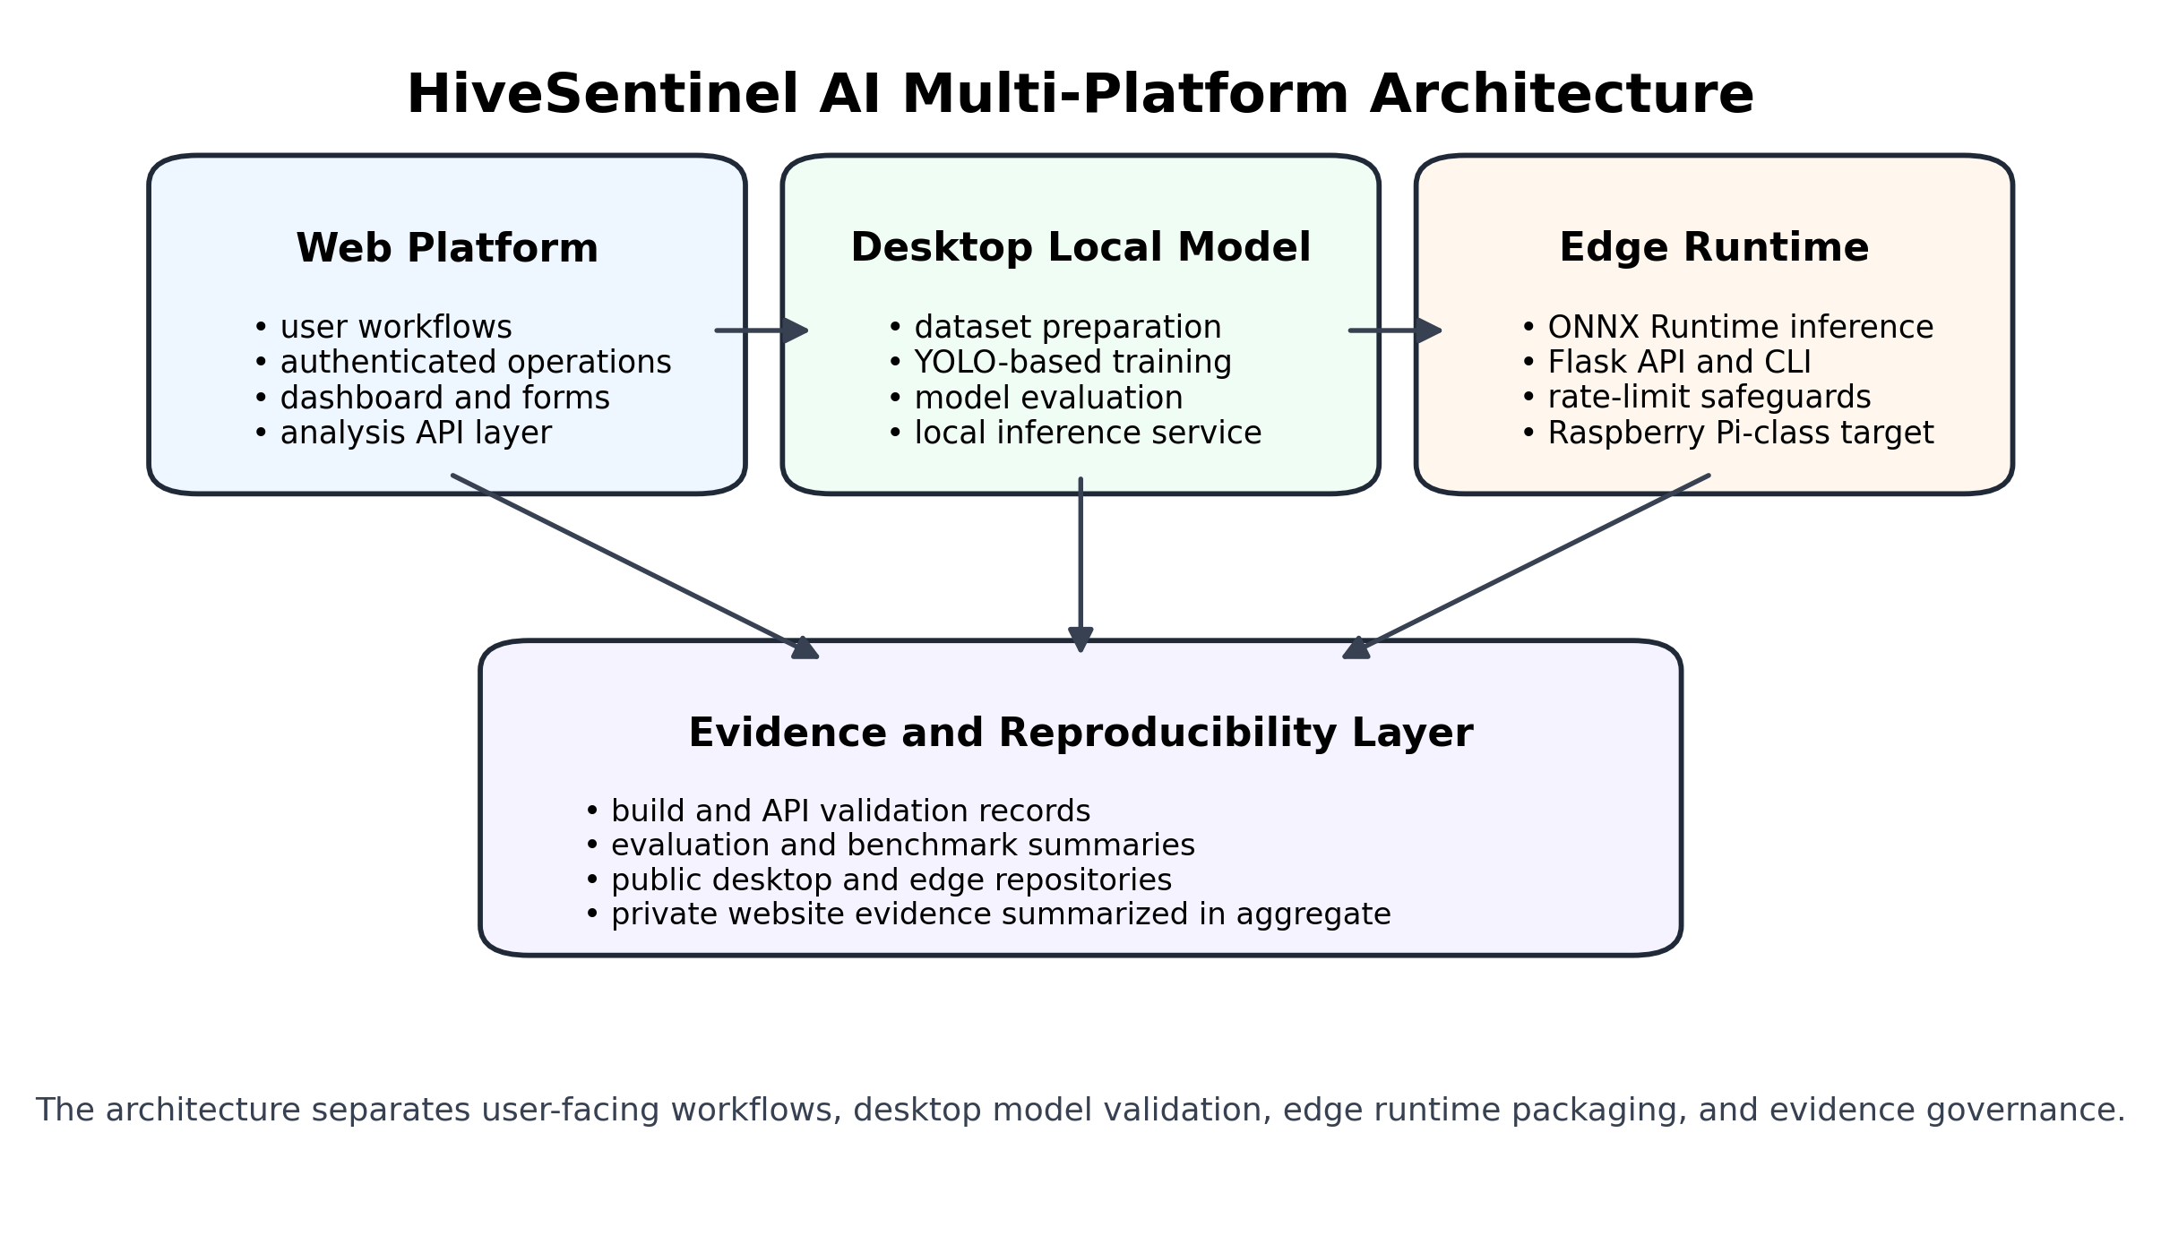Figure 1. Multi-platform system architecture of HiveSentinel AI.

The triangular connectors between the website API, the desktop-local inference service (MLSRV), and the edge API (EAPI) represent configuration-based integration opportunities. They do not imply that live users must always be routed through all three tiers. Website analysis workflows can be configured to call a local model endpoint, whereas desktop-local and edge-runtime validation can also be reported as isolated checks. These boundaries are preserved in Chapter IV so that application-level, desktop-model, and edge-runtime evidence remain methodologically distinct.
At the web-application level, the architecture contains the following website submodules:
• multi-provider image analysis and knowledge-base enrichment;
• personal dashboard, history, and export workflows;
• model-comparison interface, public guidance chatbot, learning hub, and localization layer;
• friends, direct messaging, notifications, forum sharing, and moderation; and
• administrator analytics, user management, insect knowledge-base curation, content management, chatbot Q&A management, and contact-message review.
Terminology boundary: the website exposes POST /api/chat as a public guidance chatbot backed by cloud Mistral inference and database/static fallbacks. The desktop-local inference service separately exposes an offline /api/chat path backed by Ollama/Moondream for advisory secondary review in the local two-stage prediction flow. These chat endpoints are homonymous but architecturally distinct and must not be treated as a single subsystem in evaluation reporting.

3.5 Technologies and Tools
3.5.1 Website Stack
- Framework/runtime: Next.js (16.1.6), React (19.2.4), TypeScript
- Database/ORM: Prisma ORM, MySQL as the engineered data source
- Authentication: NextAuth/Auth.js with Prisma adapter
- UI and state: Tailwind for UI composition, Radix UI components, form and schema validation tools
- AI integration layer: Vercel AI SDK provider interfaces (Google/Groq/Mistral gateway stack)
• Internationalization: next-intl with English and Turkish message catalogs and localized export document labels.
• File storage: optional Vercel Blob integration for user avatar uploads.
• Visualization: Recharts-based dashboard components for personal analytics.
• Password security: bcrypt hashing for credential registration through POST /api/auth/signup.

3.5.2 Desktop Local Model Stack
- Model family: Ultralytics YOLOv8 classification pipeline
- Core libraries: PyTorch, torchvision, ultralytics, scikit-learn, matplotlib
- API Serving: FastAPI + Uvicorn (local inference)
- Data and utilities: pandas, Pillow, OpenCV, NumPy, YAML

3.5.3 Edge Runtime Stack
- Inference engine: ONNX Runtime (CPUExecutionProvider)
- Service layer: Flask API + CLI inference entrypoint
- Dependencies policy: inference-only runtime (requirements-pi.txt) with no PyTorch on device
Operational controls apply rate limits and request-size constraints, set local bind defaults, and provide optional metrics and history in SQLite format.

3.6 Data Source / Input Data / Dataset
The desktop-local model uses a canonical six-class YOLO classification dataset referred to in this thesis as yolo_insects_multi. The dataset follows the classification layout of Ultralytics YOLO, with the train, validation, and test folders containing six class subfolders. Ground-truth labels are derived from the subfolder names, which is the contract of folder-based classification that YOLOv8-cls pipelines use.
The six classes are honey_bee, honey_bee_varroa, hornet_asian, hornet_european, other_insect_hive, and wasp_common. The dataset audit captured a total of 99,067 images, with 68,774 images in the training split, 14,376 images in the validation split and 15,917 images in the test split. Project evidence for dataset integrity used non-zero file-size validation and PIL verify spot-checking on up to 60 random images; therefore, the dataset should not be described as a full decode verification of every image. The dataset is adequate for reporting methodology and distribution, while the severe class imbalance, especially the low support of hornet_european, should be considered when interpreting results.

3.6.1 Data Acquisition and Local Dataset Assembly
The final training dataset utilized in this thesis is the locally consolidated yolo_insects_multi dataset. This dataset was created specifically for six-class YOLO classification dataset and was organized in the standard YOLO-cls folder structure for datasets and contains the training, validation, and testing portions. The class taxonomy is honey_bee, honey_bee_varroa, hornet_asian, hornet_european, other_insect_hive, and wasp_common. Labels in the consolidated dataset are not treated as independent metadata files in the final training folders; instead, they are derived from parent folder names after local source-specific mapping into the six thesis classes.
Data acquisition was carried out through a reproducible local collection workflow rather than through a single pre-existing public archive. Public upstream sources were downloaded or referenced through project scripts, and the raw materials were first staged under the raw-data area of the project. The upstream inputs include Zenodo records for bee, varroa, sticky-board, and insect-classification material; Hugging Face image datasets; iNaturalist class-specific bulk downloads; Wikimedia Commons images; and optional Kaggle datasets that require an API token. The scripts used for acquisition and source staging are summarized in Table 3.
After download, local merge and preparation scripts harmonized the heterogeneous image sources into a common class taxonomy. This process involved mapping source-specific labels into the six target classes, preparing a folder-based classification layout, and constructing the consolidated yolo_insects_multi directory with train, validation, and test subfolders. The resulting dataset contains 68,774 training images, 14,376 validation images, and 15,917 test images, for a total of 99,067 images. The local build pipeline can be summarized as download, raw-data staging, source merging and preparation, build_yolo_insects_multi.py, dataset validation through validate_dataset.py, and optional training-class balancing through cap_train_class_size.py.
This local assembly design was utilized to maintain the reproducibility of the training and evaluation contracts while keeping a clear separation of the public upstream datasets and the final consolidated dataset for training. For the final model folders, ground-truth labels are operationally defined by the local mapped folder names, not by the original heterogeneous source labels. This distinction is necessary because the thesis reports the consolidated dataset as a local research artifact, rather than as a direct copy of a single upstream dataset.
Table 3. Public upstream image sources and local acquisition scripts used before yolo_insects_multi assembly.
Source / status | Public source | Local acquisition script(s) | Role in local dataset assembly
Zenodo 4085044 - Varroa/bee (required) | zenodo.org/records/4085044 | download_datasets.py; scripts/download_all_training_sources.py | Bee/Varroa source material with train/val/test/gt.csv structure.
Zenodo 8325384 - Insect Detect classification v2 (required) | zenodo.org/records/8325384 | download_datasets.py; scripts/download_all_training_sources.py | General insect-classification material used during local source aggregation.
Zenodo 10231845 - Sticky-board Varroa supplement (required) | zenodo.org/records/10231845 | scripts/download_all_training_sources.py | Supplementary Varroa-related sticky-board material.
Hugging Face ggsmith/Hymenoptera (required) | huggingface.co/datasets/ggsmith/Hymenoptera | scripts/download_hf_hymenoptera.py | Hymenoptera imagery supporting bee, wasp, and hornet coverage.
Hugging Face MikeTrizna/bees (required) | huggingface.co/datasets/MikeTrizna/bees | scripts/download_all_training_sources.py | Bee imagery contributing to bee-class diversity.
iNaturalist (required) | inaturalist.org | scripts/download_inat_training_bulk.py -> data/raw/inat_train/ | API-based per-class bulk download for class-specific image acquisition.
Wikimedia Commons (required) | commons.wikimedia.org | scripts/download_commons_insects.py | Hornet, wasp, and other insect imagery for source enrichment.
Kaggle honey bee annotated images (optional; API access required) | kaggle.com/datasets/jenny18/honey-bee-annotated-images | scripts/download_all_training_sources.py | Optional honey-bee source subject to Kaggle API access.
Kaggle synthetic honeybee Varroa images (optional; API access required) | kaggle.com/datasets/sammynorman/synthetic-images-of-honeybees-infested-with-varroa | scripts/download_all_training_sources.py | Optional Varroa-related source subject to Kaggle API access.
Kaggle bees vs wasps (optional; API access required) | kaggle.com/datasets/datasnaek/bees-vs-wasps | scripts/download_all_training_sources.py | Optional bee/wasp source subject to Kaggle API access.
As of this thesis revision, the consolidated yolo_insects_multi dataset has not yet been publicly deposited, and no public URL, DOI, or downloadable archive is available. Only the upstream sources listed in Table 3 are public; the merged dataset itself was built locally from the mapped source materials and thus, this thesis does not provide a public citation or download link for the consolidated dataset. An audited split and class distribution are provided in Table 4, and the same distribution is depicted in Figure 2. Figure 2 shows a large dominance of the other_insect_hive class and a small representation of the hornet_european class in both the validation and testing data. Due to this, the thesis examines the results for the hornet_european class with caution.
Table 4. Audited dataset split and class distribution for the desktop-local YOLOv8 classification dataset.
Class | Train | Validation | Test | Total
honey_bee | 8,271 | 1,628 | 2,671 | 12,570
honey_bee_varroa | 3,107 | 451 | 942 | 4,500
hornet_asian | 697 | 148 | 151 | 996
hornet_european | 20 | 4 | 5 | 29
other_insect_hive | 56,297 | 12,063 | 12,065 | 80,425
wasp_common | 382 | 82 | 83 | 547
Total | 68,774 | 14,376 | 15,917 | 99,067

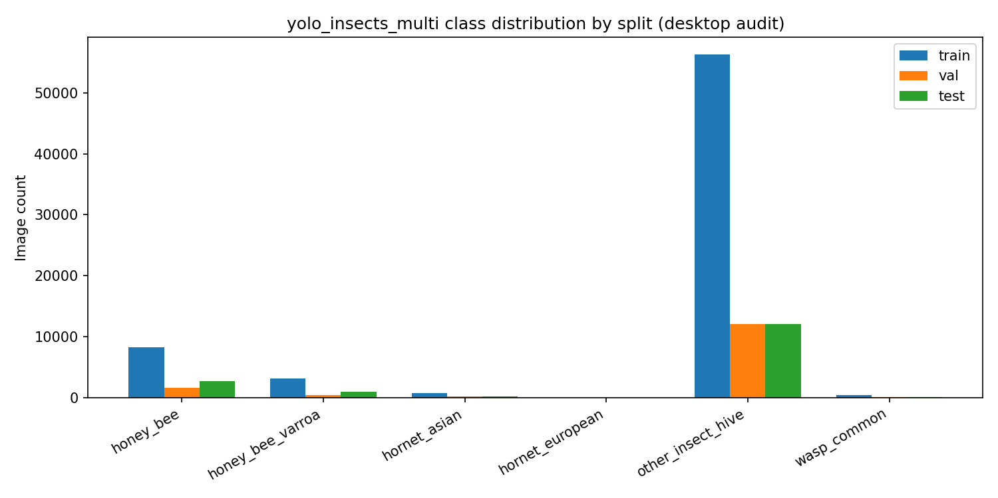
Figure 2. yolo_insects_multi class distribution by split for the desktop-local dataset.

3.7 Data Preparation and Processing Procedures
Data preparation followed the project dataset contract and configuration files, as opposed to ad-hoc manual labeling. The dataset configuration determines the train, validation, and test split folders, six class names, and nc = 6. This makes the dataset structure explicit and repeatable across training, evaluation, and inference scripts without relying on machine-specific local paths.
The preparation procedure includes source aggregation, construction of the multi-class folder layout, dataset validation, split verification, and class-order checking. The class order used for training and export is honey_bee, honey_bee_varroa, hornet_asian, hornet_european, other_insect_hive, and wasp_common. The same order is also used by the edge-runtime classes.json contract, preventing mismatches between the PyTorch/YOLO and ONNX inference paths.
For inference, input images are decoded, converted to RGB, resized according to the configured image size, and passed through the preprocessing assumptions of the selected runtime. The desktop-local example evaluation uses the promoted production weights with imgsz 224. The edge runtime uses an Ultralytics-compatible preprocessing mode, no additional normalization in the runtime configuration, temperature calibration, and abstain thresholds to reduce overconfident outputs under uncertain predictions.
The dataset and preprocessing design therefore support reproducibility at three levels: folder-based ground truth, explicit class-index ordering, and matching model/runtime contracts between desktop-local and low-resource edge inference.

3.8 Implementation Details

3.8.1 Website Implementation
The website implementation followed an API-first, role-aware architecture implemented with Next.js App Router, Prisma ORM, and MySQL. Beyond build-time and route-level validation (subsection 3.11.1), the web platform implements a workflow-oriented monitoring application that connects multi-provider vision analysis, personal analytics, collaboration features, and administrative curation in a single deployment.
Core analysis workflow. The primary user workflow is exposed at /analyze, locale-prefixed /en and /tr entry points, and POST /api/analyze. A public GET /api/models endpoint exposes the configured vision providers and variants to the UI. Authenticated users upload or capture an image (drag-and-drop, file selection, or webcam; JPEG/PNG/WebP/GIF up to 5 MB), select a vision provider and model variant among Mistral, Google Gemini, and Groq configurations, and receive a structured response containing species identification, risk level, confidence, possible hive damage, and ranked protection methods. The server parses an extended JSON enrichment payload (taxonomic context, differential diagnosis, seasonal risk, IPM guidance, image-quality assessment, and uncertainty interpretation) and merges model output with the curated insect knowledge base when a catalog match exists. The knowledge base is aligned with the same six-class pest taxonomy used in the desktop YOLO pipeline (honey_bee, honey_bee_varroa, hornet_asian, hornet_european, other_insect_hive, wasp_common). Successful analyses are persisted in AnalysisHistory only for authenticated sessions; the API applies per-IP rate limits for anonymous calls and per-user limits when a session is present. Client-side and server-side export paths, including immediate post-analysis export and GET /api/export/analysis/[id], support HTML, CSV, and JSON formats.
Model comparison workflow. A dedicated comparison interface at /compare orchestrates parallel POST /api/analyze requests for the same image across selected providers. The client aggregates per-model latency, confidence, risk assignment, and key-feature overlap (mean pairwise Jaccard similarity) and supports reproducible export of the comparison payload in HTML, CSV, and JSON formats. Comparison results are exported client-side; although Prisma defines ModelComparison tables, the current /compare UI does not persist comparison runs to the database. The standalone POST /api/compare route is a rate-limited stub; comparison is intentionally client-orchestrated to reuse the canonical analysis contract. The separate /[locale]/compare page displays reference benchmark charts only and must not be confused with the live /compare workflow.
Personal analytics and history. The /dashboard route provides authenticated aggregate metrics (totals, high-risk counts, recent detections, chart summaries) backed by GET /api/me/dashboard. The /history route provides searchable and filterable access to prior analyses; GET /api/me/analysis/[id] returns a single owned record. User profiles support beekeeper-oriented fields (location, experience level, hive count) alongside avatar upload. Per-analysis export is available through GET /api/export/analysis/[id] with localized HTML, CSV, and JSON formats.
Collaboration and community layers. The platform implements a social collaboration layer comprising username-based friend requests (/friends), direct messaging (/chat with HTTP polling, not WebSockets), in-app notifications, and analysis sharing in both chat and forum contexts. Shared activities can be viewed and exported consistently from chat and forum export endpoints. The community forum (/forum) exposes seeded thematic categories (general, beekeeping, threat identification, protection, and help) with message posting, activity-share message types, and user/message reporting flows moderated through the admin console.
Guidance and localization. A public guidance chatbot (POST /api/chat) combines Mistral text generation with a static apiculture knowledge string and database-backed Q&A fallbacks; GET /api/chat/suggestions supplies quick prompts. This website chatbot is distinct from the optional offline Ollama/Moondream assistant in the desktop-local inference stack. Learning content is served at /learn by merging static articles with database-managed Article records. The interface supports English and Turkish localization through next-intl, including localized export labels.
Administrative operations. The /admin console provides role-protected analytics (GET /api/admin/analytics with 7/30/90-day ranges), user lifecycle management, global analysis inspection (including /admin/analyses/[id] detail and POST /api/admin/analyses/export bulk export), insect knowledge-base CRUD with image upload and import of uncatalogued detections into the catalog, chatbot Q&A CMS with bulk import/export, dual content-management paths (versioned Content with publish/unpublish and separate Article records for the learn hub), moderation report handling, and contact-message review. Admin authorization re-validates role and active status from the database on each protected API call; SUPER_ADMIN is required for role elevation and cannot be deactivated through the status API.
Table 5 summarizes the main website modules and routes that operationalize the application-layer workflow described above.
Table 5. Website application modules and primary routes (HiveSentinel AI web platform).
Module | User role | Primary routes | Principal capabilities
Landing and auth | Public | /, /auth/signin, /auth/signup | Marketing entry, OAuth (Google/GitHub), credential signup/login
Image analysis | Authenticated | /analyze, POST /api/analyze | Multi-provider vision inference, enrichment, knowledge-base merge, history persist
Model comparison | Authenticated | /compare | Parallel /api/analyze calls, latency/confidence/risk comparison, Jaccard feature agreement, export
Personal dashboard | Authenticated | /dashboard, GET /api/me/dashboard | KPIs, Recharts trends, reorderable sections, HTML export
Analysis history | Authenticated | /history, GET /api/me/history | Search/filter, per-record export (HTML/CSV/JSON)
Profile and settings | Authenticated | /profile, /settings, PATCH /api/me, POST /api/me/avatar | Profile fields, avatar via Vercel Blob, theme preferences
Social graph | Authenticated | /friends, /api/friends/* | Requests, accept/reject, friends-only messaging eligibility
Direct messaging | Authenticated | /chat, /api/chat/messages | One-to-one chat, polling, read receipts, share analysis cards
Notifications | Authenticated | /api/notifications | Friend/chat/share events, mark read
Community forum | Public browse / authenticated post | /forum, /api/forum/* | Categories, threaded messages, activity share, user/message reports
Guidance chatbot | Public | POST /api/chat | Mistral plus knowledge-base fallback Q&A widget
Learning hub | Authenticated | /learn, /learn/[slug] | Static plus database-merged articles
Localized guide | Public | /[locale]/guide | System onboarding diagrams
Contact | Public | /contact, POST /api/contact | Support message intake
Public model catalog | Public | GET /api/models | Lists configured vision providers and variants for Analyze/Compare UI
Localized analyze | Authenticated | /en, /tr | Locale-prefixed analyze workflow equivalent to /analyze
Admin analysis export | ADMIN | POST /api/admin/analyses/export | Bulk export of analysis records
Admin article CMS | ADMIN | /api/admin/articles | CRUD for learn-hub articles (separate from versioned Content CMS)
Admin console | ADMIN / SUPER_ADMIN | /admin/*, /api/admin/* | Analytics, users, insects KB, analyses, CMS, chatbot Q&A, moderation, contact inbox
Database bootstrap and deployment. npm run db:init seeds default administrator credentials, four RiskLevel rows, and sample insect/species knowledge-base records when empty. Docker Compose packages a web service and MySQL 8.4 database for reproducible local deployment, consistent with the Docker versions recorded in Table 8.
Operational controls. Middleware protects core authenticated pages (/analyze, /dashboard, /history, /profile, /settings, /compare, /learn, /admin, and locale roots) while leaving forum, chat, friends, and contact pages publicly reachable at the page level; mutating APIs remain session-protected. Request bodies for signup and contact flows are validated with Zod schemas. A structured AppErrorCode taxonomy surfaces camera, upload, network, timeout, and AI-provider failures to the UI. The client debug-log endpoint is disabled in production. Rate limiting is implemented in memory per client IP and/or per user for signup, analysis, chat, forum posting, friend actions, sharing, notifications, and admin routes (see Table 6). These controls support abuse resilience in single-instance development deployments but are not presented as distributed rate limiting across horizontally scaled replicas.
Integration note. Environment variables document a future optional hook (USE_LOCAL_INSECT_MODEL, LOCAL_INSECT_MODEL_URL) for delegating inference to a local FastAPI service, but the current POST /api/analyze implementation uses cloud vision LLM providers only. Integration with the desktop-local YOLO service or edge ONNX runtime remains configuration-dependent and methodologically distinct from the website’s primary multi-provider analysis path.
Website verification activities documented in Chapter IV include static type checking, production build completion, Prisma initialization and db:init seeding, HTTP method/route matrices, authenticated boundary probes, social and admin mutation checks, forum payload validation, chat/contact rate-limit probes (rate_limit_probe_chat_contact artifact), and controlled stress testing on the analyze route family.

3.8.2 Desktop Local Implementation
The desktop-local component implements the training, promotion, and inference workflow for the YOLOv8 classifier. It includes:
- YOLOv8 classification training and evaluation scripts;
- promotion and use of the selected production model weights;
- implementation of the local inference service through inference_server.py;
- phase-based evaluation and reporting through scripts such as phase3_evaluate.py; and
- secondary review and SQLite-backed event metrics where available.
To support claims, the implementation separates full validation-split reporting, example-image inference checks, latency summaries, and API health outputs. These outputs are used only within their documented scope.
The desktop-local service is not limited to the /predict route. It also exposes operational and observability endpoints such as /health, /history, /dashboard, /api/chat, and local UI pages. Inference events and secondary-review events are persisted in SQLite tables such as analysis_history and second_opinion_events through additive schema evolution. These mechanisms support traceability and post-hoc analysis of local inference behavior, but they do not by themselves prove improved predictive validity in field deployment.
The desktop stack also contains an optional local LLM support layer through Ollama with the default model moondream:latest. This layer is used for advisory secondary image review in a two-stage prediction flow, where the YOLO classifier remains the primary decision source and the Moondream response supplies agreement states such as agree, uncertain, disagree, or unavailable. The same local assistant infrastructure supports offline /api/chat interactions. This secondary-review layer is advisory and offline-local; it is not the primary metric source and should not be presented as formal calibration or authoritative diagnosis.
Desktop reproducibility is further supported by environment-hardening and automation utilities, including local YOLO_CONFIG_DIR control, integration-off settings for external experiment trackers, training preflight checks, and an end-to-end orchestration script for dataset preparation, validation, training, evaluation, and promoted-weight handling. These artifacts improve process repeatability and run stability, while still leaving exact cross-machine determinism and k-fold validation outside the current evidence base.

3.8.3 Edge Local Implementation
The edge-local package implements a compact inference runtime designed for low-resource environments. It includes:
- infer.py for command-line ONNX inference and timing;
- api_server.py for localhost HTTP inference;
- an ONNX model contract with classes.json and runtime.json configuration files;
- runtime defaults for preprocessing, calibration, abstain behavior, and request handling; and
- quality gates such as run_all_checks.py, verify_dod.py, and pytest-based checks.
- The edge model track is separate from the desktop promoted production artifact. The low-resource ONNX runtime is tied to the pi4_edge_n224_v1 profile, which uses a YOLOv8n-cls base, the hivesentinel_pi_n224_v1 run name, image size 224, and ONNX export with opset 12 in FP32. It shares the six-class taxonomy with the desktop pipeline, but it should not be described as the same trained artifact as the desktop YOLOv8s promoted weight.
- The edge service exposes more than /health and /predict. The package includes a built-in local /ui dashboard, metrics summaries, prediction history and export routes, and a restricted /db/download pattern that requires localhost access and an admin-key style control. Prediction records can include risk_level and risk_score fields for operational risk signaling, and the SQLite-backed logic supports summary, timeseries, and risk-distribution aggregation. These features demonstrate traceability and software readiness, not ecological risk-model validation.
- The edge inference path also includes implementation safeguards such as sequential ONNX execution, request-size and rate-limit controls, configured abstain reason codes, and an ONNX-graph Softmax detection safeguard to avoid double-softmax probability distortion. A systemd deployment template is prepared as a readiness artifact, while physical Raspberry Pi 4 execution evidence remains a future-validation requirement.

3.9 Main Modules and Workflow
The complete methodological workflow is as follows:
- Validate and prepare the six-class dataset;
- train and evaluate the desktop-local YOLOv8 classifier;
- select and promote production weights;
- export or validate the ONNX artifact for edge-runtime inference;
- validate desktop-local and edge-runtime APIs and inference paths;
- collect, index, and label all thesis-source outputs according to their evidence scope.
In addition, the website workflows are validated as runtime and mutation test matrices to support the combined interpretation of application-level and model-level findings within the same chapter.

3.10 Algorithms, Models, APIs, and Pipelines Used
- Primary AI model strategy: YOLOv8 classification for distinguishing six classes of insects/pests.
- Evaluation pipeline: phase-specific scripts generating summary statistics of accuracies, confusion outputs, and threshold artifacts.
- Desktop inference pipeline: localized model serving, with health/predict/history dashboards.
- Edge inference pipeline: CPU-based inference via ONNX Runtime through a command-line interface coupled with a Flask API.
- Website API pipeline: role-protected REST endpoints that secure application operations and AI-augmented tasks.
The thesis does not assert the introduction of a new base model architecture; rather, it asserts the integration, validation, and reproducibility of efforts across multiple levels of system deployment. The contribution is therefore positioned as an integration and validation study built on established open-access advances in detection, classification, segmentation, edge inference, and reproducible ML workflows (Alomar et al., 2023; Cheng et al., 2024; Kirillov et al., 2023; Liu et al., 2023; Oquab et al., 2023; Ravi et al., 2024; Wang, Chen, et al., 2024; Wang, Yeh, & Liao, 2024; Zhao et al., 2024).

3.10.1 Model Configuration, Training Protocol, and Reproducibility Parameters
The local desktop model track utilizes the Ultralytics YOLOv8 classification pipeline and classifies insects and bee pests into six classes. The promoted desktop-local production weight file, best_production.pt, is present and was used for thesis evaluation. However, exact promoted production training metadata, including runs/production/args.yaml and promoted-folder results.csv, was not available in the project evidence reviewed for this thesis. For methodological transparency, related-run configuration evidence from hivesentinel_full_multi_v2 is reported as fallback only: YOLOv8 classification base yolov8s-cls.pt, optimizer auto, epochs 80, batch 8, learning rate 0.01, seed 0, and augmentation settings hsv_h = 0.015, hsv_s = 0.7, hsv_v = 0.4, fliplr = 0.5, mosaic = 1.0, and auto_augment = randaugment. Related-run training evidence used imgsz 384, whereas reported Phase 3 validation and promoted-model example-image evaluations used imgsz 224. These values are therefore related-run and evaluation-scope evidence, not exact promoted-production hyperparameters. No k-fold cross-validation evidence was available in the project evidence reviewed for this thesis; the project uses a fixed train/validation/test split, and quantitative claims must distinguish validation-split, diagnostic example-image, and any future test-split evidence.
Pseudocode 1. Reproducible Desktop-Local Evaluation Pipeline: (1) verify the six-class folder layout and dataset YAML, (2) load the selected promoted weights, (3) select the appropriate split or categorized example folders, (4) run inference with the documented image size, (5) export predictions and class-level metrics, (6) generate confusion and per-class metric outputs, and (7) label the results as validation-split, test-split, or example-image evaluation according to the actual input source.

3.10.2 Low-Resource Edge Runtime Configuration
The low-resource edge-runtime track uses an ONNX model artifact and a class-mapping contract defined in the edge runtime package. The class mapping defines the same six-class order used by the desktop-local dataset and model contract: honey_bee, honey_bee_varroa, hornet_asian, hornet_european, other_insect_hive, and wasp_common.
The edge runtime is configured for ONNX Runtime inference through command-line and Flask API entry points. The available runtime configuration records an Ultralytics preprocessing mode, no additional runtime normalization, temperature value 2.0, and abstain thresholds with min_conf 0.65, min_margin 0.04, and max_entropy 1.35; abstain reasons include low_confidence, low_margin, and high_entropy. Test-time augmentation is disabled in the available configuration. These values should be interpreted as configured uncertainty-policy defaults, not as formal calibration validation, because ECE/reliability-diagram calibration artifacts were not available in the project evidence reviewed for this thesis.
The edge API evidence identifies api_server.py as the Flask service entry point and infer.py as the command-line inference entry point. The documented service defaults bind to 127.0.0.1 on port 5050, apply a maximum request body size of 8 MB, and use a rate limit of 30 requests per minute per IP. The low-resource package is inference-only for deployment purposes: PyTorch is not required on the edge device because the runtime uses ONNX Runtime through requirements-pi.txt.
The edge evidence provided for this phase is labeled as development-host edge-runtime evaluation. It verifies the presence of an ONNX model, class contract, runtime defaults, and an inference pathway oriented toward localhost, but it does not offer evidence for the claim of actual Raspberry Pi 4 field performance. For this, dedicated Raspberry Pi 4 logs, screenshots, and timing captures are necessary. The prediction pathway is illustrated in Figure 3, along with the services, user interactions, model predictions, and data logs.

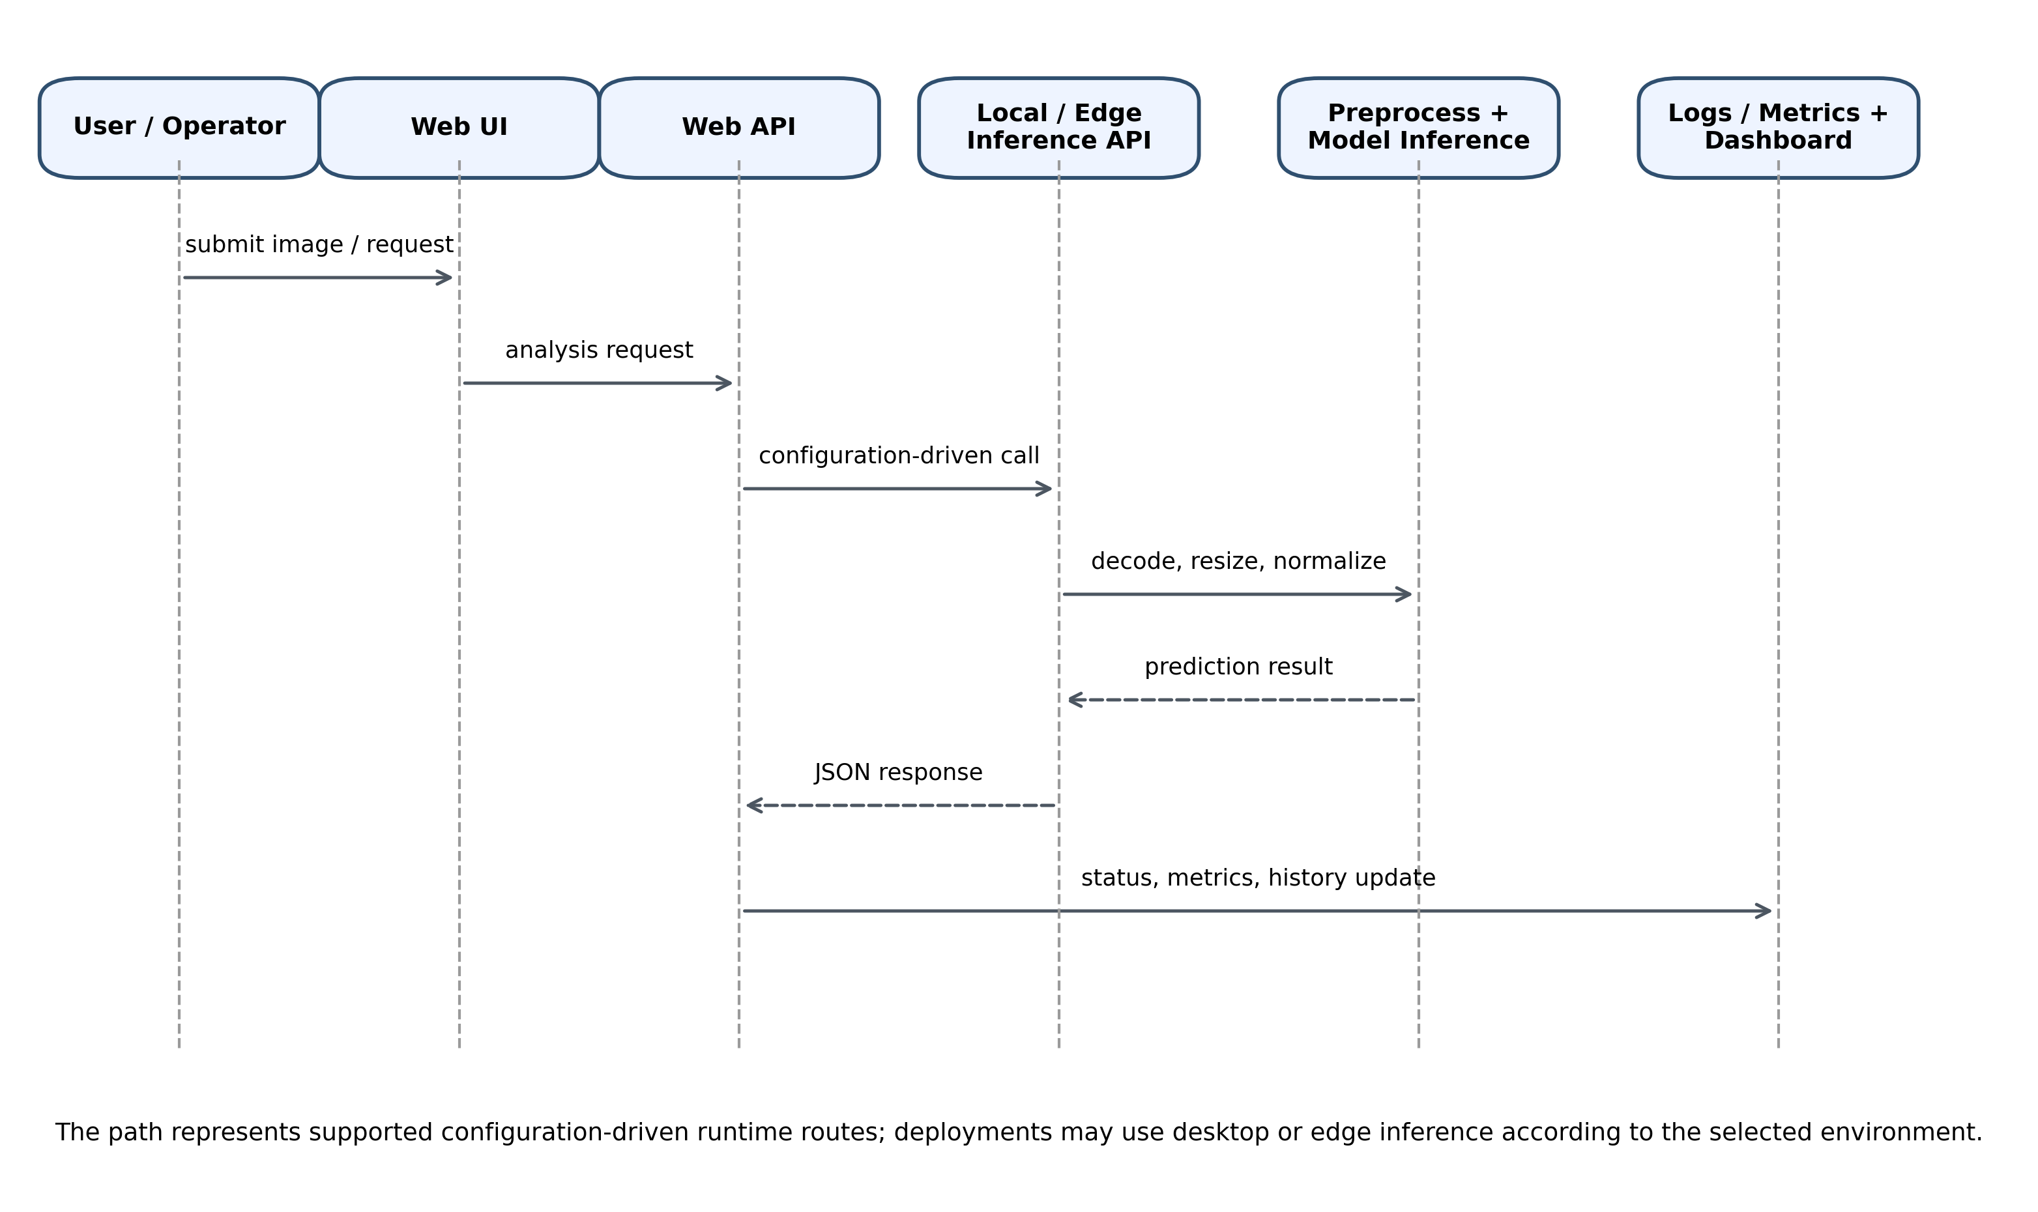
Figure 3. Runtime prediction request sequence across HiveSentinel AI components.

The diagram does not imply that a deployment must employ desktop and edge endpoints concurrently, but rather that the noted configuration mechanisms are flexible to the aforementioned runtime pathways.

3.11 Experimental Setup / Testing Setup
Testing and validation were performed to ensure that all the evidence sources are linked to their input files, model artifacts, and their respective execution environments. The methodology differentiates (i) the existing Phase 3 validation split metrics, (ii) example-image assessments using the 71 categorized images, and (iii) checks of edge runtime on development hosts, which do not constitute Raspberry Pi 4 field benchmarks.

3.11.1 Website Validation Setup
Website validation incorporated build verification, route verification, endpoint smoke testing, boundary testing for authentication, mutation testing, and rate-limit or stress-testing probes. These tests offer application-layer evidence but do not support claims regarding model accuracy.
Website validation additionally exercised social, forum, friend, chat, share-analysis, and administrator mutation routes documented in the project’s API method matrices and condensed mutation logs. Chat and contact endpoints were probed for rate-limit behavior (rate_limit_probe_chat_contact artifact). Database bootstrap via npm run db:init was used to verify Prisma seeding of risk levels, sample insect knowledge-base records, and default administrator creation prior to authenticated workflow tests.

3.11.2 Desktop-Local Validation Setup
Desktop-local validation included checks for dataset integrity, auditing class distributions and model weights, selection of production weights, validation split report from Phase 3 files, example-image inference checks, and measurement of CPU latency for categorized example images. The example-image set, which consists of 71 images, is used for illustrating behavior analysis, and does not substitute for the official test sample held out.
The desktop diagnostic package uses canonical JSON latency values rather than older draft Markdown latency summaries. In the 71-image diagnostic example set, desktop mean, median, and p95 latency are 42.91 ms, 29.71 ms, and 114.67 ms, respectively. These values are retained as diagnostic example-image latency values only and should not be merged with validation-split accuracy or with unrelated stress-probe latency summaries.

3.11.3 Low-Resource Edge Runtime Validation Setup
Edge runtime validation consisted of checks for ONNX model provisions, mapping of classes, checking runtime defaults, measurement of latency for example images, and checking the localhost API. The available edge results provide software-readiness evidence for the edge runtime only and do not constitute performance evidence of Raspberry Pi 4 in the field.
The edge diagnostic package similarly uses canonical JSON latency values. In the 71-image development-host edge-runtime evaluation, mean, median, and p95 latency are 14.09 ms, 8.86 ms, and 34.71 ms, respectively. These values are not physical Raspberry Pi 4 hardware timings and should not be used as field-performance evidence.

3.12 Evaluation Metrics or Evaluation Criteria
The evaluation framework categorizes metrics by subsystems. The metrics of interest for model behavior include accuracy, class-level precision, class-level recall, F1-score, support, and confusion matrices, given that real predictions and ground truth labels are available. For behavior regarding runtime, the metrics of interest include request success, API health, latency (mean, median, p95, min, max), and the number of images tested. For reproducibility, the criteria of interest include model path, dataset path, class-index contracts, configuration file, and the difference among validation-split, test-split, and example-image evidence. The thesis does not combine these evidence types. Results of the validation-split are reported as validation-split results; metrics associated with example images are reported as metrics associated with example images; and measurements regarding the development-host edge-runtime are reported as measurements regarding the development-host. Raspberry Pi 4 performance should be reported only when on-device measurements are available. Where the comparison package provides paired predictions for the same 71 example images, the thesis considers McNemar tests and bootstrap accuracy confidence intervals as diagnostic statistics. McNemar analysis applies to correct paired outcomes for the matched example-image set, and bootstrap confidence intervals apply to example-image accuracy. These approaches do not apply to the 14,376-image validation split or the 15,917-image official test split, as the provided evidence package supplies aggregate validation metrics, but does not supply full paired per-sample validation predictions for those large splits.

3.13 Ethical, Privacy, and Security Considerations
The project uses a responsible engineering ethics framework that contains:
- No fabricated metrics, datasets, or citations in reporting,
- explicit separation of validated claims from pending claims,
- local-first as the default for sensitive contexts,
- controlled API exposure with controlled request processing.
Security and privacy controls that were considered or applied include:
- Edge API binds to the localhost by default.
- Body size limits and throttle limits on requests.
- No cloud secret is required for edge packages.
- The logging design considers metadata; the thesis does not claim full anonymization.
- Complete system deployment will necessitate a custom security assessment and purpose-built deployment hardening.
For the website layer, rate-limit settings are implemented as single-instance, in-memory controls. Table 6 summarizes the documented policy used to bound public, authenticated, and administrator route families. These values should be interpreted as engineering safeguards rather than as evidence of distributed abuse-prevention under a multi-instance production deployment.
Table 6. Website API rate-limit policy (in-memory per deployment instance).
Route family | Limit key | Max requests | Window
Signup | IP | 8 | 1 hour
Contact form | IP | 20 | 1 hour
Analyze (anonymous) | IP | 45 | 1 hour
Analyze (authenticated) | User ID | 120 | 1 hour
Avatar upload | User ID | 40 | 1 hour
Compare orchestration | User ID | 80 | 1 hour
Direct chat messages | User ID | 200 | 1 minute
Forum post | User ID | 45 | 1 hour
Friend actions | User ID | 70 | 1 hour
Share analysis | User ID | 55 | 1 hour
Reports | User ID | 25 | 1 hour
Notifications | User ID | 150 | 1 minute
Public guidance chatbot | IP | 45 | 1 minute
Chat suggestions | IP | 120 | 1 minute
Profile PATCH | User ID | 50 | 1 hour
Admin APIs | IP / User ID | 200 / 150 | 1 minute
Note: limits are enforced in process memory; multi-instance deployments would require a shared store such as Redis for global enforcement.

3.14 Study Plan / Development Process
There were several phases built on evidence that were also iterative in design:
- Audit of datasets and model files and source reports for each component and their runtime configurations;
- Verification of each module using checks, tests, and runtime diagnostics in conjunction with documented configuration files;
- Integration of component-specific output into thesis-source reports;
- Combination of desktop-local and edge-runtime sources while keeping their evidence labels;
- Writing thesis sections using only the values that are supported by the available source files.
This methodology provides a grounded basis and structure for the thesis and helps to reduce the risk of making unsupported statements. Figure 4 shows the staged workflow with thesis synthesis and links dataset preparation, model training and evaluation, runtime package and functional validation, and performance evidence.

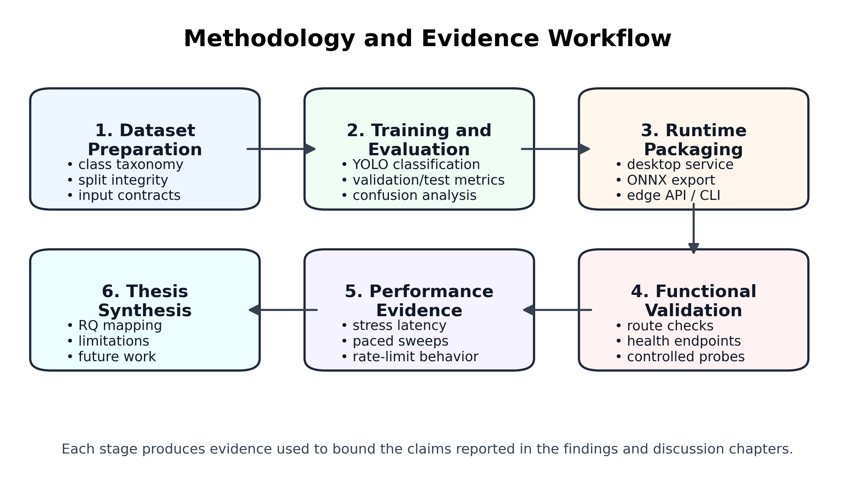
Figure 4. Methodology and evidence workflow.

CHAPTER IV

Results

4.1 Introduction
This chapter details the engineering and validation results for HiveSentinel AI. HiveSentinel AI consists of three components: a website built with Next.js, a YOLO training and inference stack built as a desktop application, and a resource-constrained deployment pack served by Flask and ONNX. All claims made herein will be substantiated by visible validation records, each of which will include dated logs, JSON summaries, CSVs, tables, figures, and attachments. When evidence is lacking for a claim, the evidence limitation will be stated explicitly, as opposed to being inferred. The evaluation scope will include the implementation and functional validation, as well as controlled performance evaluation (stress tests and micro-benchmark scripting). It will exclude a usability evaluation involving human subjects, an evaluation of production traffic, and a field deployment trial on a Raspberry Pi. In areas where this type of evidence is not available, the thesis states the boundary rather than assuming results. Chapter V provides a scholarly discussion of the results in relation to the literature review, the research gaps, and the research questions. A brief synthesis will be provided in Section 4.8. Table 7 maps each research question to the specific Chapter IV sections in which the corresponding results are reported.

Table 7. Research question grounding in Chapter IV.
Research question (Chapter I) | Primary sections in this chapter
RQ1 - Integrated web platform and AI pipeline for monitoring workflows | §4.2.1, §4.3.1 (build, route, mutation, and analysis-endpoint evidence)
RQ2 - Classification performance on the project dataset | §4.4.1–4.4.3 (dataset integrity, Phase 3 metrics, confusion/threshold artifacts)
RQ3 - Offline-capable operation, stable API behavior, stress performance | §4.5.1, §4.6 (desktop stress and health/dashboard summaries); website stress log §4.3.2
RQ4 - Pi-oriented runtime feasibility with safeguards | §4.2.3, §4.5.2, §4.6 (pytest, ONNX/Flask metrics, paced sweep, rate-limit probe)
RQ5 - Additional measurements for strict physical Pi claims | §4.5.2, §4.7 item 5 (explicit planned field protocol boundary)

The structure below follows: implementation findings, functional validation, model and dataset results, performance observations, system output observations, error analysis, and brief synthesis.

4.2 Implementation Findings

4.2.1 Website Application Build and Tooling Baseline
The collected website validation records show the successful completion of key engineering gates for establishing a reproducible Next.js + Prisma codebase. These gates include static type checking via npm run lint (tsc --noEmit), a production build via npm run build, and schema/seed initialization via npm run db:init. Supporting records capture specific runtime versions of Node.js (v22.22.0), npm (10.8.2), Docker client (28.3.2) and Docker Compose (v2.38.2-desktop.1) on the evidence capture host.
Table 8 presents the toolchain along with the website validation, enabling readers to correlate build reproducibility with a specific host snapshot, rather than as a normative “required versions” policy.

Table 8. Website engineering snapshot based on recorded component-level validation results.
Validation item | Recorded evidence | Interpretation
Static type check | npm run lint / tsc --noEmit completed | TypeScript readiness
Production build | npm run build completed | Successful application build
Database initialization | npm run db:init via Prisma workflow | Schema/seed initialization evidence
Captured host versions | Node.js v22.22.0; npm 10.8.2; Docker client 28.3.2; Docker Compose v2.38.2-desktop.1 | Recorded validation environment
Tooling caveat | MySQL CLI missing from capture host PATH | Environment limitation; Prisma evidence remains available

It is important to note the operational tools limitations. The same validation record shows that the MySQL command line client was missing from the capture host path. This indicates a limitation of the environment, not of the database. Application-level initialization evidence is still available via the scripted Prisma workflows and corresponding logs.

4.2.2 Desktop ML Codebase Readiness
Desktop evidence records Python version 3.12.6, pip version 25.3, NVIDIA GPU visibility via nvidia-smi, and successful completion of the training preflight and setup verification scripts. Static compilation checks from the desktop-local project root recorded an exit code of zero. An automated unit testing execution captured 17 tests, leaving 3 skipped tests due to artifact-path checks, rather than due to regression.
The captured evidence supports the thesis claim that the training and evaluation codebase was in a tool-documented, verifiable state as of the evidence capture date.

4.2.3 Edge (ONNX + Flask) package readiness
Quality-gate scripts, packaging verification scripts, seven passing pytest tests, and ONNX model availability checks (EV-P-PYTEST) demonstrate that the lightweight runtime package meets its software acceptance criteria on the machine used for execution. However, a clear methodological caveat should be noted, as documented in subsection 4.5, regarding hardware representativeness.
For the desktop track, local automated checks include dataset-structure validation, preflight checks, contract-oriented secondary-opinion regression checks, prediction-output exports, metrics JSON files, and latency-summary JSON files. For the edge track, run_all_checks.py performs a package-oriented quality gate covering preflight, pytest, and definition-of-done verification. The seven passing pytest tests cover package checks such as configuration, preprocessing, database support, and smoke behavior; API behavior is additionally supported by smoke and collection scripts rather than a comprehensive Flask API unit-test suite.

4.3 Functional Validation Results

4.3.1 Route Coverage, Authenticated Boundaries, Controlled Probes
Assembled structured evidence includes:
- a matrix to describe behavior of HTTP methods and routes (structured CSV validation artifacts),
- GET sweep spreadsheets to evaluate accessible status mixes,
- condensed textual logs containing mutation and administrator CRUD probes,
- schema examples illustrating forum payloads and edge-case examples,
- logs of endpoint analysis, along with execution of the project’s consolidated website validation scripts and summaries,
- and a website chat/contact protection validation exercise recorded as the rate-limit probe artifact.
The structured evidence integrates extensive functional validation probes and combines multiple techniques to demonstrate a defense-in-depth approach to the web API rather than a series of unstructured manual checks.
Collectively, the probe evidence supports the claim that authenticated and unauthenticated access paths responded as expected at the time of capture.
Beyond core analyze and authentication boundaries, the recorded mutation matrix scope included forum message posting, friend-request flows, direct-message send/read paths, analysis-sharing endpoints, and administrator CRUD operations on users, insects, analyses, and chatbot Q&A records. These probes support the Chapter III claim that the website is a multi-module application rather than a single-route upload demonstrator.

4.3.2 Controlled Load on the Analyze Route Family
Correctness is only part of functional robustness: an extended stress log captures sustained requests to the analysis workflow. The goal of the stress log is to capture repeatability of the engineering process; it is not aimed at extrapolating to internet-scale concurrency.

4.4 Dataset, Model, and Experiment Results

4.4.1 Dataset scale and structural integrity
After split accounting, the multi-class corpus contained 99,067 images, divided into 68,774 samples for training, 14,376 samples for validation, and 15,917 samples for testing. Project evidence for dataset integrity used non-zero file-size checks and PIL verify spot-checking on up to 60 random images; therefore, this integrity evidence should not be described as a full decode verification of every image.
Given the reported results, there is high confidence in the integrity of the samples. However, there is not sufficient evidence to make claims about the ecological representativeness of the dataset in the real world.

4.4.2 Phase 3 classifier accuracy summaries
As part of the Phase 3 evaluation, the promoted desktop-local classifier was evaluated on the validation split containing 14,376 images. The validation split provides the strongest available full validation-split metric in the attached results package and must not be described as the held-out test split. Table 9 reports the per-class precision, recall, F1-score, and support values, while Figure 5 shows the corresponding validation-split confusion-count matrix.

Table 9. Validation-split classification report for the promoted desktop-local model.
Class | Precision | Recall | F1-score | Support
honey_bee | 0.8901 | 0.9257 | 0.9076 | 1,628
honey_bee_varroa | 0.9666 | 0.7694 | 0.8568 | 451
hornet_asian | 0.7143 | 0.9122 | 0.8012 | 148
hornet_european | 0.0000 | 0.0000 | 0.0000 | 4
other_insect_hive | 0.9897 | 0.9819 | 0.9858 | 12,063
wasp_common | 0.3832 | 0.7805 | 0.5141 | 82
Macro average | 0.6573 | 0.7283 | 0.6776 | 14,376
Weighted average | 0.9711 | 0.9668 | 0.9680 | 14,376

Readers should distinguish this validation-split evidence from the official test split and from the curated example-image checks reported later. The validation result provides full-split quantitative evidence, whereas the example-image evaluations are diagnostic demonstrations based on a small categorized folder set.

4.4.2.1 Validation-Split Summary and Statistical Interpretation
The validation split produced a top-1 accuracy of 0.96675 across 14,376 images. This value is reported alongside macro and weighted precision, recall, and F1-score in Table 10. Because the class distribution is highly imbalanced, the weighted averages are strongly influenced by the dominant other_insect_hive class, while the macro averages better expose weaker rare-class behavior.

Table 10. Validation-split summary statistics and interpretation.
Quantity | Value | Interpretation
Evaluation scope | Validation split | Full validation split; not the official test split
Images evaluated | 14,376 | All validation images in the attached Phase 3 metrics file
Top-1 accuracy | 0.9667 | Strong full-split validation accuracy
Macro precision / recall / F1 | 0.6573 / 0.7283 / 0.6776 | Sensitive to rare-class instability
Weighted precision / recall / F1 | 0.9711 / 0.9668 / 0.9680 | Dominated by high-support classes

The summary in Table 10 is statistical in the descriptive sense: it reports full-split support, accuracy, macro averages, and weighted averages from the attached validation output. Formal paired significance testing for the validation split is not performed because the available validation evidence is aggregate and does not provide paired per-image predictions for multiple models on the same split.
Precision, recall, and F1-score are therefore reported where the attached files provide them: the full validation split for the promoted desktop-local model and the 71-image example evaluations for the desktop and edge-runtime pipelines. No unsupported values are estimated.
4.4.2.2 External Reported-Performance and System-Level Comparison
After the validation-split results of the promoted desktop-local classifier were established, the reported performance was positioned against selected recent bee-health, bee-monitoring, Varroa-detection, hive-entrance, hornet-detection, and general insect-pest recognition studies. This comparison is not treated as a universal leaderboard because the studies differ in task type, dataset composition, metric definition, and hardware setting. Instead, the purpose is to determine whether HiveSentinel AI provides a stronger combined answer across model performance, dataset scale, deployment readiness, and reproducibility evidence.
The comparison in Table 11 therefore uses a bounded interpretation. HiveSentinel AI is not described as the best model developed so far, and the 0.96675 result is not described as test accuracy. Rather, the desktop-local result is presented as a strong validation-split result that is higher than the main reported metric of several selected comparators, while the edge-runtime system is compared mainly through lightweight deployment preparation and API-level controls.
Table 11. External reported-performance and system-level comparison of HiveSentinel AI and selected comparator studies.
Study / system link | Model or architecture used | Task / domain | Dataset or evidence scale | Main reported metric | Technical comparison and safe interpretation
HiveSentinel AI desktop-local model | Ultralytics YOLOv8 classification pipeline; promoted production weights; local FastAPI inference service | Six-class bee-pest classification: honey_bee, honey_bee_varroa, hornet_asian, hornet_european, other_insect_hive, wasp_common | 99,067 total images; 68,774 train, 14,376 validation, 15,917 test; reported result is validation split only | 0.96675 top-1 validation accuracy; 0.9711 / 0.9668 / 0.9680 weighted precision / recall / F1 | Primary high-performance thesis model. It provides stronger reported desktop validation performance than several selected comparators, but it is not reported as held-out test accuracy.
HiveSentinel AI low-resource edge runtime | ONNX Runtime CPUExecutionProvider with Flask API, CLI inference, classes.json/runtime.json contracts, rate limiting, request-size controls, and PyTorch-free runtime policy | Raspberry Pi-class edge-runtime preparation and local/offline inference service behavior | 71 diagnostic example images on the development host; not physical Raspberry Pi 4 field timing | 0.4507 diagnostic example-image accuracy; macro F1 0.3479; lower latency than desktop example run in the current development-host evidence | Used as the small-system track. It is compared through deployment readiness, safety controls, and reproducible packaging rather than as a full benchmark against field-deployed hardware systems.
Liang (2024) | Attention-based Multimodal Neural Network (AMNN) combining visual and audio signals | Bee health evaluation and hive-status assessment | Multimodal bee health evaluation setup; four health conditions reported in the study | 92.61% overall accuracy; F1-score higher than 90% across evaluated health conditions | A strong bee-health comparator with lower reported overall accuracy than HiveSentinel desktop validation accuracy. The task is health evaluation, not the same six-class pest classification task.
Alex et al. (2024) | YOLOv5m and YOLOv5s fine-tuned object detection models | Bee detection and behaviour monitoring from images | 9,664 bee images with train/validation/test splits; bounding-box object detection task | YOLOv5m reported as most effective; YOLOv5s used for real-time detection at 5.1 ms/frame with slightly lower ability | Useful bee-monitoring comparator. HiveSentinel uses a larger image corpus and broader pest taxonomy, but mAP and accuracy are not directly equivalent.
Ratnayake et al. (2024) | Machine-learning bee species identification including YOLO-SVM combination | Bee species identification | Bee-species recognition dataset and feature/model comparison | 90.18% accuracy for YOLO-SVM configuration | A domain-close classifier comparator with a lower reported accuracy than HiveSentinel desktop validation accuracy, while addressing a different species-identification task.
Narcia-Macias et al. (2023) | YOLOv7-tiny models for honey bee, pollen, and Varroa monitoring | Hive-entrance monitoring, tracking, pollen detection, and mite detection | Hive-entrance monitoring system with account-based website support | 96.28% tracking accuracy; 0.95 F1 for honey bee recognition; 0.831 F1 for pollen model | Very close comparator. HiveSentinel desktop validation accuracy is slightly higher than the tracking accuracy, while HiveSentinel also separates desktop validation from edge-runtime boundaries.
Vdoviak et al. (2025) | YOLO-based and Faster R-CNN-based hive-entrance detection models | Worker bee, pollen-bearing bee, drone, and wasp detection at hive entrance | Public hive-entrance dataset under diverse environmental conditions; optimized for RTX 4080 Super and Jetson AGX Orin | Reported F1 values up to approximately 93-95% for selected configurations | Relevant hive-entrance detector comparator. HiveSentinel reports a higher weighted desktop-validation F1, but task, metric, and hardware conditions differ.
O'Shea-Wheller et al. (2024) / VespAI | Deep-learning invasive Asian hornet detection system using camera trap and Raspberry Pi 4 field-oriented setup | Invasive hornet detection | Standardized bait-station / field-detection context | Mean precision-recall score reported as >=0.99 | Balanced context only. It is not used as a lower-metric comparator because its hornet-specific field-detection result is stronger in its own narrow task. HiveSentinel is broader as a multi-platform bee-pest framework.
Hakim et al. (2025) / Yolo-Pest | Fine-tuned YOLOv8x with IoT-based smart traps | Small agricultural insect pest detection in mango and maize contexts | Open-field and closed-environment smart-trap deployments; crop-pest domain | 94% average detection accuracy in field smart-trap evaluation | Useful pest-monitoring comparator with lower reported detection accuracy than HiveSentinel desktop validation accuracy, but it is crop-pest detection rather than bee-pest classification.
Nguyen et al. (2024) / DeWi | Deep-Wide learning assistance for CNN-based insect pest classifiers | General insect pest classification | IP102 and D0 insect pest benchmarks | 76.44% accuracy on IP102; 99.79% on D0 | Shows the difficulty of broad insect-pest classification. HiveSentinel should only be compared with the IP102 result cautiously because IP102 has many more classes and a different domain.
Ung et al. (2021) | Multiple CNN-based ensemble models | General insect pest classification | IP102 and D0 public pest datasets | 74.13% accuracy on IP102; 99.78% on D0 | Supports background comparison for general pest recognition. Not a direct bee-pest benchmark, but useful for showing that pest recognition can remain difficult at scale.
Zhou and Su (2021) / ExquisiteNet | Small CNN with DFSEB and ME blocks; mobile-oriented pest classifier | Lightweight pest recognition | IP102 benchmark | 52.32% accuracy on IP102 without data augmentation; 0.98M parameters | Useful lightweight-model context. HiveSentinel edge should not be compared by headline accuracy here; the comparison is mainly deployment philosophy and low-resource design.
Because Table 11 combines accuracy, F1-score, mAP-related detection performance, tracking accuracy, and system-readiness evidence across different datasets and tasks, it should be read as a reported-performance and system-level positioning table rather than as a direct same-dataset leaderboard.

4.4.3 Confusion structure and supplementary threshold artifacts
The analysis relies on the validation-split confusion-count matrix shown in Figure 5. The matrix was produced using CPU execution and an image size of 224 for the promoted desktop-local model, and its interpretation remains aligned with validation semantics rather than test-split claims.
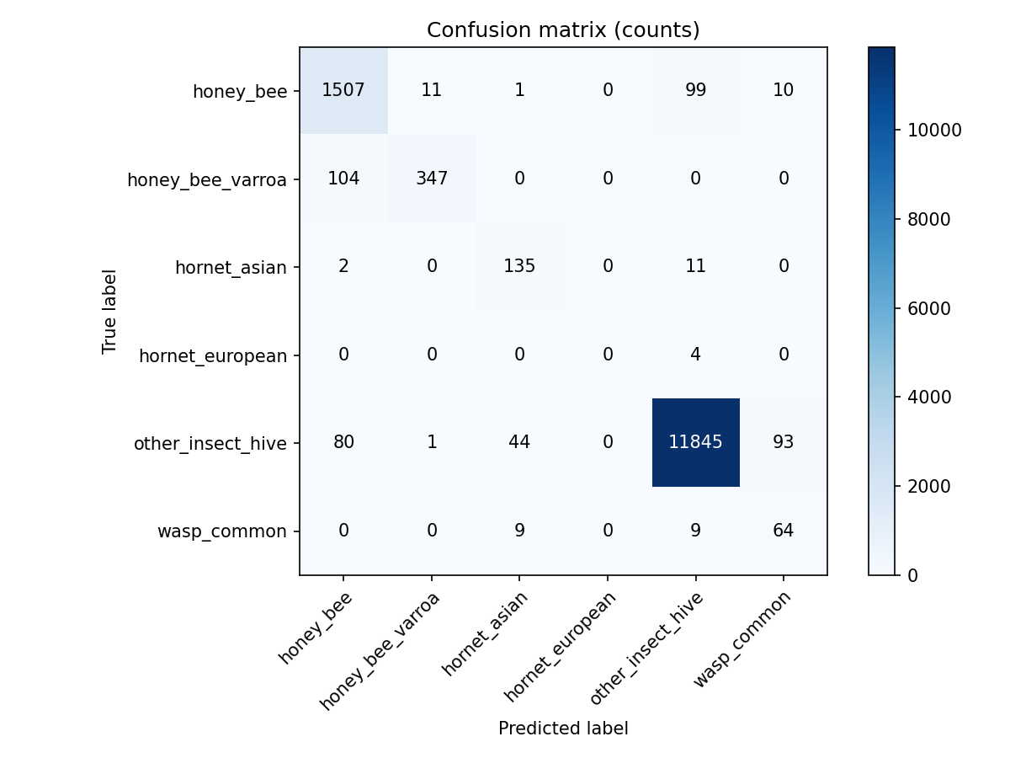
Figure 5. Validation-split confusion-count matrix for the promoted desktop-local model.

Threshold artifact exports (the Varroa binary threshold artifact, the low-confidence rejection threshold artifact) represent risk-oriented operational threshold decisions. For example, the Varroa threshold can be interpreted as an operational rule for flagging likely Varroa destructor-positive samples. This framing is useful for stakeholder reporting, but it should not be treated as a substitute for the quantitative evaluation metrics reported in this chapter.

4.4.4 Example-Image Desktop and Edge Runtime Evaluation
A separate example-image evaluation was performed on 71 categorized images with ground truth inferred from parent folder names. This evaluation was conducted for the desktop-local model and for the low-resource edge runtime. Because these examples do not constitute the official held-out test split, the results are reported as diagnostic example-image behavior rather than headline benchmark performance.
The desktop-local model achieved 0.4085 accuracy on the 71 example images, with macro precision, recall, and F1-score of 0.3448, 0.4028, and 0.3206, respectively. The edge runtime achieved 0.4507 accuracy under development-host edge-runtime evaluation, with macro precision, recall, and F1-score of 0.3674, 0.4444, and 0.3479, respectively. The edge values must not be reported as Raspberry Pi 4 field performance.
Table 12. Overall example-image evaluation metrics for desktop-local and edge-runtime pipelines.
Pipeline | Setting | n | Acc. | Macro P | Macro R | Macro F1 | Weighted P/R/F1 | Boundary
Desktop-local | CPU example folders | 71 | 0.4085 | 0.3448 | 0.4028 | 0.3206 | 0.3496 / 0.4085 / 0.3251 | Example images only
Edge runtime | Dev-host ONNX | 71 | 0.4507 | 0.3674 | 0.4444 | 0.3479 | 0.3726 / 0.4507 / 0.3528 | Dev-host only; not Pi 4
Table 12 shows that the edge-runtime example evaluation had slightly higher overall accuracy than the desktop-local example evaluation in this curated folder set, but both results remain diagnostic because the sample size is small and the images are not the official test split.

4.4.4.1 Diagnostic Paired Statistical Evaluation
The paired comparison package matched the same 71 example images across the desktop-local and development-host edge-runtime evaluations. For this diagnostic example-image set, McNemar analysis reported b = 5 desktop-only correct cases, c = 8 edge-only correct cases, 13 discordant pairs, and an exact-binomial p-value of 0.5811. This result does not provide evidence of a statistically reliable paired difference between the two example-image pipelines, and it must not be generalized to the official 15,917-image test split.
Bootstrap accuracy confidence intervals were also calculated with 5,000 resamples for the diagnostic example-image set. The desktop-local example accuracy was 0.4085 with a 95% bootstrap interval of 0.2958 to 0.5352, while the development-host edge-runtime example accuracy was 0.4507 with a 95% bootstrap interval of 0.3380 to 0.5634. The overlap between these intervals reinforces that the example-image results should be interpreted as diagnostic behavior evidence rather than as full-split performance significance.
Table 13. Per-class precision, recall, and F1-score for the 71-image desktop and edge example evaluations.
Class | Desktop P | Desktop R | Desktop F1 | Edge P | Edge R | Edge F1 | Support
honey_bee | 0.5000 | 0.0833 | 0.1429 | 0.5000 | 0.0833 | 0.1429 | 12
honey_bee_varroa | 0.0000 | 0.0000 | 0.0000 | 0.0000 | 0.0000 | 0.0000 | 12
hornet_asian | 0.2632 | 0.4167 | 0.3226 | 0.4231 | 0.9167 | 0.5789 | 12
hornet_european | 0.0000 | 0.0000 | 0.0000 | 0.0000 | 0.0000 | 0.0000 | 11
other_insect_hive | 0.3056 | 0.9167 | 0.4583 | 0.2812 | 0.7500 | 0.4091 | 12
wasp_common | 1.0000 | 1.0000 | 1.0000 | 1.0000 | 0.9167 | 0.9565 | 12
The per-class metrics in Table 13 show that the example set is useful for exposing class-level weaknesses. In particular, honey_bee_varroa and hornet_european received zero F1-score under both example-image evaluations, indicating that these example folders should be treated as diagnostic stressors rather than full-split validation evidence.
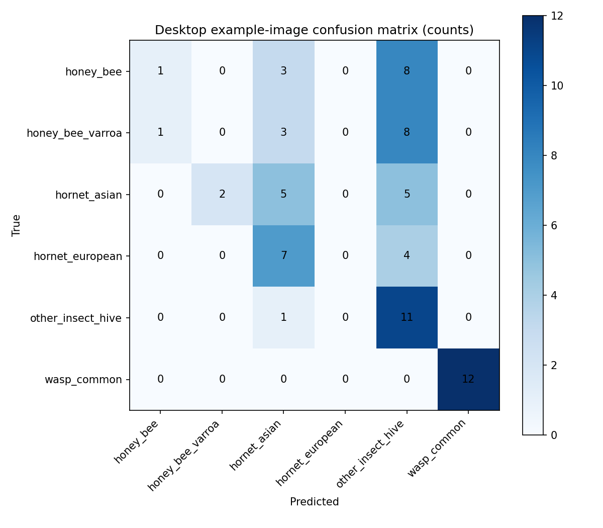
Figure 6. Desktop-local example-image confusion matrix for the 71-image evaluation.
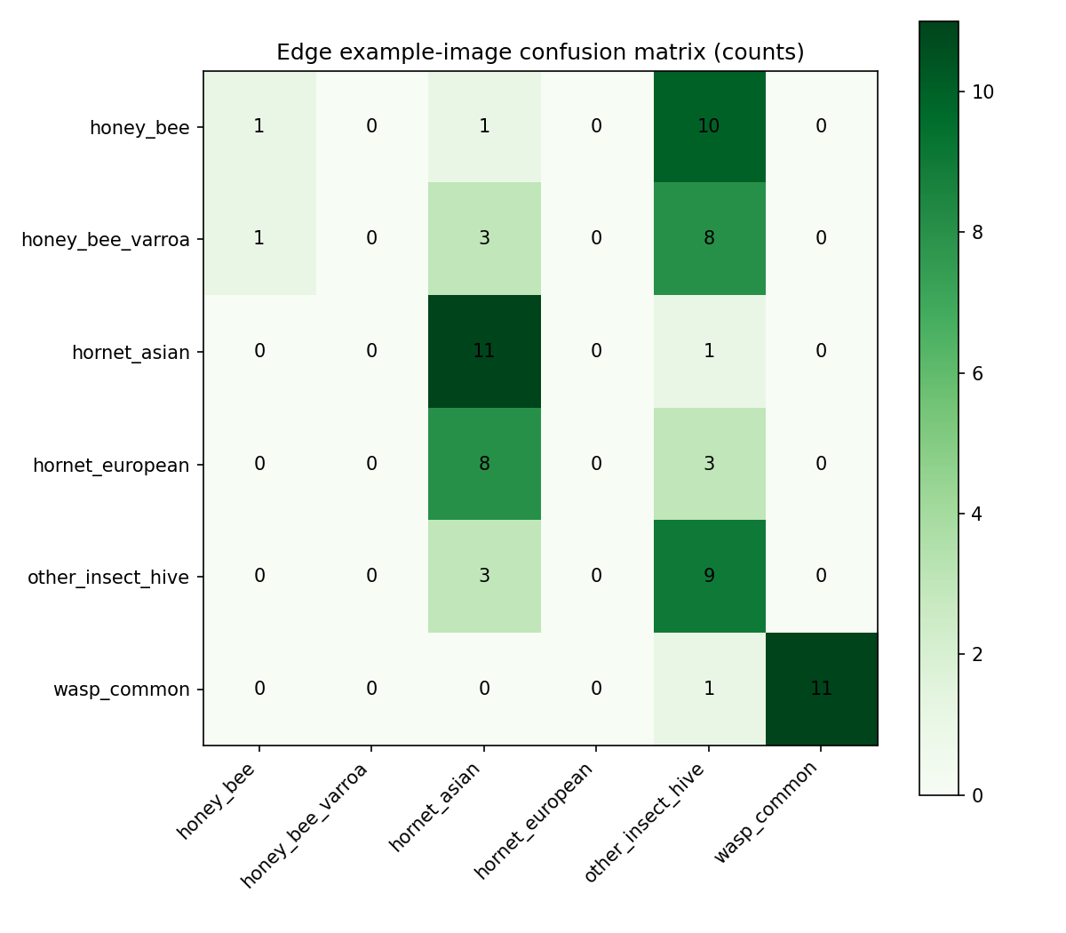
Figure 7. Low-resource edge-runtime example-image confusion matrix under development-host evaluation.
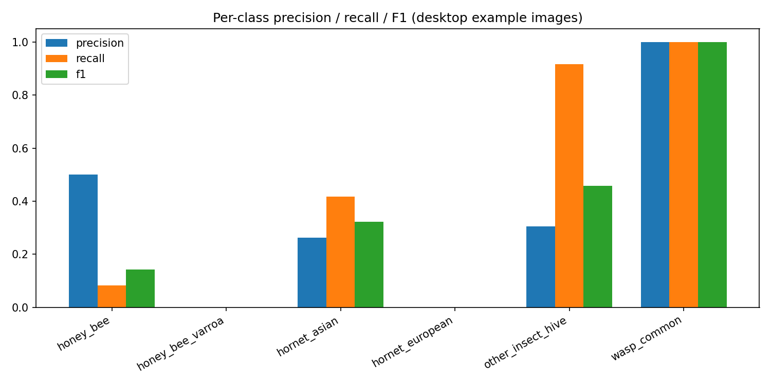
Figure 8. Desktop-local per-class precision, recall, and F1-score for example images.
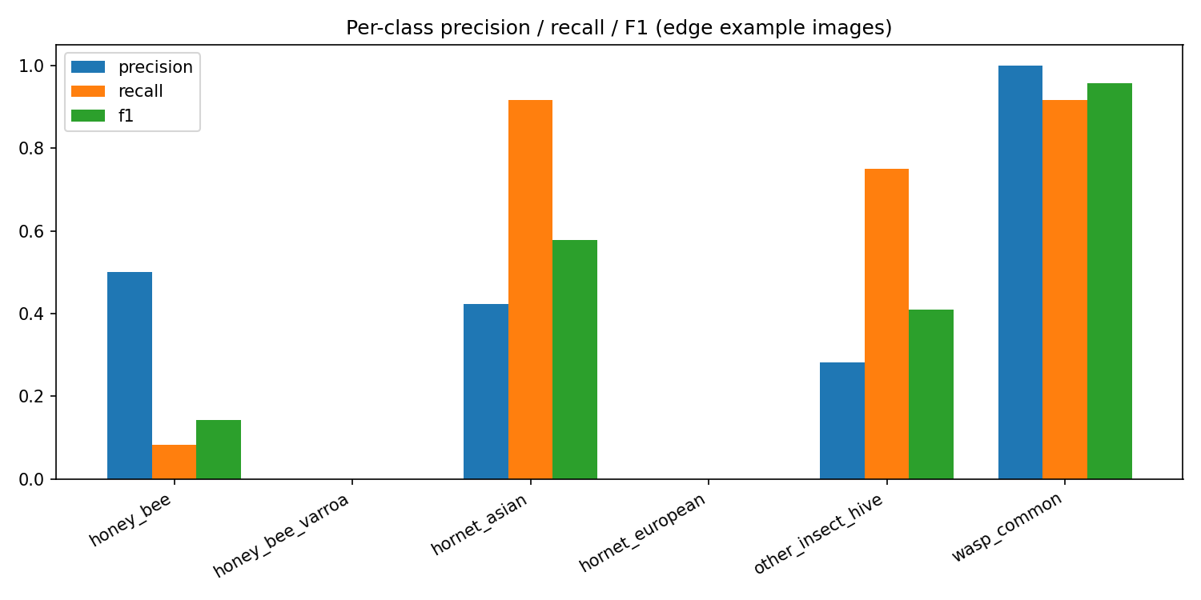
Figure 9. Edge-runtime per-class precision, recall, and F1-score for example images.
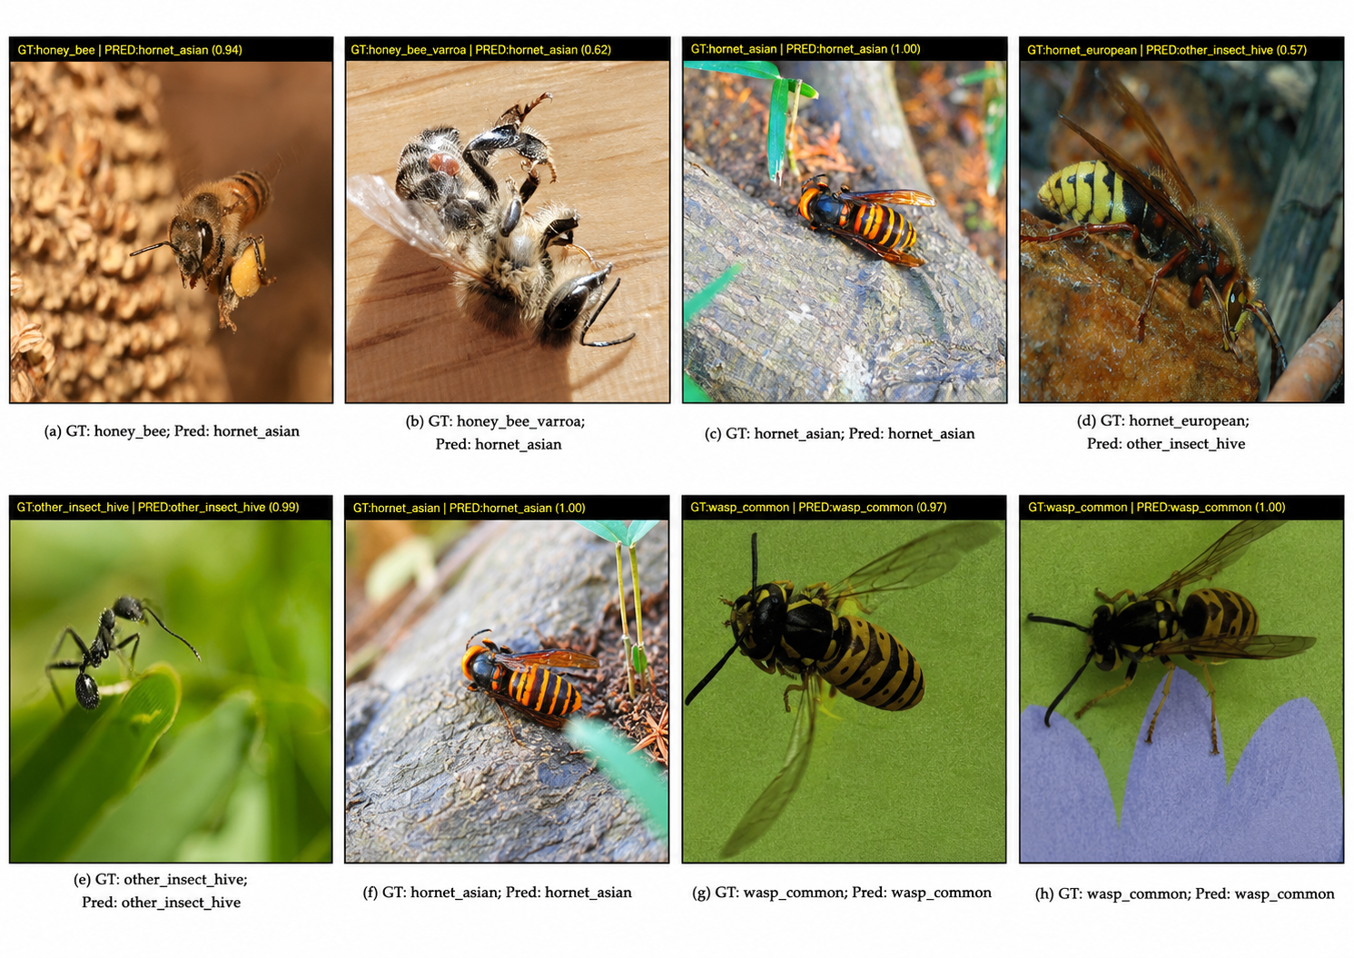
Figure 10. Representative desktop-local example predictions with ground-truth and predicted labels.
The representative images in Figure 10 illustrate the same example-image evaluation protocol: each image displays the folder-derived ground-truth label and the model prediction. These examples are useful for qualitative inspection, but they do not replace full-split metrics.
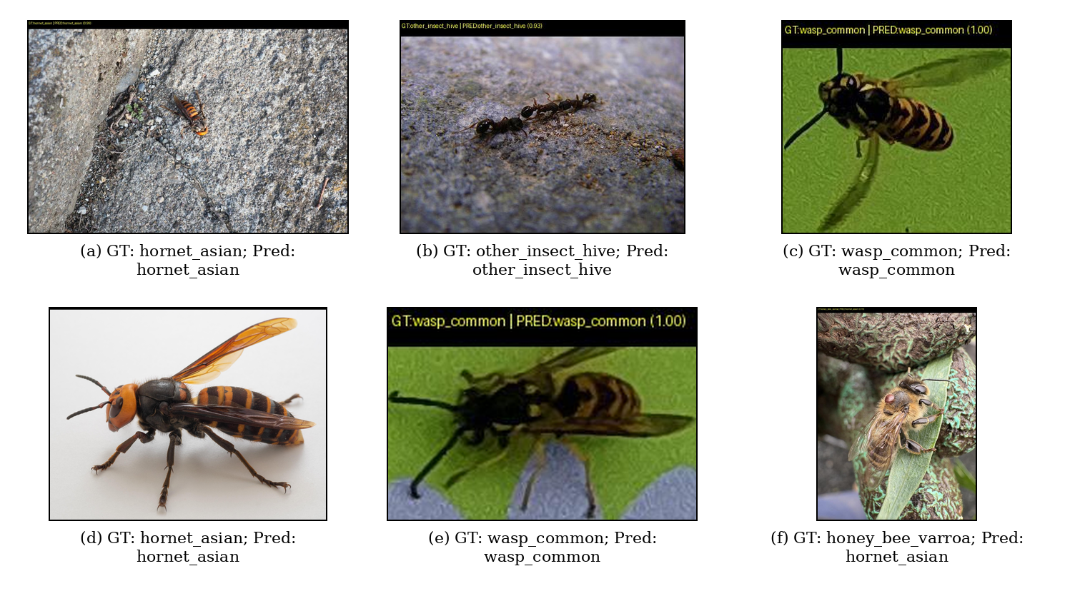
Figure 11. Representative low-resource edge-runtime example predictions under development-host evaluation.
The representative images in Figure 11 illustrate qualitative edge-runtime outputs from the ONNX Runtime and Flask-based low-resource inference package. Panels (a)-(f) show the folder-derived ground-truth label and the model prediction under the development-host evaluation protocol. These examples support qualitative inspection only and must not be interpreted as physical Raspberry Pi 4 field-performance evidence.

4.5 Performance Findings
The 71-image example evaluations also produced latency summaries for the desktop-local model and the edge runtime. These latency values are shown in Table 14 and visualized in Figures 12 and 13. The edge-runtime latency is a development-host measurement and must not be interpreted as physical Raspberry Pi 4 field performance.
Table 14. Example-image inference latency summary for desktop-local and edge-runtime evaluations.
Pipeline | Env. | n | Mean ms | Median ms | P95 ms | Min ms | Max ms
Desktop-local | CPU example eval. | 71 | 42.91 | 29.71 | 114.67 | 16.66 | 288.48
Edge runtime | Dev-host edge eval. | 71 | 14.09 | 8.86 | 34.71 | 4.59 | 214.44
The latency values in Table 14 support a bounded comparison of example-image runtime behavior only. In the attached comparison package, the development-host edge runtime shows lower mean, median, and p95 latency than the desktop-local example-image run, but this result is not a substitute for on-device Raspberry Pi 4 measurement.
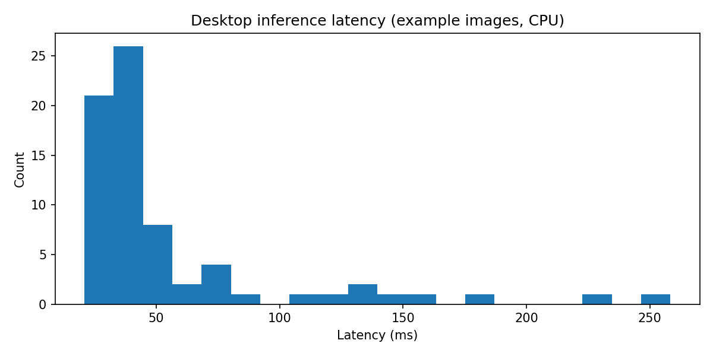
Figure 12. Desktop-local inference latency histogram for the 71 example images.
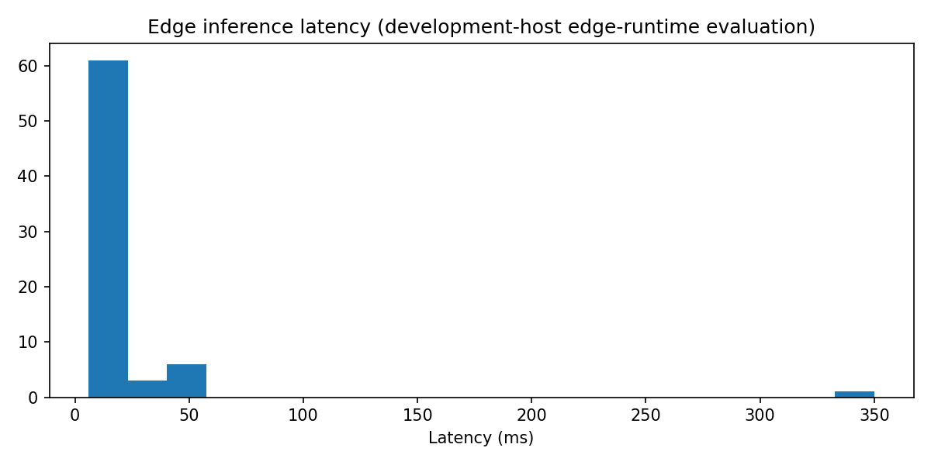
Figure 13. Low-resource edge-runtime inference latency histogram under development-host evaluation.

4.5.1 Desktop inference API Controlled Stress Probe
The stress benchmark produced 120 successful HTTP completions under a fixed recipe (i.e., six representative classes, twenty repetitions each). To support clearer interpretation, Table 15 summarizes this stress benchmark. The original summary (per class) has been kept in the authoring tool benchmark artifact, and has not been changed.

Table 15. Aggregated stress-probe latency summary (milliseconds, rounded).
Quantity | ms
Average | ~2849.3
Median | ~2773.8
Approx. P95 | ~3352.4
Max | ~3657.4
Effective throughput | ~0.35 req/s

Figure 14 plots the empirical latency histogram from the stress benchmark records, with mean and approximate P95 reference lines annotated.

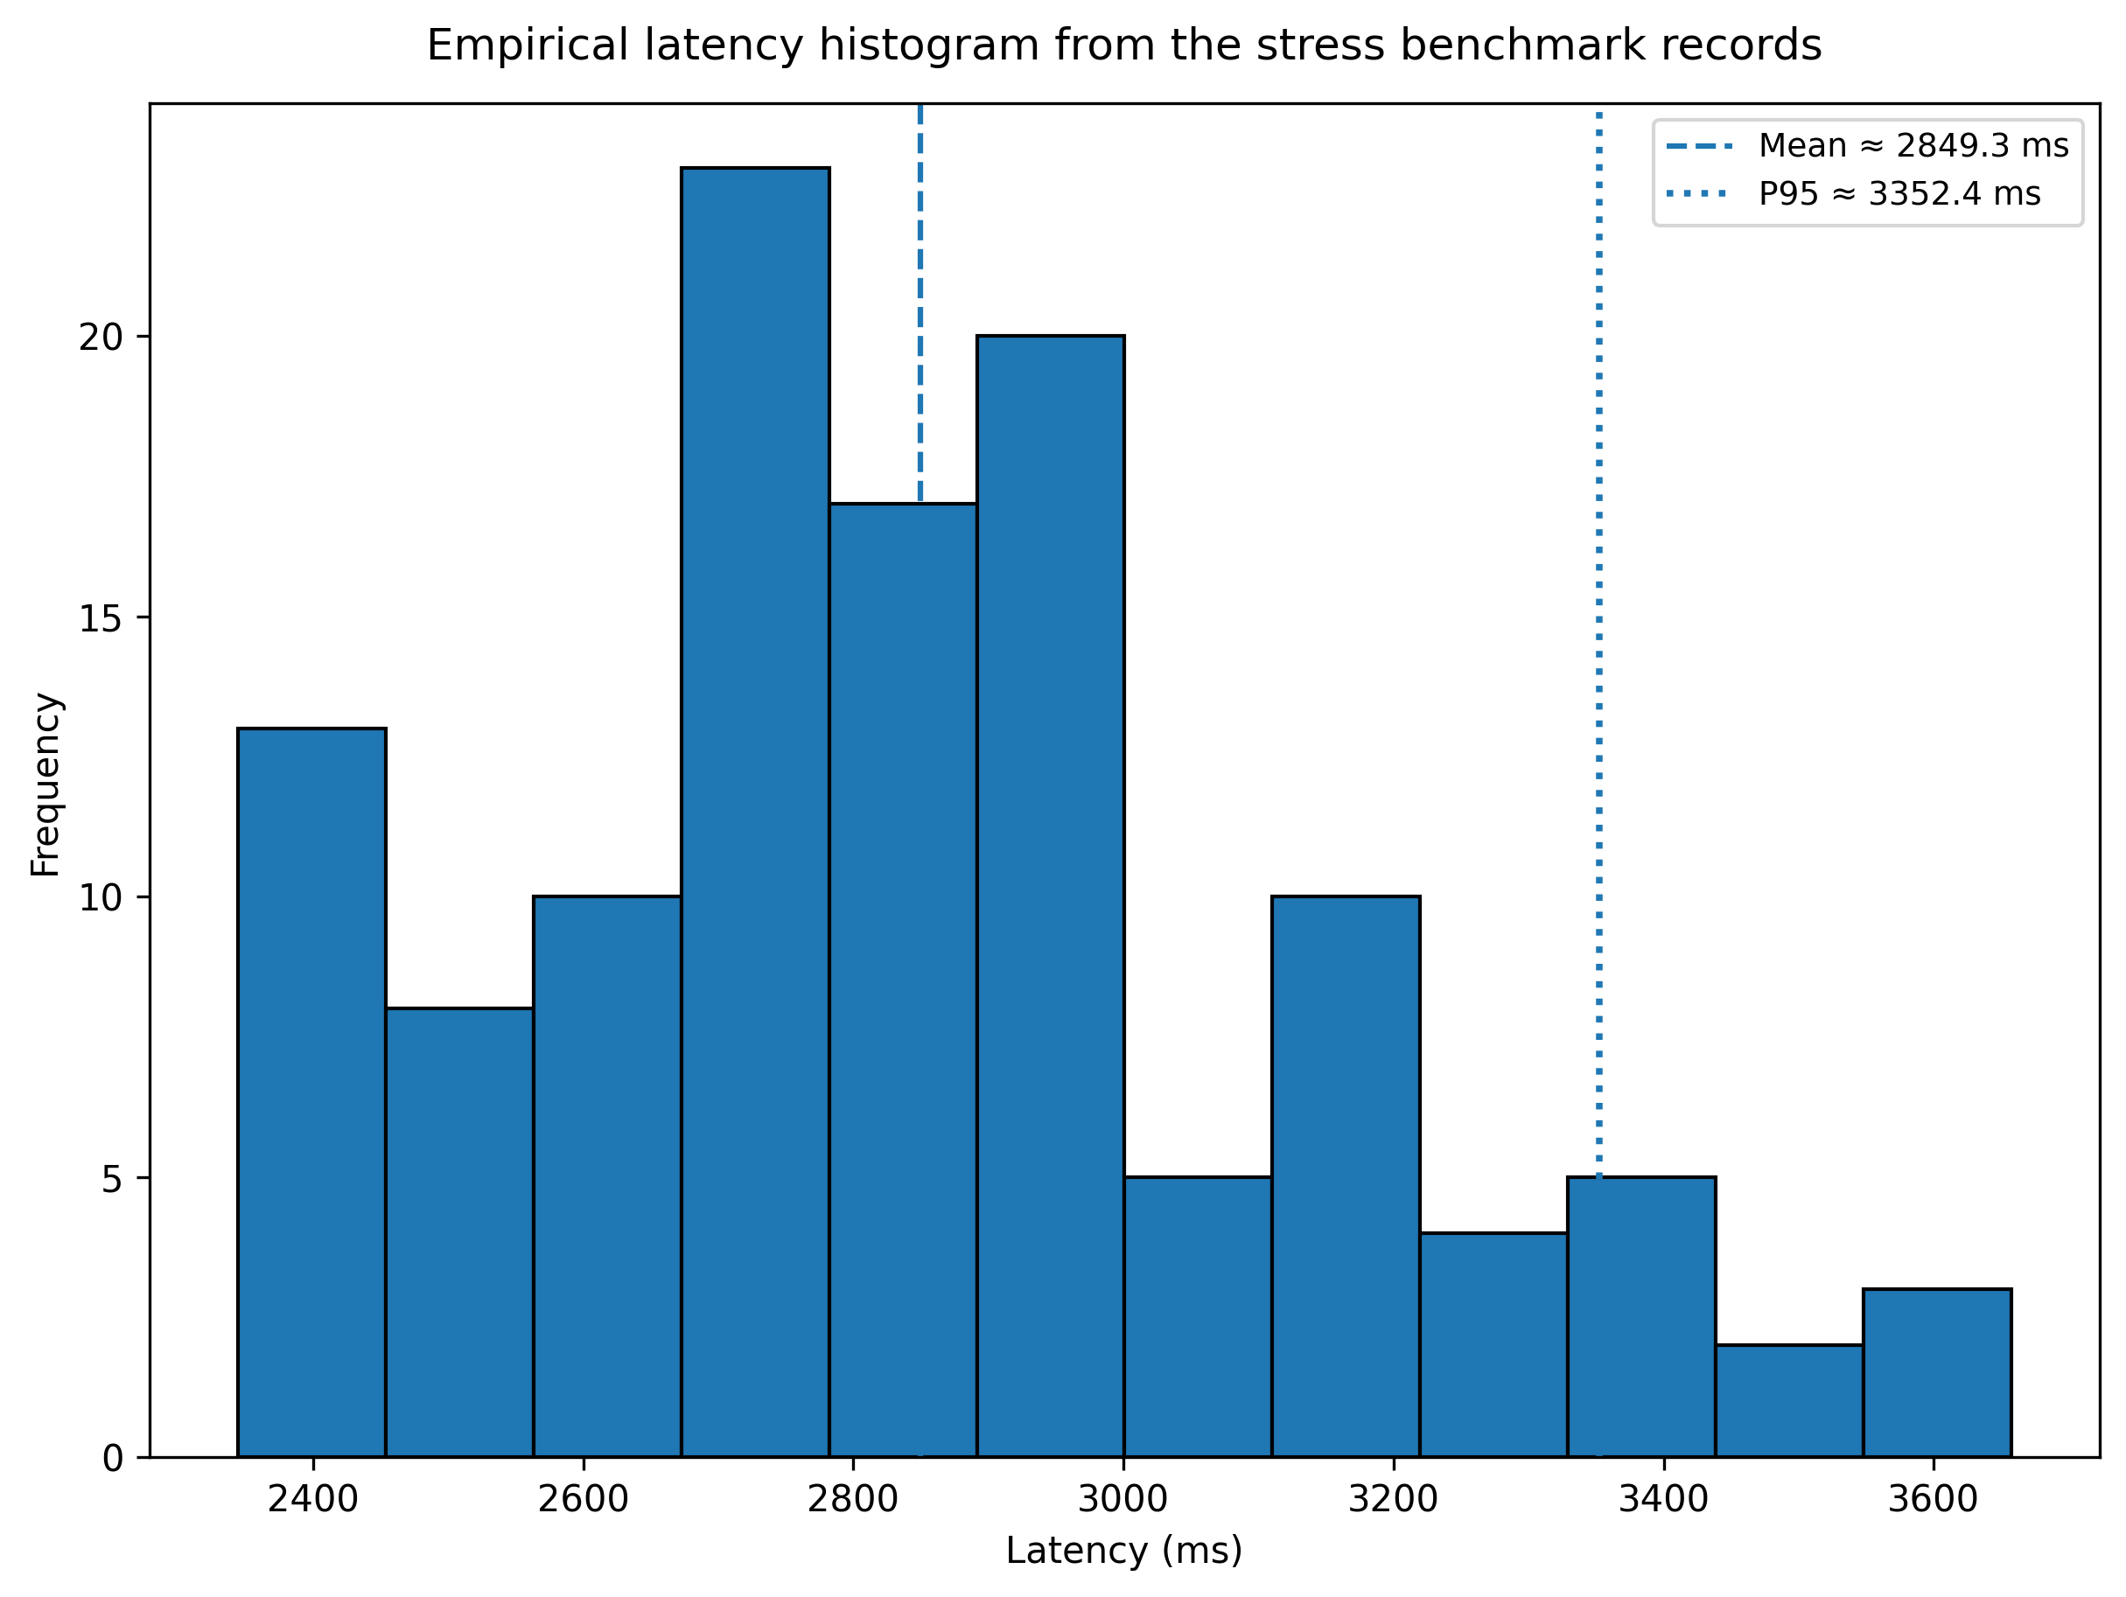
Figure 14. Empirical latency histogram from the stress benchmark records.

The workload definition and environmental caveats, including the dependency on synchronous second-opinion behavior during recording, are documented in the component-level evidence archive.

4.5.2 ONNX micro-benchmarks (capture host CPU)
ONNX Runtime micro-benchmark tools used on the recording machine generated average single-forward latencies of around 3.33 ms for the honey-bee exemplar tensor and 2.78 ms for the Asian hornet exemplar. API-side latencies sampled in the Flask metrics generated p50 latencies of approximately 7.65 ms and p95 latencies of 27.48 ms for 208 predictions in that sampling window. These metrics may have been affected by warm-up, pacing, and post-processing conditions, and they were generated in a different context from the micro-benchmarks. Both sets of latency evidence were captured on a development machine. Consequently, strict Raspberry Pi timing claims are deferred until planned tests are carried out on actual Raspberry Pi 4 machines under the conditions specified in the field protocol.

4.6 User Interface and System Output Findings
The desktop subsystem provides local UI and API support views for the history, dashboard, analysis, and helper pages. Figure 15 maps the validation evidence by component, Figure 16 links claims to supporting evidence categories, and Figure 17 compares the readiness status of the web, desktop-local, and edge-local components.

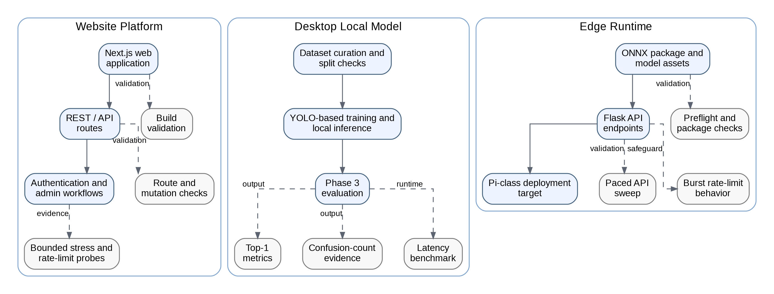
Figure 15. Component-level validation evidence map of HiveSentinel AI.
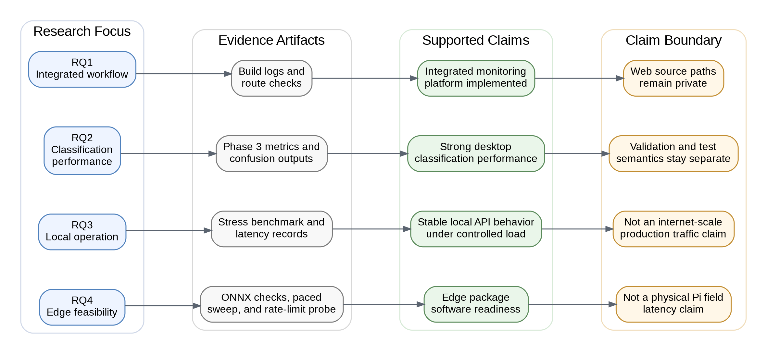
Figure 16. Evidence-to-claim traceability structure used in HiveSentinel AI.

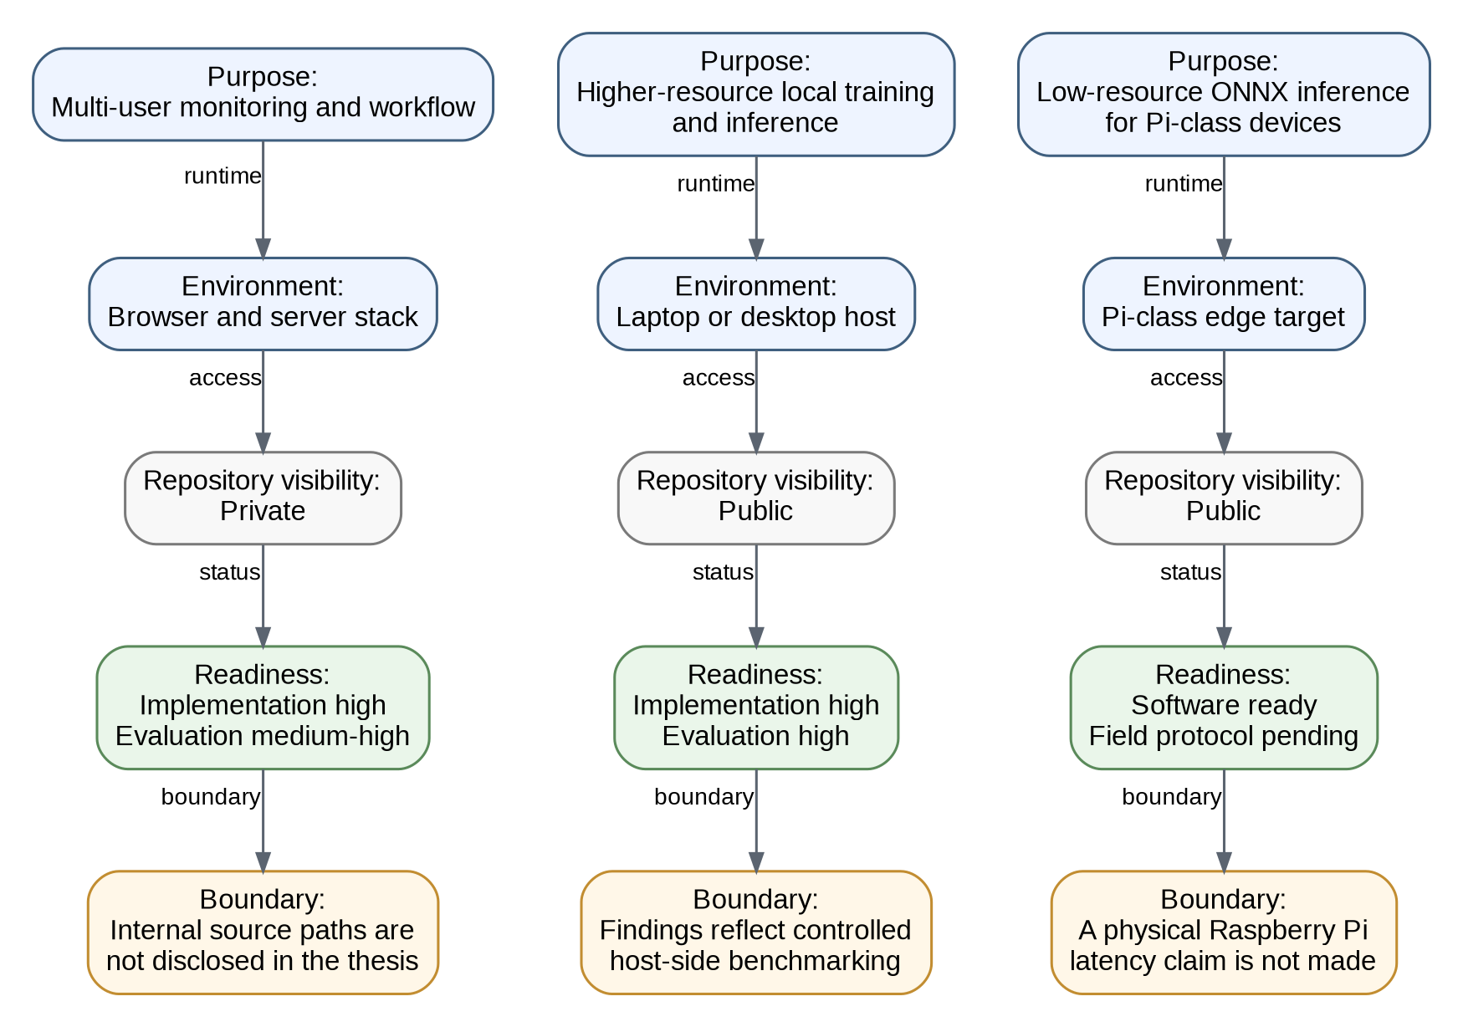
Figure 17. Three-platform deployment readiness comparison of HiveSentinel AI.

Figures 4-19 show the generated results and evidence visualizations for this chapter. Figure 5 shows the validation-split confusion-count matrix. Figures 6 and 7 show the desktop and edge example-image confusion matrices, Figures 8 and 9 visualize per-class precision, recall, and F1-score, Figure 10 presents representative desktop-local prediction examples, and Figure 11 presents representative low-resource edge-runtime prediction examples. Figure 14 visualizes the desktop stress latency distribution, Figures 15-17 support deployment-readiness interpretation, Figure 18 summarizes paced edge prediction outcomes on the development host, and Figure 19 summarizes burst-probe HTTP 200 versus HTTP 429 counts.
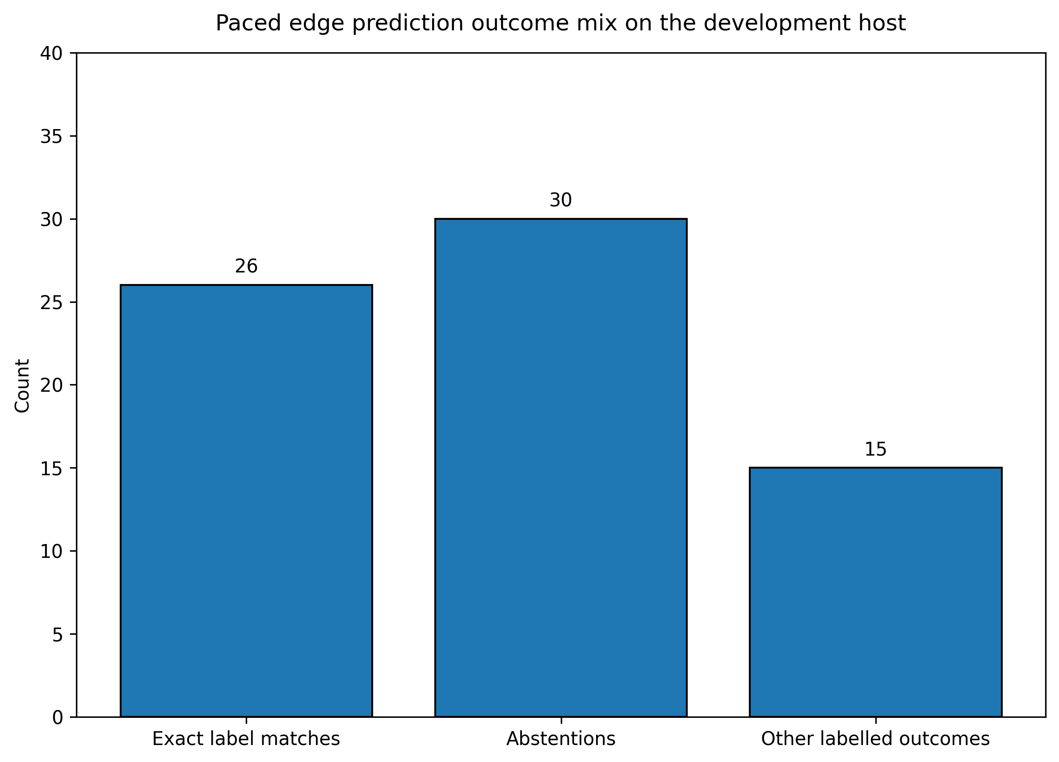
Figure 18. Paced edge prediction outcome mix on the development host.

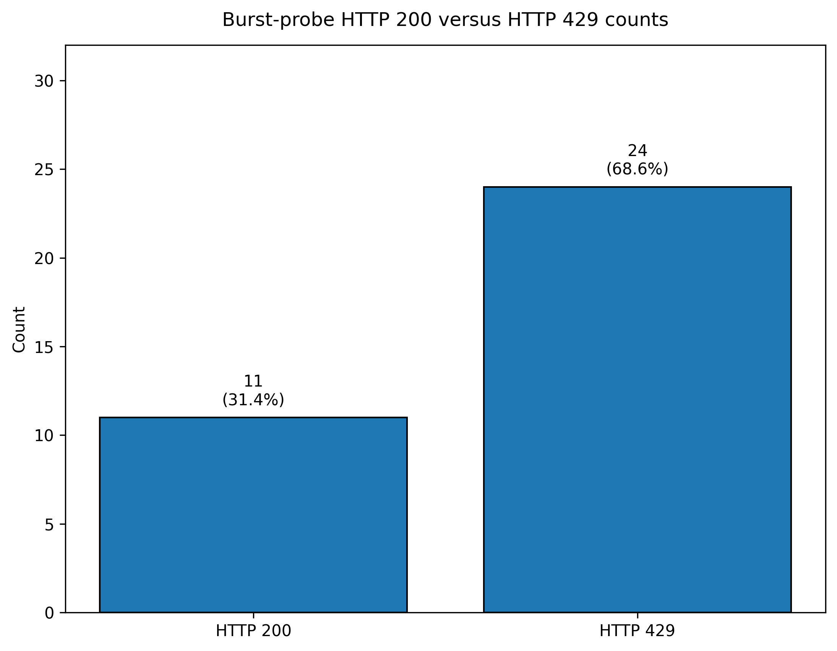
Figure 19. Burst-probe HTTP 200 versus HTTP 429 counts.

Table 16 shows the processed API JSON summary in compact table form; the “remainder” row uses arithmetic (non-exact, non-abstained results) and should be read alongside the JSON explanation of “exact” and “abstained” in the edge results package.
Abstain counts must be read by protocol. The CLI diagnostic evaluation reported 8 abstentions out of 71 images, while the API-paced sweep reported 30 abstentions and 26 exact matches out of 71 requests. These two values come from different evaluation paths and must not be merged into a single benchmark statistic. In both cases, abstention is treated as uncertainty signaling rather than as an accuracy-improvement mechanism.

Table 16. Low-resource edge-runtime API pacing summary.
Metric | Value
Total images | 71
Completed successfully | 71
Exact label matches | 26
Abstentions | 30
Derived “other labelled outcome” remainder | 71 − 26 − 30 = 15

Burst rate-limit evidence was recorded through the rate-limit probe artifact and paired console output.
4.6.1 Website User-Interface and Workflow Findings
The website layer provides the user-facing evidence for RQ1 at the application level. Whereas subsection 4.3.1 reports API and mutation validation, the implemented interface expresses a complete monitoring workflow: image submission, structured AI output with protection guidance, personal history and dashboard review, optional multi-model comparison, and community sharing through forum and direct-message channels.
Appendix Figures B1 and B2 illustrate the analysis submission path and the structured result view, including risk signaling and protection recommendations enriched beyond a single-label classification. Figure B3 illustrates the authenticated dashboard/analytics view, which aggregates personal usage rather than model-training metrics. Figures B4 and B5 illustrate administrative listing views for insect knowledge-base curation and global analysis records, respectively. These screenshots are intended as interface evidence captured in a controlled non-production environment with anonymized identifiers, consistent with the ethical framing in subsection 3.13.
It is important to bound the interpretation. The website UI evidence demonstrates workflow completeness and engineering readiness; it does not constitute a beekeeper usability study, a clinical validation, or a benchmark of cloud vision LLMs on the project’s 99,067-image YOLO training corpus. Multi-model comparison on /compare reports agreement and latency across providers for the same uploaded image, but it should not be confused with the desktop validation-split accuracy reported in subsection 4.4.2.

4.7 Error Analysis and Observed Limitations
- Class-support imbalance. The embedded Phase 3 metrics report displays validation support for the European hornet with only four instances, indicating extremely low support. Macro-F1 interpretation must therefore be limited and should not be treated as reliable evidence of class-level competence.
- Illustrative gallery mismatch signal. Out of 46 instances of HTTP smoke classification, 40 were inconsistent with the folder label. This is a distribution-shift signal and is indicative of label granularity or cropping bias, therefore it must prompt a re-audit and not a tacit acceptance of the claim of accuracy.
- Second-opinion durability. In the aggregates, there remains only one second-opinion accuracy error. For a deeper root-cause analysis, the raw JSON artifacts must be reviewed.
- Tooling consistency. Auxiliary YOLO validation utilities indicated default-path mismatch in recorded logs. This suggests auxiliary validation scripts will require a separate path-consistency validation check from the primary phase evaluative scripts.
- Environmental generalization. Unless field protocol rows are added later, all edge timing evidence here is derived from the software side on a capture workstation.
- To address the operational constraints of the above referenced limitations, Table 17 consolidates the issues, their evident sources, the operational impacts and suggested mitigations.

Table 17. Error pattern interpretation and operational risk implications.
Observed issue | Evidence source | Operational implication | Recommended mitigation
Low validation support for European hornet | Phase 3 metrics report | Rare-class competence should not be over-claimed | Expand targeted data collection and increase class support
Example-folder mismatch | HTTP smoke classification sweeps | Illustrative gallery sweeps should not be treated as IID test accuracy | Separate routing validation from accuracy reporting
One second-opinion error event | SQLite aggregate metrics | A persisted error may require optional forensic inspection | Inspect raw JSON logs if deployment debugging is required
Ancillary YOLO path mismatch | Validation utility logs | Auxiliary scripts require path-consistency checks separate from primary evaluation scripts | Maintain utility-level path validation before future runs
Development-host edge timing only | ONNX/Flask timing evidence | Software-side timing does not prove physical Raspberry Pi field performance | Execute Raspberry Pi field measurement protocol

Table 17 summarizes the thesis boundaries, their evidence sources, operational implications, and recommended mitigations. The observed limitations are not hidden failures; on the contrary, they are documented limitations for future validation.

CHAPTER V

Discussion

5.1 Introduction
Chapter IV detailed the evaluation metrics, validation records, outputs, and figures of HiveSentinel AI. This chapter places those results in context, answering the research questions and addressing the gaps in Chapter II. Boundary evidence includes the final desktop and edge quality control files, the edge reproducibility audit, the API prediction sample, and the public dataset upload instructions. This chapter adheres to the evidence rule; new Raspberry Pi measurements, public datasets, and model performance metrics are not introduced. Rather, validated results are documented, and the scope is clarified for edge-runtime evaluation and for the development-host example-image checks and the remaining validation items that require future evidence.

5.2 Interpretation of the Main Findings
The findings support a bounded systems-engineering interpretation rather than a single-metric model-success narrative. Three validation streams are most important for the discussion: the web/application layer, the desktop-local model layer, and the low-resource edge-runtime layer.
The website and application-layer evidence supports the interpretation that HiveSentinel AI is more than an isolated classifier. It is designed as a workflow-oriented monitoring system with build checks, API behavior, protected routes, and controlled operational checks. These outputs address the integration gap described in Chapter II by connecting model evidence with application-level behavior.
The desktop-local model evidence is strongest where it is explicitly tied to the Phase 3 validation split and documented desktop quality-control outputs. The final desktop QC source reports PASS status for the core predictions file, overall metrics JSON, confusion matrix image, latency JSON, thesis-ready report, ZIP archive, per-class precision/recall/F1 figure, latency histogram, dataset distribution figure, and 71 sample prediction images. However, this evidence also preserves important boundaries: the 71-image gallery results are diagnostic example-image metrics only, the Phase 3 metrics are validation-split evidence rather than a re-run official test-split study, no public dataset URL is available yet, and dataset readability was checked by spot inspection rather than exhaustive manual image review.
The edge-runtime evidence supports software-readiness interpretation for an ONNX Runtime and Flask-based low-resource inference package. The edge QC files report PASS status for prediction CSV files, overall metrics JSON, confusion matrix, latency JSON, thesis-ready report, ZIP archive, API health check, API prediction sample, per-class metric figure, latency histogram, and 71 edge sample prediction images. Nevertheless, the edge reproducibility audit states that the tests were executed on a Windows development host, not on physical Raspberry Pi 4 hardware. Therefore, the edge results should be read as development-host edge-runtime evidence, not as Raspberry Pi 4 field performance.
A useful qualitative example of the edge boundary is the API abstention sample. In the provided instance, the service output an abstained prediction with class_name = unknown because the confidence level was below the configured minimum-confidence policy. This output is useful because it shows the edge API does not have to always assign a class label, and can instead use a protective answer to describe uncertainty. While this is a development-host API example, it does not substitute for field validation on Raspberry Pi 4 hardware. The bounded reading is also supported by the diagnostic statistical comparison. McNemar testing of the 71 image example set returned p = 0.5811, and the bootstrap 95% confidence intervals for desktop-local accuracy (0.2958 to 0.5352) and development-host edge-runtime accuracy (0.3380 to 0.5634) respectively also overlap. These results suggest interpretation should be done carefully, instead of claiming that in general one runtime is statistically better than the other across the entire dataset.

5.3 Discussion in Relation to Research Questions
The main thesis questions are defined by RQ1 to RQ5 in Chapter I. Bounded interpretive answers to the questions are provided in Table 18. The completion of engineering validation has been purposefully separated from the public-release and field-hardware completion in the table, so the discussion stays scoped to what is provided in Chapter IV and the QC artifacts.

Table 18. Research questions - interpretive linkage (no new metrics; see Chapter IV for values).
RQ | Supported interpretive claim (bounded) | Primary boundary / caveat
RQ1 (integrated workflows) | HiveSentinel AI demonstrates an integrated monitoring workflow across web, desktop-local, and edge-runtime layers. At the web layer, documented build/API checks are supplemented by implemented user workflows that connect multi-provider image analysis, personal dashboard/history review, parallel model comparison, collaboration (friends, messaging, notifications), forum-based activity sharing, and administrative curation. Integration across tiers remains configuration-dependent; the thesis does not claim that every live deployment routes every request through all three layers simultaneously. | Website UI and API evidence demonstrates engineering workflow completeness, not beekeeper field validation or cloud-LLM benchmark equivalence to the desktop YOLO validation split.
RQ2 (classification performance) | The desktop-local classifier is supported most strongly by the Phase 3 validation-split evidence and is supplemented by a 71-image example-image diagnostic evaluation. | Example-image results are not official held-out test-set metrics; rare-class behavior and dataset imbalance require cautious interpretation.
RQ3 (offline/stable API/stress) | The desktop-local and application layers show controlled API, stress, and latency evidence suitable for bounded engineering interpretation. | Stress and latency values are environment-specific and should not be generalized to internet-scale or field deployments.
RQ4 (Pi-oriented runtime feasibility + safeguards) | The low-resource edge runtime demonstrates ONNX/Flask package readiness, API checks, rate-limited behavior, and an abstain-capable prediction pathway on the development host. | These results are not physical Raspberry Pi 4 field-performance measurements.
RQ5 (remaining strict Pi and release requirements) | The remaining evidence requirements are clearly identifiable: public release of the merged dataset and physical Raspberry Pi 4 execution with hardware logs and screenshots. | Until these are completed, the thesis must report dataset public availability and Pi 4 field performance as pending.

The mapping indicates the first four research questions can be answered within the current engineering evidence boundaries. As for question 5, the physical requirements for a Raspberry Pi 4 claim, such as logs, on-device captures, and measurements, along with deployment screenshots from the hardware environment, will still need to be validated in the future. The same goes for the public availability of the dataset as the consolidated yolo_insects_multi dataset has yet to be published with a public URL or DOI.

5.4 Comparison with Related Literature
Chapter II positioned this work against algorithm-centered, reliability-centered, and deployment-centered literature. The current findings support that positioning. HiveSentinel AI is not primarily a new backbone or model-architecture contribution; it is an integrated evidence-bound system study that combines web workflow validation, desktop-local model evaluation, low-resource runtime packaging, and reproducibility-oriented reporting.
Compared with reliability literature on calibration and selective prediction, the API abstention behavior is an implementation-level analogue rather than a full calibration study. The abstain example demonstrates that the service can avoid an overconfident forced label under a low-confidence condition, but formal reliability diagrams, expected calibration error, and user-level decision thresholds remain future work.
Compared with edge-deployment research, the edge-runtime package demonstrates a meaningful software-readiness layer: the model artifact, class contract, runtime configuration, API commands, and example-image evaluation were documented and tested on the development host. However, this is still weaker than a physical edge-computing field study because Raspberry Pi 4 logs, on-device latency captures, long-run thermal behavior, and real deployment screenshots were not provided.
The comparison with related work should therefore be read as a contribution in disciplined integration and traceability. The thesis contributes a structured web-desktop-edge evaluation framework while also documenting which claims remain unsupported until public dataset release, hardware-field measurement, and broader stakeholder testing are completed.
The extended comparison in Table 11 strengthens this interpretation. The promoted desktop-local model has a higher reported validation accuracy and weighted F1-score than the main reported metrics of several selected bee-health, bee-monitoring, Varroa/hive-entrance, and general insect-pest recognition comparators, while VespAI is retained as a high-performing hornet-specific field-system comparator rather than as a lower-metric example. This preserves balance: HiveSentinel AI is not claimed to be universally superior, but it provides a stronger combined justification when desktop validation performance, dataset scale, six-class bee-pest taxonomy, local inference, edge-runtime packaging, API controls, and reproducibility evidence are considered together.
Figure 20 summarizes the logic used for this comparison. The figure deliberately avoids a single metric bar chart because the external studies report different task types and metrics. Instead, it shows that the preferred claim is a multi-axis claim based on model performance, dataset and taxonomy coverage, deployment readiness, and evidence boundaries.
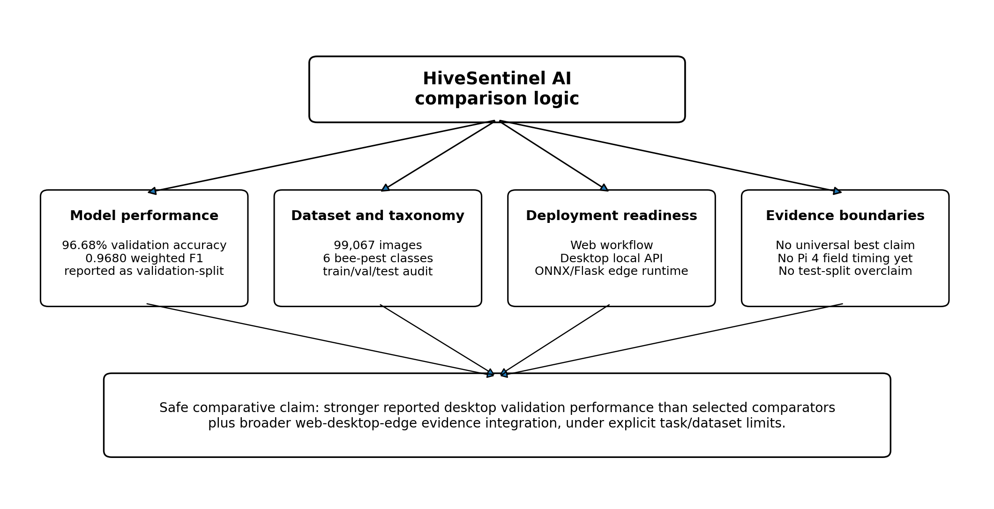
Figure 20. Comparison dimensions used to position HiveSentinel AI against selected studies.

5.5 Technical and Practical Implications
From the perspective of engineering practice, the final QC files illustrate that thesis-source artifacts can be used as release-gate evidence. The desktop and edge bundles contain much more than narrative claims; they contain pass/fail predictions, prediction outputs, JSON summaries, confusion matrices, latency files, generated figures, and zipped source packages. Hence, future maintainers will have better guidance for reproducing and building upon the work. Regarding responsible AI reporting, the most crucial implication is boundary management. A high validation-split result, a small example-image evaluation, a development-host edge check, and an API abstention sample each answer different questions. Merging them would create misleading claims, whereas distinguishing them supports a defensible and scientifically bounded thesis. For future field deployment, the implication is straightforward. The project cannot be considered operational until the public dataset release workflow is completed, the dataset is assigned a URL or DOI, the edge package is run on Raspberry Pi 4, latency and thermal logs are collected, and screenshots or API traces of field deployments that support declared statements of field performance are documented.

5.6 Strengths of the Proposed System
There are four main strengths of the proposed system that are based on documented evidence, rather than unsupported generalization.
- Integrated Multi-Layer Coverage: The web, desktop-local, and edge-runtime components provide evidence at different layers of the system and address the integration gap as discussed in Chapter II, while retaining the separation of application behavior, model behavior, and runtime behavior.
- Evidence-Based Quality Control: The desktop and edge QC reports confirm the generation and validation of expected result files, JSON summaries, figures, sample predictions, and ZIP bundles. Quality control, in this case, is more robust and clear than an undocumented quality control claim.
- Delimited Interpretability: The separation of validation-split metrics, 71-image example evaluations, and development-host edge-runtime behavior, as well as the pending Raspberry Pi 4 field measurements, guard against the interpretation of the figures in a diagnostic context as field measurements.
- Operational Uncertainty Handling: The edge API abstain sample demonstrates the low-resource runtime’s capability to produce an unknown class output under low confidence, which promotes positive operational behavior, while formal calibration analysis remains beyond the current evidence.

5.7 Consolidated Limitations and Boundary Conditions
The final evidence base defines the thesis boundaries and limitations clearly without ambiguity or hidden failures. These are measurable limits. Dataset limitations encompass class imbalance, constraints with rare class support, and the absence of a public download link for the consolidated yolo_insects_multi dataset.
The final merged dataset has still not been published with a public URL or DOI, but the public dataset upload package has been completed. Therefore, only the upstream sources and the local assembly process can be cited as public at this stage.
Model-evaluation limitations include the distinction between the full validation-split evidence and the smaller 71-image example-image evaluations. The example-image results are useful for qualitative, diagnostic, and paired statistical interpretation, including McNemar and bootstrap accuracy checks, but they should not be described as official held-out test-set performance. Full test-split statistical significance would require exporting per-sample prediction vectors for the same official test images.
Edge-deployment limitations are the strongest boundary. The reproducibility audit confirms that the edge tests were development-host edge-runtime evaluations and that strict Raspberry Pi 4 proof still requires physical benchmark logs, on-device latency captures, and deployment screenshots from the hardware environment.
These boundaries reinforce the thesis contribution: HiveSentinel AI is a validated multi-platform software-engineering framework with documented desktop and edge-runtime evidence, but not yet a completed physical Raspberry Pi 4 field benchmark or public dataset-release study.
The following evidence items were not available in the project evidence reviewed for this thesis: a public DOI/URL for the merged yolo_insects_multi dataset, physical Raspberry Pi 4 on-device benchmark proof, exact promoted-production args.yaml, promoted-folder results.csv, full test-split edge per-sample evaluation, k-fold cross-validation evidence, and formal calibration artifacts such as ECE or reliability diagrams. These items should remain framed as future evidence requirements rather than as hidden or implied accomplishments.

5.8 Implications for Future Research and Practice
From the perspectives of research and practice, the next validation steps should fill the identified evidence gaps, rather than be driven by conjecture.
- Public dataset upload: The yolo_insects_multi archive should be uploaded to a stable host (i.e. Zenodo, Kaggle, Hugging Face Datasets, Google Drive), with a permanent URL or DOI published, and a checksum validated post-download.
- Validation of the physical Raspberry Pi 4: The described edge package should be run on the Raspberry Pi 4, with on-device measurement of latency, thermal, and power stability, and hardware execution documented with screenshots or logs.
- Validation of calibration and abstention: The existing abstain policy should be extended with calibration and the uncertainty of beekeeper-facing risk considered through the lens of reliability diagrams and expected calibration error.
- Production-lineage preservation: future training and promotion runs should archive the selected weight file together with args.yaml, results.csv, class mapping, dataset snapshot, evaluation command, and checksum information so that promoted-model provenance can be reconstructed without relying on related-run fallback evidence.
- Full edge test-split export: future edge evaluation should export per-sample predictions for the official held-out test split if full edge benchmark claims are desired. Until then, the 71-image edge values must remain diagnostic example-image evidence.
- Evaluation of human use and field use: The current thesis focuses on system implementation and evidence-bounded validation; thus, ethical and privacy design concerns must guide research with beekeepers and other domain users in the future.

CHAPTER VI

Conclusion and Recommendations

6.1 Introduction
This chapter synthesizes the verified results of HiveSentinel AI across its website platform, desktop-local model pipeline, and edge-focused runtime package. It describes the final engineering contribution of the thesis as an integrated, reproducible, and deployment-aware framework for bee pest detection, supported by documented evidence for the system, model, and runtime.
The validated results discussed in Chapters IV and V provide the basis for the recommendations. Future work is framed as an opportunity to extend the software-engineering contribution rather than as a weakness of the implemented system.

6.2 Conclusion
This thesis developed, implemented, and assessed an advanced pest monitoring system built as a multi-layered monitoring stack. The system integrates a Next.js web application with a Prisma-supported backend, a desktop Ultralytics YOLO classification pipeline, local inference and deployment services, and a Flask-served ONNX runtime package.
At the application layer, the website extends the monitoring stack with multi-provider vision workflows, personal and administrative analytics, exportable reports, and community collaboration modules that connect detection output to human review and knowledge-base curation.
At the model level, the strongest full-split evidence in the current source bundle is the Phase 3 validation evaluation of the promoted yolo_insects_multi configuration, which achieved 0.96675 top-1 accuracy across 14,376 validation images. This result is reported strictly as validation-split performance and is interpreted together with the class-level precision, recall, F1-score, and confusion-matrix evidence in Chapter IV.
At a systems level, this thesis asserts that AI model evaluation extends to application-level evidentiary support, API validation, desktop stress tests, edge runtime packaging, and reproducibility-oriented appendices. The integration of the discussed frameworks addresses the gap explained in Chapter II, when a bee pest monitoring classification system is evaluated as a fully functional, multi-platform software framework instead of a standalone, isolated classifier. This thesis argues that HiveSentinel AI offers a validated MSc-level contribution to bee pest monitoring. It also provides a basis for further empirical field-based work with Raspberry Pi 4, complete held-out test-split precision/recall/F1 reporting, prediction vectors, statistical analysis, and usability studies targeting beekeepers.
The final comparison also answers the practical question of why HiveSentinel AI is a defensible model-and-system choice. The desktop-local model provides strong reported validation performance relative to selected lower-reported comparator studies, while the low-resource edge runtime provides a controlled deployment path through ONNX Runtime, Flask, request-size boundaries, rate limiting, and reproducibility artifacts. This conclusion remains bounded: it is a strong evidence-based MSc contribution, not a claim of universal state-of-the-art superiority across all bee, insect, or commercial monitoring tasks.

6.3 Main Contributions of the Study
The contributions are purposefully constrained and engineering-oriented. They depict what is backed by the repository structure, evaluation records, tables, and system outputs, while deliberately omitting unsupported declarations related to unexecuted multi-architecture and hardware-field experiments.
Contribution C1: This thesis shows a consistent strategy for coupling model metrics with component-level application and runtime validation. This creates a hybrid evaluation structure and helps fill the traceability gap defined in Chapter II by allowing for inspection of outputs at the subsystem level. This represents a multi-layer contribution.
Contribution C2: The example illustrates the compromise between safety and accuracy within the bounds of edge responsiveness (and in connection to the rate-limit probes, the default binding, and request-size parameters, as defined in the methodology). This example shows that the robustness of the service is as important as the accuracy of the model. This aligns with the reliability-oriented literature discussed in Chapter II, which are centered on reliability, and purposefully avoids claiming formal calibration.
Contribution C3: The thesis outlines the separation of validation-split metrics, example-image summaries, illustrative behaviors, and edge timing. Such separation within applied AI reporting diminishes the tendency to over-claim within the context of monitoring narratives, and thus, is a valuable contribution.
Contribution C4: Through Bounded Edge Positioning, the thesis outlines the current level of software validation for the Raspberry Pi and what validation of field measurements would require for hardware (Chapter I, RQ5). This clarifies the deployment ambiguity identified in Chapter II. Table 19 summarizes the evidence-based and out-of-scope claims and presents a boundary statement for the entire thesis.

Table 19. Evidenced versus out-of-scope claims (thesis-wide boundary statement).
Theme | Evidenced in current bundle (yes / partial / no) | Notes
Website build + core API validation workflows | Yes | As recorded in private website validation logs and summarized in master evidence files.
Desktop Phase 3 validation accuracy + dataset integrity + controlled stress | Yes | Values and logs are referenced in Chapter IV; the confusion matrix must be described as validation-split evidence.
Edge package tests + paced API + burst rate limiting (software host) | Yes | Does not replace testing on actual Raspberry Pi hardware under field conditions.
Physical Raspberry Pi 4 field latency / thermal / long-run stability | No | Planned protocol; not reported as completed in the current workspace evidence set.
Beekeeper usability study or clinical / regulatory validation | No | Not part of the evidenced scope; must not be implied in conclusions.

6.4 Recommendations According to Findings
These recommendations directly stem from the documented findings and constraints, but they do not imply commercialization readiness.
- Retain an evidence-based practice for software releases. Following any significant update to a subcomponent or alteration of the model weights, update the evidence inventory with build logs, summary evaluations, and stress test records, and retain dated validation records rather than relying solely on release notes.
- Retain configuration accuracy when making claims about system integration. When referring to website-to-local or website-to-edge inference, reference the actual routing configuration (i.e., environment variables and deployment documentation) so that the integration caveat in Chapter III remains valid for future iterations.
- Treat illustrative-folder mismatches as a maintenance issue. The smoke test and edge evaluation evidence presented in Chapter IV should be considered evidence of packaging and routing validation, rather than evidence of accuracy as such.
- Prioritize data governance for low-support classes before expanding hornet-related claims. The highest-risk cases of semantic failure, as evidenced by confusion and support diagnostics, are related to the boundary cases of hornet-related claims.
- Collect evidence relating to interfaces in controlled environments. If screenshots of interfaces are to be included in the final version of the thesis, they should be collected in a controlled environment and using anonymized data that is not in production, and should adhere to the same ethical framework as the evidence logs.

6.5 Recommendations for Further Research
Future research should focus on extending the evidenced system rather than presupposing the completion of future extensions.
- Conduct and save the public Raspberry Pi field measurement procedure, including the recording of latency at various thermal and input conditions, so that edge claims can move from software-host evidence to hardware-field legitimacy, provided that new recordings justify that transition.
- Design calibration-aware evaluation systems (i.e. reliability diagrams and selective prediction metrics) as separate study episodes with pre-registered splits. Future work should use the reliability strand in Chapter II rather than building statistical claims on existing study logs.
- Conduct structured rare-class augmentation or taxonomy revision guided by confusion-matrix and validation-count analysis, with explicit protocol versioning in the component-level evidence archive.

6.6 Future Work
The move from Section 6.5 to future work emphasizes engineering continuity rather than only academic milestones.
- Future implementations should include synchronized validation records and evaluation artifacts at each development stage to support reproducibility of the extended system.
- Future implementations should maintain a documented workflow for updating result visualizations as new evaluation evidence is provided.
- Optional hardening of the second-opinion pathway should be considered if operational dependency on that pathway increases. In that case, the second-opinion error-class aggregation should be explored at the JSON level.

6.7 Final Remarks
HiveSentinel AI represents a coherent MSc-level systems implementation whose primary scientific value lies in disciplined validation, integration, and boundary-setting rather than speculative novelty. This thesis argues that a bee-monitoring stack can be constructed with modern web tools and a disciplined desktop ML lifecycle using an ONNX-first edge runtime. However, field hardware ground truth, formal reliability assessment, and human-centered assessment should be addressed in future work when they become research goals.
In essence, this thesis argues that in applied monitoring systems, evidence discipline is part of the contribution. What is demonstrably executed, logged, and bounded is often just as important as the primary accuracy outcome.

References
Alomar, K., Aysel, H. I., & Cai, X. (2023). Data augmentation in classification and segmentation: A survey and new strategies. Journal of Imaging, 9(2), 46. https://www.mdpi.com/2313-433X/9/2/46
Ahmed, S., et al. (2024). IoT based intelligent pest management system for agriculture. Scientific Reports. https://www.nature.com/articles/s41598-024-83012-3
Ansel, J., Yang, E., He, H., Gimelshein, N., Jain, A., Voznesensky, M., et al. (2024). PyTorch 2: Faster machine learning through dynamic Python bytecode transformation and graph compilation. ASPLOS 2024. https://docs.pytorch.org/assets/pytorch2-2.pdf
Aziz, D., et al. (2025). Remote sensing and artificial intelligence: Revolutionizing insect pest management in agriculture. Frontiers in Sustainable Food Systems. https://www.frontiersin.org/journals/sustainable-food-systems/articles/10.3389/fsufs.2025.1551460/full
Báez-Sánchez, D. J., et al. (2025). Pest detection in edible crops at the edge. Sensors, 25(21), 6620. https://www.mdpi.com/1424-8220/25/21/6620
Chakrabarty, S., et al. (2026). Application of artificial intelligence in insect pest identification: A review. AI in Agriculture, 16, 44-61. https://www.sciencedirect.com/science/article/pii/S2589721725000686
Cheng, T., Song, L., Ge, Y., Liu, W., Wang, X., & Shan, Y. (2024). YOLO-World: Real-time open-vocabulary object detection. Proceedings of the IEEE/CVF Conference on Computer Vision and Pattern Recognition. https://openaccess.thecvf.com/content/CVPR2024/html/Cheng_YOLO-World_Real-Time_Open-Vocabulary_Object_Detection_CVPR_2024_paper.html
Divasón, J., et al. (2024). Analysis of Varroa mite colony infestation level using new technologies and deep learning. Sensors. https://pmc.ncbi.nlm.nih.gov/articles/PMC11207890/
Edmunds, S. C., et al. (2026). Integrating machine learning standards in disseminating and assessing research. Data Science Journal, 25(1), 1. https://datascience.codata.org/articles/10.5334/dsj-2026-001
Eken, B., et al. (2025). A multivocal review of MLOps practices, challenges and open issues. ACM Computing Surveys. https://dl.acm.org/doi/full/10.1145/3747346
Faubel, L., et al. (2023). MLOps challenges in Industry 4.0. SN Computer Science. https://link.springer.com/article/10.1007/s42979-023-02282-2
Gawlikowski, J., Tassi, C. R. N., Ali, M., Lee, J., Humt, M., Feng, J., et al. (2023). A survey of uncertainty in deep neural networks. Artificial Intelligence Review, 56, 1513-1589. https://link.springer.com/article/10.1007/s10462-023-10562-9
Ghazal, S., et al. (2024). Computer vision in smart agriculture and precision farming: Techniques and applications. AI in Agriculture. https://www.sciencedirect.com/science/article/pii/S2589721724000266
Giovannesi, L., et al. (2025). Vit4V: A video classification method for the detection of Varroa destructor. CVPR Workshops. https://openaccess.thecvf.com/content/CVPR2025W/V4A/papers/Giovannesi_Vit4V_a_Video_Classification_Method_for_the_Detection_of_Varroa_CVPRW_2025_paper.pdf
Hermens, F. (2024). Automatic object detection for behavioural research using YOLOv8. Behavior Research Methods, 56, 7307-7330. https://link.springer.com/article/10.3758/s13428-024-02420-5
Kirillov, A., Mintun, E., Ravi, N., Mao, H., Rolland, C., Gustafson, L., et al. (2023). Segment anything. Proceedings of the IEEE/CVF International Conference on Computer Vision. https://openaccess.thecvf.com/content/ICCV2023/html/Kirillov_Segment_Anything_ICCV_2023_paper.html
Khanam, R., & Hussain, M. (2024). YOLOv11: An overview of the key architectural enhancements. arXiv preprint. https://arxiv.org/abs/2410.17725
Leybourne, D. J., Musa, N., Ferguson, A. W., & Bruce, T. J. A. (2024). Can artificial intelligence be integrated into pest monitoring schemes to help achieve sustainable agriculture? An entomological, ecological and ethical perspective. Agricultural and Forest Entomology. https://eprints.whiterose.ac.uk/id/eprint/212650/
Liu, X., Peng, H., Zheng, N., Yang, Y., Hu, H., & Yuan, Y. (2023). EfficientViT: Memory efficient vision transformer with cascaded group attention. CVPR 2023. https://openaccess.thecvf.com/content/CVPR2023/html/Liu_EfficientViT_Memory_Efficient_Vision_Transformer_With_Cascaded_Group_Attention_CVPR_2023_paper.html
Min, X., Ma, Y., Jiang, Y., & Chen, L. (2025). Computer vision meets generative models in agriculture: Technological advances, challenges, and opportunities. Applied Sciences, 15(14), 7663. https://www.mdpi.com/2076-3417/15/14/7663
Mittal, P., et al. (2024). A comprehensive survey of deep learning-based lightweight object detection models for edge devices. Artificial Intelligence Review, 57, 242. https://link.springer.com/article/10.1007/s10462-024-10877-1
Nyakuri, J. P., et al. (2025). AI and IoT-powered edge device optimized for crop pest detection and management. Scientific Reports. https://www.nature.com/articles/s41598-025-06452-5
Oquab, M., Darcet, T., Moutakanni, T., Vo, H., Szafraniec, M., Khalidov, V., et al. (2023). DINOv2: Learning robust visual features without supervision. arXiv preprint. https://arxiv.org/abs/2304.07193
O’Shea-Wheller, T. A., Corbett, A., Osborne, J. L., Recker, M., & Kennedy, P. J. (2024). VespAI: A deep learning-based system for the detection of invasive hornets. Communications Biology, 7, 354. https://www.nature.com/articles/s42003-024-05979-z
Ratnayake, A. M. B., Yasin, M. N. M., & Abas, E. (2024). Buzzing through data: Advancing bee species identification with machine learning. Applied System Innovation, 7(4), 62. https://www.mdpi.com/2571-5577/7/4/62
Ravi, N., Gabeur, V., Hu, Y.-T., Hu, R., Ryali, C., Ma, T., Khedr, H., et al. (2024). SAM 2: Segment anything in images and videos. arXiv preprint. https://arxiv.org/abs/2408.00714
Ryu, J., et al. (2025). YOLOv8 with post-processing for small object detection in real-time applications. Applied Sciences, 15(13), 7275. https://www.mdpi.com/2076-3417/15/13/7275
Schackart, K. E., Imker, H. J., Cook, C. E., & Price, J. (2024). Detailed implementation of a reproducible machine learning-enabled workflow. Data Science Journal, 23(1), 23. https://datascience.codata.org/articles/10.5334/dsj-2024-023
Semmelrock, H., et al. (2025). Reproducibility in machine-learning-based research: Overview, barriers, and drivers. AI Magazine. https://onlinelibrary.wiley.com/doi/10.1002/aaai.70002
Shin, J. Y., et al. (2026). An automated AI-based vision inspection system for bee health monitoring. Agriculture, 16(8), 840. https://www.mdpi.com/2077-0472/16/8/840
Shoaib, M., et al. (2025). Leveraging deep learning for plant disease and pest detection: Current progress and future directions. Plant Methods. https://pmc.ncbi.nlm.nih.gov/articles/PMC11885274/
Singh, R., & Gill, S. S. (2023). Edge AI: A survey. Internet of Things and Cyber-Physical Systems, 3, 71-92. https://www.sciencedirect.com/science/article/pii/S2667345223000196
Surantha, N., & Sutisna, N. (2025). Key considerations for real-time object recognition on edge computing devices. Applied Sciences, 15(13), 7533. https://www.mdpi.com/2076-3417/15/13/7533
Tariq, M. U., Saqib, S. M., Mazhar, T., Khan, M. A., Shahzad, T., & Hamam, H. (2025). Edge-enabled smart agriculture framework: Integrating IoT, lightweight deep learning, and agentic AI for context-aware farming. Sensors. https://www.mdpi.com/1424-8220/25/6/1811
van Leeuwen, M. C., et al. (2024). Toward versatile small object detection with Temporal-YOLOv8. Sensors, 24. https://pmc.ncbi.nlm.nih.gov/articles/PMC11598073/
Vdoviak, G., Sledevič, T., Serackis, A., et al. (2025). Evaluation of deep learning models for insects detection at the hive entrance for a bee behavior recognition system. Agriculture, 15(10), 1019. https://www.mdpi.com/2077-0472/15/10/1019
Venkateswara, S. M., et al. (2025). Deep learning based agricultural pest monitoring and classification. Scientific Reports. https://www.nature.com/articles/s41598-025-92659-5
Vinatier, T., & Pérez-López, E. (2026). AI for accurate insect pest monitoring: A path toward resilient agriculture. PLOS Sustainability and Transformation, 5(1), e0000216. https://journals.plos.org/sustainabilitytransformation/article?id=10.1371/journal.pstr.0000216
Wang, C. (2024). Calibration in deep learning: A survey of the state-of-the-art. arXiv preprint. https://arxiv.org/abs/2308.01222
Wang, A., Chen, H., Liu, L., Chen, K., Lin, Z., Han, J., & Ding, G. (2024). YOLOv10: Real-time end-to-end object detection. arXiv preprint. https://arxiv.org/abs/2405.14458
Wang, C.-Y., Yeh, I.-H., & Liao, H.-Y. M. (2024). YOLOv9: Learning what you want to learn using programmable gradient information. arXiv preprint. https://arxiv.org/abs/2402.13616
Woo, S., Debnath, S., Hu, R., Chen, X., Liu, Z., Kweon, I. S., & Xie, S. (2023). ConvNeXt V2: Co-designing and scaling ConvNets with masked autoencoders. CVPR 2023. https://openaccess.thecvf.com/content/CVPR2023/html/Woo_ConvNeXt_V2_Co-Designing_and_Scaling_ConvNets_With_Masked_Autoencoders_CVPR_2023_paper.html
Yaseen, M. (2024). What is YOLOv8: An in-depth exploration of the internal features of the next-generation object detector. arXiv preprint. https://arxiv.org/abs/2408.15857
Zaman, A. (2024). Computer vision and machine learning for automated monitoring of native social and solitary bees. Monash University. https://bridges.monash.edu/articles/thesis/Computer_Vision_and_Machine_Learning_for_Automated_Monitoring_of_Native_Social_and_Solitary_Bees/28330475
Zhao, Y., Lv, W., Xu, S., Wei, J., Wang, G., Dang, Q., Liu, Y., & Chen, J. (2024). DETRs beat YOLOs on real-time object detection. CVPR 2024. https://openaccess.thecvf.com/content/CVPR2024/html/Zhao_DETRs_Beat_YOLOs_on_Real-time_Object_Detection_CVPR_2024_paper.html
Alex, A. J., Barnes, C. M., Machado, P., Ihianle, I., Markó, G., Bencsik, M., & Bird, J. J. (2024). Enhancing pollinator conservation towards Agriculture 4.0: Monitoring of bees through object recognition. arXiv preprint. https://arxiv.org/abs/2405.15428
Hakim, A., et al. (2025). Yolo-pest: An optimized YOLOv8x for detection of small insect pests using smart traps. Scientific Reports. https://www.nature.com/articles/s41598-025-97825-3
Howard, A., Sandler, M., Chu, G., Chen, L.-C., Chen, B., Tan, M., Wang, W., Zhu, Y., Pang, R., Vasudevan, V., Le, Q. V., & Adam, H. (2019). Searching for MobileNetV3. Proceedings of the IEEE/CVF International Conference on Computer Vision. https://arxiv.org/abs/1905.02244
Liang, A. (2024). Developing an AI-based integrated system for bee health evaluation. arXiv preprint. https://arxiv.org/abs/2401.09988
Narcia-Macias, C. I., Guardado, J., Rodriguez, J., Rampersad-Ammons, J., Enriquez, E., & Kim, D.-C. (2023). IntelliBeeHive: An automated honey bee, pollen, and Varroa destructor monitoring system. arXiv preprint. https://arxiv.org/abs/2309.08955
Nguyen, T., Nguyen, H., Ung, H., Ung, H., & Nguyen, B. T. (2024). Deep-wide learning assistance for insect pest classification. arXiv preprint. https://arxiv.org/abs/2409.10445
ONNX Runtime. (n.d.). IoT deployment on Raspberry Pi. https://onnxruntime.ai/docs/tutorials/iot-edge/rasp-pi-cv.html
Ultralytics. (n.d.). Image classification with Ultralytics YOLO. https://docs.ultralytics.com/tasks/classify
Ultralytics. (n.d.). Model export with Ultralytics YOLO. https://docs.ultralytics.com/modes/export
Ung, H. T., Ung, H. Q., & Nguyen, B. T. (2021). An efficient insect pest classification using multiple convolutional neural network based models. arXiv preprint. https://arxiv.org/abs/2107.12189
Zhou, S.-Y., & Su, C.-Y. (2021). An efficient and small convolutional neural network for pest recognition - ExquisiteNet. arXiv preprint. https://arxiv.org/abs/2107.07167

Appendices

Appendix A - Dataset Class Taxonomy and Split Summary
Appendix A - Table 1 lists the six class tokens used in the dataset, and Appendix A - Table 2 reports the train, validation, and test split counts used by the desktop-local model pipeline.
This appendix summarizes the dataset class taxonomy and split counts used to support the desktop-local model pipeline and the thesis evaluation narrative.

Appendix A - Table 1. Dataset class taxonomy used in HiveSentinel AI.
# | Class token (folder name) | Short operational gloss (English)
1 | honey_bee | Western honey bee worker / hive-context imagery (class-as-label token)
2 | honey_bee_varroa | Honey bee with visible Varroa destructor context (class-as-label token)
3 | hornet_asian | Asian giant hornet–oriented class bucket (class-as-label token)
4 | hornet_european | European hornet–oriented class bucket (class-as-label token)
5 | other_insect_hive | Other hive-relevant arthropods / distractor insects (class-as-label token)
6 | wasp_common | Common wasp–oriented class bucket (class-as-label token)

Appendix A - Table 2. Dataset split counts used in the desktop-local model pipeline.
Split | Image count
Train | 68,774
Validation | 14,376
Test | 15,917
Total | 99,067

Appendix B - Web Platform Interface Screenshots
This section provides the interface images from the web platform. The screenshots in this appendix are intended to use anonymized or mock-up data and should not expose users, tenants, authentication tokens, or private operational URLs. Figures B1-B5 present the web interface screenshots for analysis submission, detection visualization and protection guidance, authenticated dashboard analytics, administrative insect knowledge-base listing, and administrative analysis records listing. Admin analytics are discussed in Chapter III and Chapter IV as textual evidence; no additional Appendix B6 figure is added in this revision.

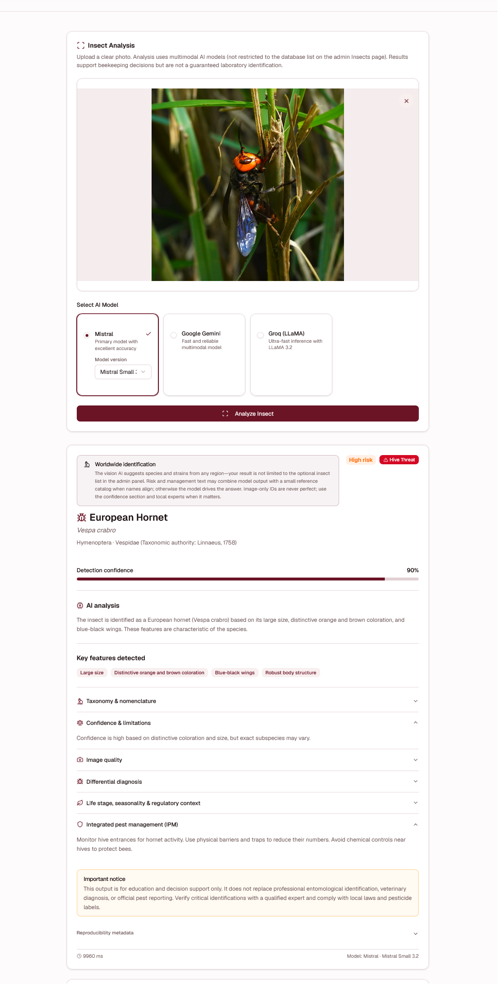
Figure B1. Web interface screenshot: analysis submission and AI result overview.

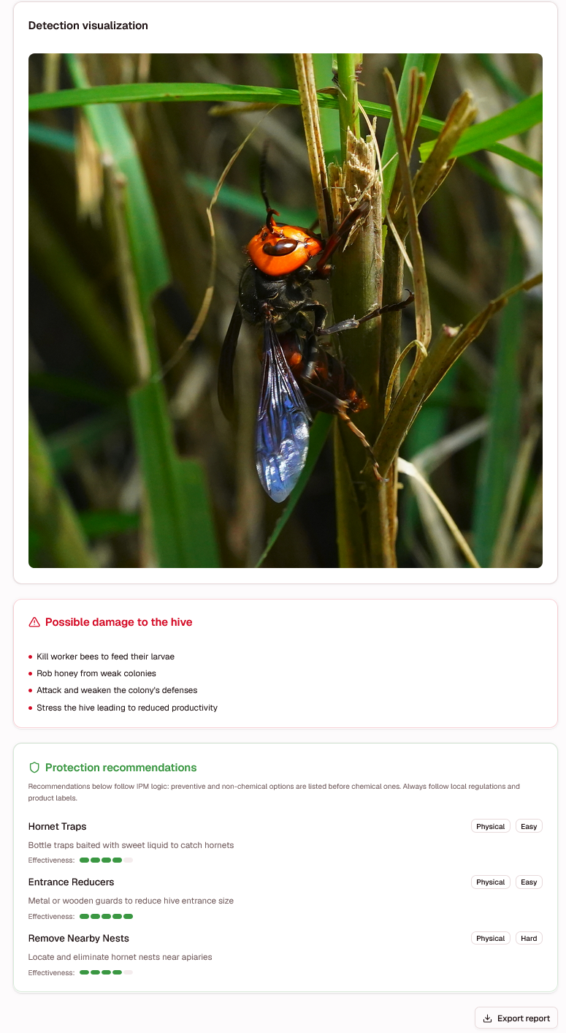
Figure B2. Web interface screenshot: detection visualization and protection recommendations.

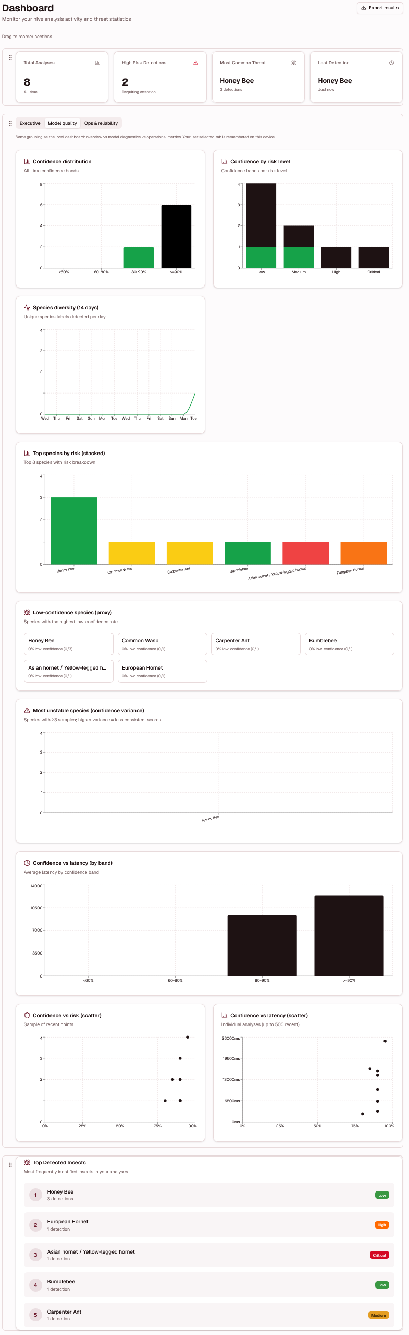
Figure B3. Web interface screenshot: authenticated dashboard and analytics view.
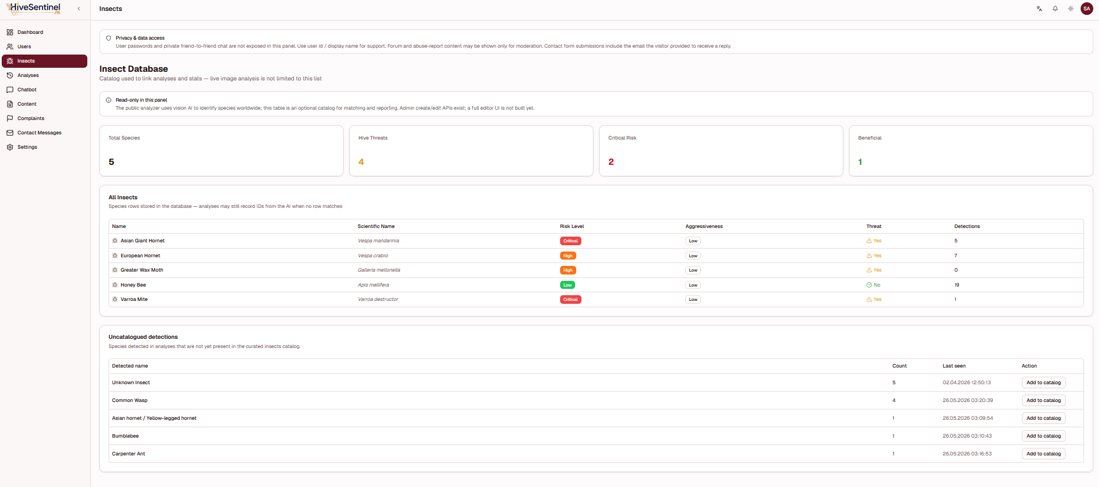
Figure B4. Web interface screenshot: administrative insect database listing view.

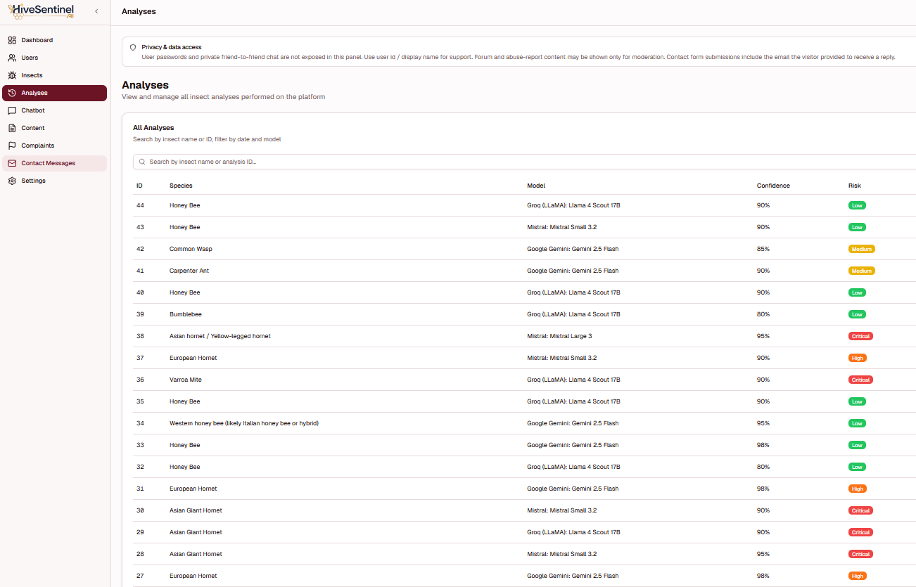
Figure B5. Web interface screenshot: administrative analysis records listing view.

Appendix C - Research Question to Evidence Matrix
This appendix maps the research questions to the main thesis sections and representative evidence categories used during the evaluation discussion. Appendix C - Table 1 presents this mapping in tabular form.

Appendix C - Table 1. Mapping of research questions to thesis sections and representative evidence categories.
RQ | Short formulation | Primary thesis sections | Representative evidence IDs (non-exhaustive)
RQ1 | Integrated web platform and AI pipeline for monitoring workflows | Chapter IV §4.2, §4.3.1 | EV-W-FIN, EV-W-METH, EV-W-ANLZ, EV-D-IDX, EV-D-COMPILE
RQ2 | Classification performance on the project dataset | Chapter IV §4.4 | EV-D-P3-MT, EV-D-P3-MV, EV-D-P3MET, EV-D-P3CM, EV-D-SMOKE-J
RQ3 | Offline-capable operation, stable API behavior, stress performance | Chapter IV §4.5, §4.6 | EV-D-STRESS-J, EV-D-STRESS-R, EV-D-HEALTH, EV-D-DASH, EV-W-STRESS
RQ4 | Pi-oriented runtime feasibility with safeguards | Chapter IV §4.2.3, §4.5.2, §4.6 | EV-P-IDX, EV-P-FIN, EV-P-PYTEST, EV-P-PRED-PAC-J, EV-P-RLIM
RQ5 | Additional measurements for strict physical Pi field claims | Chapter IV §4.5.2, §4.7 | Planned protocol - not claimed as completed in current evidence package

Appendix D - Project Git Repositories and Reproducibility Snapshot
This appendix expands the repository-visibility summary introduced in Chapter III by providing direct code-availability links and access notes for the HiveSentinel AI project family. The two public repositories listed in Appendix D - Table 1 are the canonical code locations for the desktop-local model pipeline and the low-resource edge runtime. The website platform repository remains private to avoid disclosing deployment-sensitive configurations, hosting logic, and security-related implementation details. Therefore, this appendix functions as a link and reproducibility register rather than a second system-component comparison table.

Appendix D - Table 1. Direct repository links and reproducibility access notes.
Project | Reproducibility scope | Visibility | Repository URL / access note
Project 1 | Website platform: user workflow, authentication, authorization, database-backed application logic, and web/API validation summaries. | Private | Private repository; not disclosed in the thesis for security, hosting, and deployment-configuration reasons.
Project 2 | Desktop / Laptop Local Model: dataset documentation, YOLOv8-based training/evaluation scripts, local inference service, and report-generation workflow. | Public | https://github.com/muratyanasoglu/HiveSentinel-AI---Local-Model.git
Project 3 | Low-Resource Edge Runtime: ONNX Runtime and Flask-based inference package prepared for Raspberry Pi-class deployment and protocol-level testing. | Public | https://github.com/muratyanasoglu/HiveSentinel-AI---Raspberry-Pi-Model

Appendix E - Raspberry Pi Field Measurement Protocol
This appendix describes the protocols for field measurements. This is a necessary first step before confident, quantitative results can be provided on the performance of the Raspberry Pi 4 devices running on HiveSentinel AI. It is a procedural appendix, not an appendix of performance evidence collected from the field. This serves to make the last hardware validation step obvious, and formulate a process that is repeatable and auditable.
Appendix E - Tables 1 and 2 specify the required field-measurement setup and procedure, while Figure E1 summarizes the workflow that must be completed before physical Raspberry Pi performance claims are made.
The procedures outlined here must be undertaken with actual Raspberry Pi hardware in a controlled setting, and the conditions of each test must be documented. Results must be archived with the final thesis evidence package after measurement is completed. Consequently, Chapter IV and Chapter VI must refer to Raspberry Pi functionality as software- and protocol-level evidence, not as documented physical field evidence.
The planned Raspberry Pi field measurement protocols are outlined in Figure E1. The flow has been included to illustrate that claims regarding the performance of the physical edge will require the assessment of hardware-level timings, thermal management, and stability, in addition to the validation of the development-host ONNX/Flask.
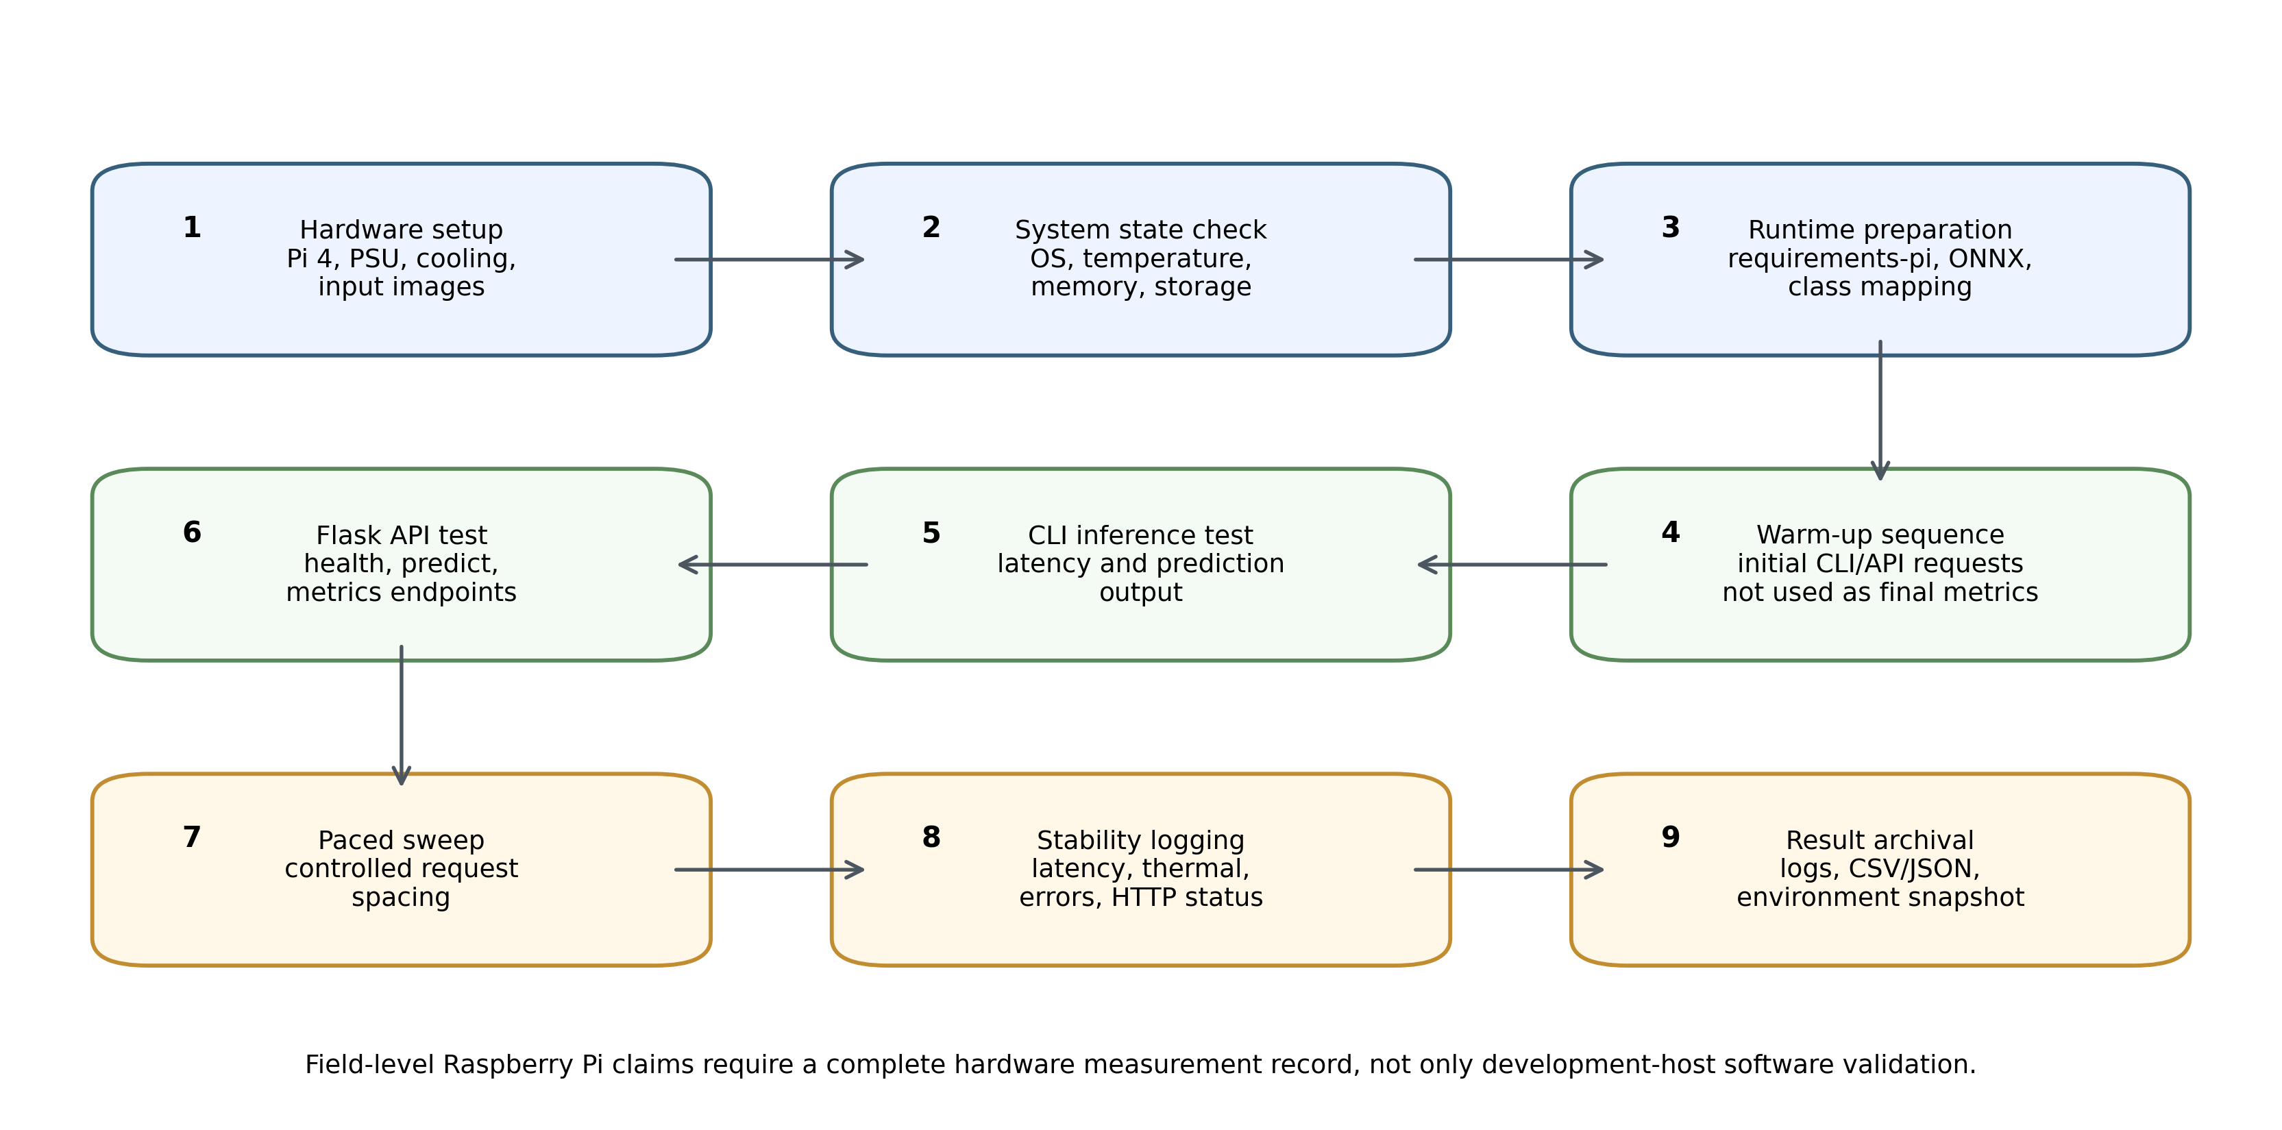
Appendix E - Figure E1. Raspberry Pi field measurement protocol workflow.

Appendix E - Table 1. Raspberry Pi field measurement setup requirements.
Protocol item | Required documentation
Hardware target | Raspberry Pi 4 or equivalent Raspberry Pi-class target used for the field measurement.
Memory and storage | Record RAM capacity, storage type, available free space, and operating system image/version.
Power supply | Record rated power supply, cable type, and whether undervoltage warnings occurred.
Thermal condition | Record ambient temperature, enclosure state, cooling method, and CPU temperature before and after runs.
Network condition | Record whether tests run locally through loopback, local network, or offline CLI inference.
Model artifact | Record ONNX model version, class mapping version, input size, and runtime configuration.
Image set | Record the number of images, class coverage, and whether the image set is public, synthetic, or field-captured.

Appendix E - Table 2. Raspberry Pi measurement procedure and metrics to be recorded.
Step | Procedure | Recorded output
1 | Boot the Raspberry Pi target and record system state before testing. | OS version, CPU temperature, available memory, power status.
2 | Run a warm-up sequence before timing measurements. | Warm-up count, warm-up latency summary, any runtime warnings.
3 | Execute CLI inference on the selected image set. | Mean, median, p95, maximum latency, failures, and class outputs.
4 | Execute API inference using the same or equivalent image set. | HTTP success rate, response latency, response schema, and error counts.
5 | Execute a paced request sequence under controlled load. | Completed requests, throughput, p95 latency, and observed stability.
6 | Execute a burst/safeguard probe if safe for the device. | HTTP 200/429 behavior, rate-limit activation, and recovery behavior.
7 | Record post-run hardware state. | CPU temperature, throttling warnings, memory state, and stability notes.
8 | Archive the complete measurement package. | Raw logs, summary tables, runtime configuration, and hardware notes.

Acceptance of strict Raspberry Pi field-performance language should include a comprehensive performance documentation set, which includes measurements, hardware specifications, timing footprints, success and failure counts, thermals, and preserved raw logs. In the absence of any measurement, the current bounded claim should be preserved. The edge runtime is software-validated and protocol-ready; strict Raspberry Pi 4 field performance is still pending.

Appendix F - Model Classes and Runtime Configuration
This appendix describes the classification of models and the concepts of runtime configurations offered by HiveSentinel AI. This appendix aims to provide the information necessary to reproduce a given result by separating fixed, system-level configuration information from interpretations in the chapters. Descriptions are written for a public academic audience and do not include private web-platform repository paths.
Appendix F - Tables 1 and 2 provide the model-class taxonomy and the runtime-configuration concepts that support consistent interpretation across the desktop-local and edge-local components.

Appendix F - Table 1. Model class taxonomy and operational interpretation.
Class token | Operational interpretation | Primary monitoring relevance
honey_bee | Western honey bee imagery without explicit visible pest context. | Baseline bee-recognition class and non-threat comparison.
honey_bee_varroa | Honey bee imagery with visible Varroa-related context. | Varroa-associated monitoring signal.
hornet_asian | Asian hornet-oriented image category. | Invasive or high-risk predator monitoring signal.
hornet_european | European hornet-oriented image category. | Predator/distractor class for hornet differentiation.
other_insect_hive | Other hive-relevant or distractor insect imagery. | Reduces over-assignment to the main pest classes.
wasp_common | Common wasp-oriented image category. | Wasp monitoring and differentiation from bee/hornet classes.

Appendix F - Table 2. Runtime configuration concepts used across HiveSentinel AI components.
Configuration concept | Desktop-local model pipeline | Edge / Raspberry Pi-oriented runtime
Model format | Training and evaluation use the desktop deep-learning pipeline and promoted model weights. | Inference uses an ONNX Runtime-oriented package for lightweight execution.
Class mapping | Class labels are aligned with the six-class taxonomy used in the dataset and evaluation protocol. | Runtime predictions must use the same six-class mapping to avoid label drift.
Input handling | Images are decoded, resized, normalized, and passed through the local inference service. | Images are processed through a lightweight CLI or API inference flow with device-aware constraints.
Confidence behavior | Confidence scores support interpretation of prediction strength and potential low-confidence handling. | Low-confidence or abstention behavior should be recorded when enabled by runtime configuration.
Service interface | The desktop service exposes local prediction and introspection behavior for validation. | The edge service exposes lightweight health/prediction/metrics behavior when API mode is used.
Operational safeguards | Stress and health checks support repeatable engineering validation. | Rate limiting, request-size boundaries, and local-first deployment reduce misuse and device overload risk.
Evidence boundary | Desktop evaluation results support model and service validation under the documented protocol. | Strict hardware-field claims require execution of Appendix E on the target Raspberry Pi device.

Configuration concepts in this appendix should be used together with the available public desktop/local model repository and the public Raspberry Pi/edge runtime repository. Private web-platform implementation paths are omitted in this appendix.
Appendix G - External Comparator Source and Model Link Register
This appendix records the external comparator sources used for the bounded comparison in Chapter IV and Chapter V. The links are provided so that the model families, datasets, and reported metrics can be checked directly. The table is not a same-dataset benchmark registry; it is a source-and-scope register for the comparison narrative.
Appendix G - Table 1. External comparator source and direct model/source link register.
Comparator source | Direct link | Model / method | Task domain | Reported statistic used | Use in thesis comparison
HiveSentinel AI desktop-local model | Internal thesis evidence | Ultralytics YOLOv8 classification pipeline; local FastAPI inference | Six-class bee-pest classification | 0.96675 validation accuracy; 0.9680 weighted F1 | Primary high-performance local/desktop thesis model; validation split only.
HiveSentinel AI low-resource edge runtime | Internal thesis evidence | ONNX Runtime CPUExecutionProvider + Flask API + CLI inference | Raspberry Pi-class local/offline runtime preparation | 71-image diagnostic example check; development-host only | Small-system thesis track; compared mainly by deployment preparation and controls.
Liang (2024) | https://arxiv.org/abs/2401.09988 | AMNN multimodal neural network | Bee health evaluation | 92.61% overall accuracy; F1 higher than 90% | Lower reported main accuracy than HiveSentinel desktop validation result; different task.
Alex et al. (2024) | https://arxiv.org/abs/2405.15428 | YOLOv5m / YOLOv5s | Bee object detection and monitoring | 9,664 images; YOLOv5s real-time at 5.1 ms/frame | Domain-close bee-monitoring comparator; metric differs from classification accuracy.
Ratnayake et al. (2024) | https://www.mdpi.com/2571-5577/7/4/62 | YOLO-SVM and ML classifiers | Bee species identification | 90.18% accuracy for YOLO-SVM | Lower reported accuracy; species identification rather than six-class pest taxonomy.
Narcia-Macias et al. (2023) | https://arxiv.org/abs/2309.08955 | YOLOv7-tiny | Honey bee, pollen, and Varroa monitoring | 96.28% tracking accuracy; 0.95 F1; 0.831 pollen F1 | Very close comparator; HiveSentinel desktop validation accuracy slightly higher, with broader evidence separation.
Vdoviak et al. (2025) | https://www.mdpi.com/2077-0472/15/10/1019 | YOLO-based / Faster R-CNN-based detectors | Hive entrance insect detection | Approx. 93-95% F1 for selected configurations | Relevant hive-entrance detector; task and hardware differ.
O'Shea-Wheller et al. (2024) / VespAI | https://www.nature.com/articles/s42003-024-05979-z | Deep-learning camera-trap system with Raspberry Pi 4 orientation | Invasive Asian hornet detection | Mean precision-recall score >=0.99 | Included for balanced context; not a lower-metric comparator.
Hakim et al. (2025) / Yolo-Pest | https://www.nature.com/articles/s41598-025-97825-3 | Fine-tuned YOLOv8x with smart traps | Crop-pest detection | 94% average detection accuracy | Lower reported field detection accuracy; different crop-pest domain.
Nguyen et al. (2024) / DeWi | https://arxiv.org/abs/2409.10445 | Deep-Wide learning assistance for CNNs | General insect pest classification | 76.44% IP102 accuracy; 99.79% D0 accuracy | Used cautiously for broad pest-recognition context.
Ung et al. (2021) | https://arxiv.org/abs/2107.12189 | Multiple CNN ensemble | General insect pest classification | 74.13% IP102 accuracy | General pest context; not bee-specific.
Zhou and Su (2021) / ExquisiteNet | https://arxiv.org/abs/2107.07167 | Small CNN, 0.98M parameters | Lightweight pest recognition | 52.32% IP102 accuracy | Low-resource pest-recognition context; not a direct HiveSentinel edge benchmark.
Ultralytics YOLO classification/export documentation | https://docs.ultralytics.com/tasks/classify | YOLO classification and export formats | Technical deployment support | ONNX export and validation support | Supports technical basis for YOLO classification and ONNX deployment pathway.
ONNX Runtime Raspberry Pi documentation | https://onnxruntime.ai/docs/tutorials/iot-edge/rasp-pi-cv.html | ONNX Runtime edge image classification | Raspberry Pi image classification tutorial | Raspberry Pi ONNX inference pathway | Supports feasibility of ONNX Runtime as a Raspberry Pi-class runtime target.

Similarity Report

CV
Muhammed Murat Yanaşoğlu
Software Engineer | AI Engineer
Nicosia, TRNC | eng.muratyanasoglu@gmail.com | https://muratyanasoglu.com/ | ORCID: https://orcid.org/0009-0007-4722-8079
EDUCATION
Artificial Intelligence Engineering | Master's Degree | 100% English Instruction
Near East University | Nicosia, TRNC
• Participated in academic research papers and AI-focused engineering projects.
• High Honor student: Spring 2024-2025 (GPA 3.50) and Fall 2025-2026 (GPA 4.00).
• ORCID profile: https://orcid.org/0009-0007-4722-8079
Software Engineering | Bachelor's Degree | 100% English Instruction
Near East University | Nicosia, TRNC
• Completed the four-year engineering bachelor's program in three years and the English preparatory program in one semester.
• High Honor student: Fall 2024-2025 (GPA 3.93), Spring 2023-2024 (GPA 3.76), and Fall 2022-2023 (GPA 3.81).
• Founder and President of the Near East University Artificial Intelligence Club.
PROFESSIONAL AND RESEARCH EXPERIENCE
Information Technology Specialist (Bilgi İşlem Uzmanı)
Ercan International Airport (T & T İşletmesi) | Nicosia, TRNC | 1 June 2026 - Present
• Supports IT systems, user assistance, operational continuity, and technology-related problem solving within the airport environment.
AI Engineer
Porttus AI | Seattle, United States | June 2025 - February 2026 | Remote
• Developed AI-integrated automation systems, internal Python packages, documentation workflows, RAG-based voice assistant systems, fine-tuned AI chatbots, OCR-supported pipelines, and Docker/CI-CD based project components.
AI Engineer / Front-End Web Developer
Trylon AI | Denver, Colorado, United States | February 2025 - June 2025 | Remote
• Contributed to AI service optimization, frontend/backend web development, AI integration, technical presentations, documentation, and planning tasks.
Software Engineer - Intern
Near East University AI & Robotics Institute | Nicosia, TRNC | June 2024 - September 2024 | On-site
• Supported software development and academic research projects, including Python-based data analysis, visualization, documentation, and technical presentations.
Front-End Web Developer
Nüve Core Software and Digital Agency | Ankara, Türkiye | September 2023 - March 2024 | Remote
• Worked with React.js, Next.js, TypeScript, Tailwind CSS, and modern frontend practices; contributed to responsive UI implementation and performance optimization.
Software Engineer - Intern
Nüve Core Software and Digital Agency | Ankara, Türkiye | July 2023 - September 2023 | On-site
• Gained experience in Agile/Scrum workflows, project documentation, frontend technologies, third-party API integrations, and unit testing.
SELECTED ACADEMIC AND TECHNICAL PROJECTS
SiteScribe - AI-Powered Construction Change Order Management Platform
Developed a multi-tenant Next.js, TypeScript, Prisma, and MySQL platform for evidence-based change order workflows, RBAC, notifications, approval flows, PDF/ZIP export, and optional Mistral AI integration. Public repository and academic paper: https://github.com/muratyanasoglu/SiteScribe.git; Zenodo record: https://zenodo.org/records/19103585
AI-Powered OCR Project for Ancient Languages
Built a Django-based OCR and AI analysis system for Latin, Ancient Greek, and Fraktur texts with Tesseract OCR, Google Gemini integration, translation, summarization, historical context, and TXT/JSON/Word/PDF export. Repository: https://github.com/muratyanasoglu/AI-Powered-OCR-Project-for-Ancient-Languages-Ancient-Greek-Fraktur-Old-German-Classical-Latin.git
RegLens - Enterprise RegTech Compliance and Audit Automation Platform
Developed a regulatory monitoring and compliance automation platform using Next.js, TypeScript, Prisma, MySQL, AI-supported normalization/matching, RBAC, audit evidence generation, security logs, rate limiting, and PWA support. Repository: https://github.com/muratyanasoglu/RegLens.git
Object Name Tutor - Bilingual ROI-Controlled Object Recognition System
Developed an offline educational computer-vision application using a YOLOv8n and MobileNetV2 detector-classifier pipeline for bilingual vocabulary learning and real-time object recognition. Repository: https://github.com/muratyanasoglu/Object-Name-Tutor-An-Offline-Bilingual-ROI-Controlled-Object-Recognition-System-.git
Near East University Prof. Dux - AI-Powered Artwork Analysis Platform
Developed an AI-powered artwork analysis, model comparison, and blog-generation web platform with downloadable HTML/JSON outputs. Web platform: https://profdux-artwork-analysis-app.vercel.app/
Near East University Student Office Hours Reservation Website
Developed a student-academic appointment management system with student and academic portals, availability management, approval/rejection workflows, and messaging support. Repository: https://github.com/muratyanasoglu/student-office-hour-websites
End-to-End AI Platform for U.S. Immigration Petition Preparation
Developed a private full-lifecycle AI platform for user data collection, evidence management, draft generation, revision workflows, multi-LLM orchestration, multilingual voice assistant support, and chatbot support.
AI-Powered Personal Websites
Developed AI-supported personal/professional websites: https://www.mervekirmiziyuz.com/ | https://drsergazy.com/
TECHNICAL SKILLS
• Programming Languages: Python, SQL, TypeScript, PHP.
• Frameworks and Libraries: Pandas, NumPy, Matplotlib, Next.js, React.js, HTML, CSS, Tailwind CSS, Bootstrap CSS, Tesseract OCR.
• Databases and Tools: PostgreSQL, MySQL, SQLAlchemy, phpMyAdmin, XAMPP, n8n, Langflow, Docker, CI/CD, software project management, requirements analysis, software architecture and design, image processing and ROI-based workflows.
CERTIFICATES
• Python for Data Science, AI & Development - IBM
• Developing AI Applications with Python and Flask - IBM
• Generative AI: Elevate Your Software Development Career - IBM
• Django Application Development with SQL and Databases - IBM
• Developing Front-End Apps with React - IBM
• Developing Back-End Apps with Node.js and Express - IBM
• Full-Stack Application Development Capstone Project - IBM
• Full-Stack Software Developer Assessment - IBM
• Application Development using Microservices and Serverless - IBM
• Getting Started with Git and GitHub - IBM
• Introduction to Cloud Computing - IBM
• Introduction to Containers with Docker, Kubernetes & OpenShift - IBM
• Introduction to Web Development with HTML, CSS, and JavaScript - IBM
• Certificate of Success in Entrepreneurship - European Union
• Internship High Success Certificate - Near East University AI and Robotics Institute
• Certificate originals are available on the personal website: https://muratyanasoglu.com/
ACADEMIC AND UNIVERSITY ACTIVITIES
• Founder and President: Artificial Intelligence Club, Near East University.
• Member: CodeCrafters Software Club, Near East University.
• Representative: Software Engineering Department Representative, Near East University.
• Languages: Turkish (Native), English (Advanced), French (Beginner), Fusha Arabic (Beginner).

